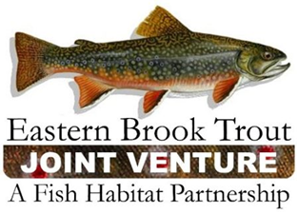
Steering Committee Conference Call
December 19, 2017
1:00 – 3:00 p.m.

Call-In Number: 888-844-9904
Participant Code: 7299722

AGENDA

- Steering Committee Roll Call & Establishment of Quorum (Nat Gillespie)

- Approval of September 19, 2017 SC Call Summary (Nat Gillespie)

- Outcome of Email Approval for the June 20, 2017 SC Call Summary (Nat Gillespie)

- Review and Approval of FY18 EBTJV/FWS-NFHAP Project Rankings (Steve Perry)

- Approval of FY18 EBTJV Coordination and Operations Project as Top FWS-NFHAP Funding Priority (Steve Perry)

- Overview of EBTJV FY18 Workplan and Accomplishment Report (Steve Perry)

- Feedback on draft “Roadmap-2nd Edition” (Steve Perry)

- Webinars and/or Workshops on Brook Trout-Related Decision Support Tools (Steve Perry)

- NFH Board’s FHP Performance Evaluation (Steve Perry)

- NFHAP Project Tracking Database Update (Steve Perry)

- Adopting 2018 Dates for Steering Committee Teleconferences (Steve Perry)

- Other Business

