Removal of Illegally Introduced and Missed Rainbow Trout from Lynn Camp Prong, Great Smoky Mountains National Park

Project Location: Tennessee, Blount County
Congressional District of Project: TN 1 and 2
Congressional District of Applicant: TN 1 and 2
EBTJV / NFHAP Funding Requested: $49,000
Total Project Cost: $250,295
Total Federal Matching: $105,000
Total Non-Federal Matching: $96,295

APPLICANT
Organization: National Park Service
Project Officer: Steve Moore
Street: 107 Park Headquarters Road
City, State, Zip: Gatlinburg, TN 37738
Telephone Number: (865) 436 - 1250
Fax Number: (865) 430 - 0341
EMail Address: steve_e_moore@nps.gov

U.S. Fish and Wildlife Service Sponsoring Office
Fish and Wildlife Service Office: Southeast Region, Warm Springs Regional Fisheries Center
- Project Officer: Tom Sinclair
Street: 1875 Century Boulevard, Suite 250
- City, State, Zip: Atlanta, GA 30345
- Telephone Number: (404) 679 - 7324
- Fax Number: (404) 679 - 4141
EMail Address: thomas_sinclair@fws.gov

USFWS FONS Database Project Number: 42216-2010-268

Coordination Completed with US Fish and Wildlife Service Fisheries Office (Check One):
X Yes, August 19, 2010 Date Coordination Began
No
I. PROJECT DESCRIPTION, SCOPE OF WORK, AND PARTNER INFORMATION

A. Project Description and Scope of Work (Max Characters: 500)
In 2008 Great Smoky Mountains National Park (GRSM) partnered with Tennessee Wildlife Resources Agency, N. C. Wildlife Resources Commission, Trout Unlimited, Federation of Fly Fishers, Orvis and the Eastern Brook Trout Joint Venture to restore the Lynn Camp Prong watershed for brook trout. In September 2008, 10.2 km (6.4 miles) of Lynn Camp Prong and 2.2 km (1.4 miles) of Marks Creek was treated with Fintrol® (antimycin) to remove non-native rainbow trout. Surveys in June and July 2009 collected a small number of rainbow trout in two locations in Lynn Camp Prong and in the upstream most 500 m of Marks Creek. These sections were re-treated with Fintrol® in late July to remove the remaining rainbow trout. Follow up electrofishing surveys of these and other stream sections collected no rainbow trout. In September and October 2009 approximately 2,000 native “Southern Appalachian” brook trout were collected and released into the restored stream sections.

Surveys in June 2010 to evaluate the survival and reproductive success of the reintroduced brook trout discovered that rainbow trout had been illegally stocked into the project area. The illegal introduction was verified by the presence of two rainbow trout of hatchery origin in the four adults initially collected. Fishery staff electrofished the remainder of the project area and collected an additional 29 adult and 33 young of the year rainbow trout, providing evidence that the fish had been stocked prior to spawning. Managers decided at this point to continue electrofishing efforts with the goal of eliminating all adult rainbow trout from the stream and thus eliminate the possibility of spawning in the spring of 2011. During this process, project managers also realized that a 60 m section of a tributary stream containing a small number of rainbow trout had not been treated in 2008. Steps were immediately taken to eliminate this source of rainbow trout. As of mid-August 2010, 209 young of the year (YOY) and 57 adult rainbow trout have been removed from about 2.9 km (1.8 miles) of the original project area. No adult rainbow trout were collected during the last removal effort.

Law enforcement personnel plan to conduct patrols in the Lynn Camp area and may place trail cameras in an effort to document illegal activities. Additionally many Trout Unlimited volunteers and concerned citizens have offered to hike the trail occasionally in an attempt to document illegal activities. Fisheries staff also plans to conduct additional public outreach sessions to remind local residents of the goals and objectives of brook trout restoration and the value of this project to the Park and TN. We have some information on who may have illegally introduced the rainbow and have an indication they will attend a public information meeting. If this fails fishery and law enforcement staff plan to meet with them in a one on one meeting to explain the seriousness of the action and what could possibly result if a future illegal introduction occurs.

Project Objectives:

- In 2011, sample the stream to determine the distribution of rainbow trout and establish the treatment area.
- Complete an amendment to the existing Environmental Assessment so that so that rotenone can be used to retreat as Fintrol® (antimycin) is not available.
- If this effort is successful, collect and stock approximately 1,000 – 1,500 brook trout to supplement the existing population in September and October 2011.

B. Proposed Methods (Max Characters: 350)
The initial action in the planning process for 2011 is to amend the existing Environmental Assessment (EA) for the use of rotenone. This is a necessary step as Fintrol® is currently not available. In mid to late June 2011 approximately 5.7 km (3.6 miles) of Lynn Camp Prong will be surveyed to determine the distribution of remaining rainbow trout. Based on this information plans for a second treatment in September will be finalize. Prior to treatment staff will electrofish the proposed treatment reach to collect as many of the introduced brook trout as possible and move them to safe refuges in Marks Creek or upper Lynn Camp Prong or Indian Flats Prong.

C. Project Timeline
- November and December 2010 - finalize the amendment to the EA
- June and July - complete distribution surveys and define treatment area
- Late-August - collect and move brook trout
- Early September - treat the project area
- October - validate removal success and return collected brook trout to the treatment area

D. Proposed Accomplishment Summary (Max Characters: 350)
The proposed project will result in the removal illegally introduced and missed rainbow trout from the Lynn Camp prong watershed. The successful removal of these fish and reintroduction of native brook trout will meet the objectives of Great Smoky Mountains National Park and Tennessee for the protection and conservation of native brook trout in the State. Additionally, the project will help meet a goal of the National Fish Habitat Action Plan (NFHAP) and the Eastern Brook Trout Joint Venture (EBTJV) by restoring brook trout to a watershed in which they have been reduced by over 90%.

E. State the Importance of the project to the Resource (Max Characters: 350)
The successful completion of this restoration project will reconnect brook trout populations in three tributary streams thus eliminating fragmentation in this watershed. This reconnection of steam segments will result in this population being the largest contiguous brook trout populations in Great Smoky Mountains National Park.

F. Problem and Specific Cause of the Problem (Max Characters: 350)
Field surveys in June 2010 to evaluate the success of the reintroductions discovered that rainbow trout had been illegally stocked into the project area. This was verified by the presence of two fin clipped rainbow trout in the four adult fish initially collected. Project managers decided to electrofish the remainder of the project area to determine the extent of the illegal introductions. This effort collected and additional 29 adult and 33 young of the year rainbow trout. Managers decided at this point to continue electrofishing efforts with the goal of eliminating all adult rainbow trout from the stream. During this process, project managers also realized that a 60 m section of a tributary stream containing a small number of rainbow trout had not been treated in 2008. Steps were immediately taken to eliminate this source of rainbow trout. As of mid-August 2010, 209 young of the year (YOY) and 57 adult rainbow trout have been removed from about 2.9 km (1.8 miles) of the original project area. No adult rainbow trout were collected during the last removal effort.

Given the amount of effort that has been put in this project already, every effort must be made to eliminate the remaining rainbow trout. Additionally given some new information, project managers believe that they know who illegally introduced rainbow trout. They plan to meet with these individuals to let them know what we suspect and that law enforcement personnel will be watching for them and their vehicles in the Park.

G. Objective of the Project with Reference to the Problem (Max characters: 350)
The objectives of this effort are: (1) eliminate all illegally introduced and missed rainbow trout in the Lynn Camp Prong watershed; (2) more public outreach to provide information on the project and brook trout restoration in general; and (3) increased law enforcement and volunteer patrols. The hope is this that last two objectives will help deter and eliminate future illegal introductions.

H. Partner Information (not to exceed 100 words)

Partner Name | Contribution  In-Kind | Contribution  Cash | Federal or Non- Federal | Partner  Category | Role of Partner
Little River Chapter of Trout Unlimited | $9,195 | $45,000 | Non-Federal | Conservation Group (local) | Volunteer help and cash for personnel (seasonal) and supplies
Trout Unlimited (National) |  | $10,000 (applied for) | Non-Federal | Conservation Group (national) | Cash for equipment and supplies
TN Council of Trout Unlimited |  | $1,000 | Non-Federal | Conservation Group (state) | Cash for equipment and supplies
NC Council of Trout Unlimited |  | $2,500 | Non-Federal | Conservation Group (state) | Cash for rotenone and treatment equipment
Friends of GRSM |  | $12,000 | Non-Federal | Local Conservation Group | Cash for 2 Resource Assistants (12 weeks) and 1 intern (8 weeks)
Federation of Fly Fishers |  | $3,600 | Non-Federal | Conservation Group (national) | Cash for intern (8weeks)
Trout and Salmon Foundation |  | $8,000 (applied for) |  | Conservation Group (national) | Cash for intern (8 weeks) and Pod Cast production
TN Wildlife Resources Agency | $5,000 |  |  | State Agency | Assistance with treatment
National Park Service | $70,000 |  | Federal | Federal Agency | Project planning,  coordination and implementation

II. MAP OF PROJECT AREA (one only)
Figure 1. — Map of the section of Lynn Camp Prong watershed, Great Smoky Mountains National Park that will be retreated. The UTM’s at the barrier are 258627 E and 3944601 N, datum NAD83.

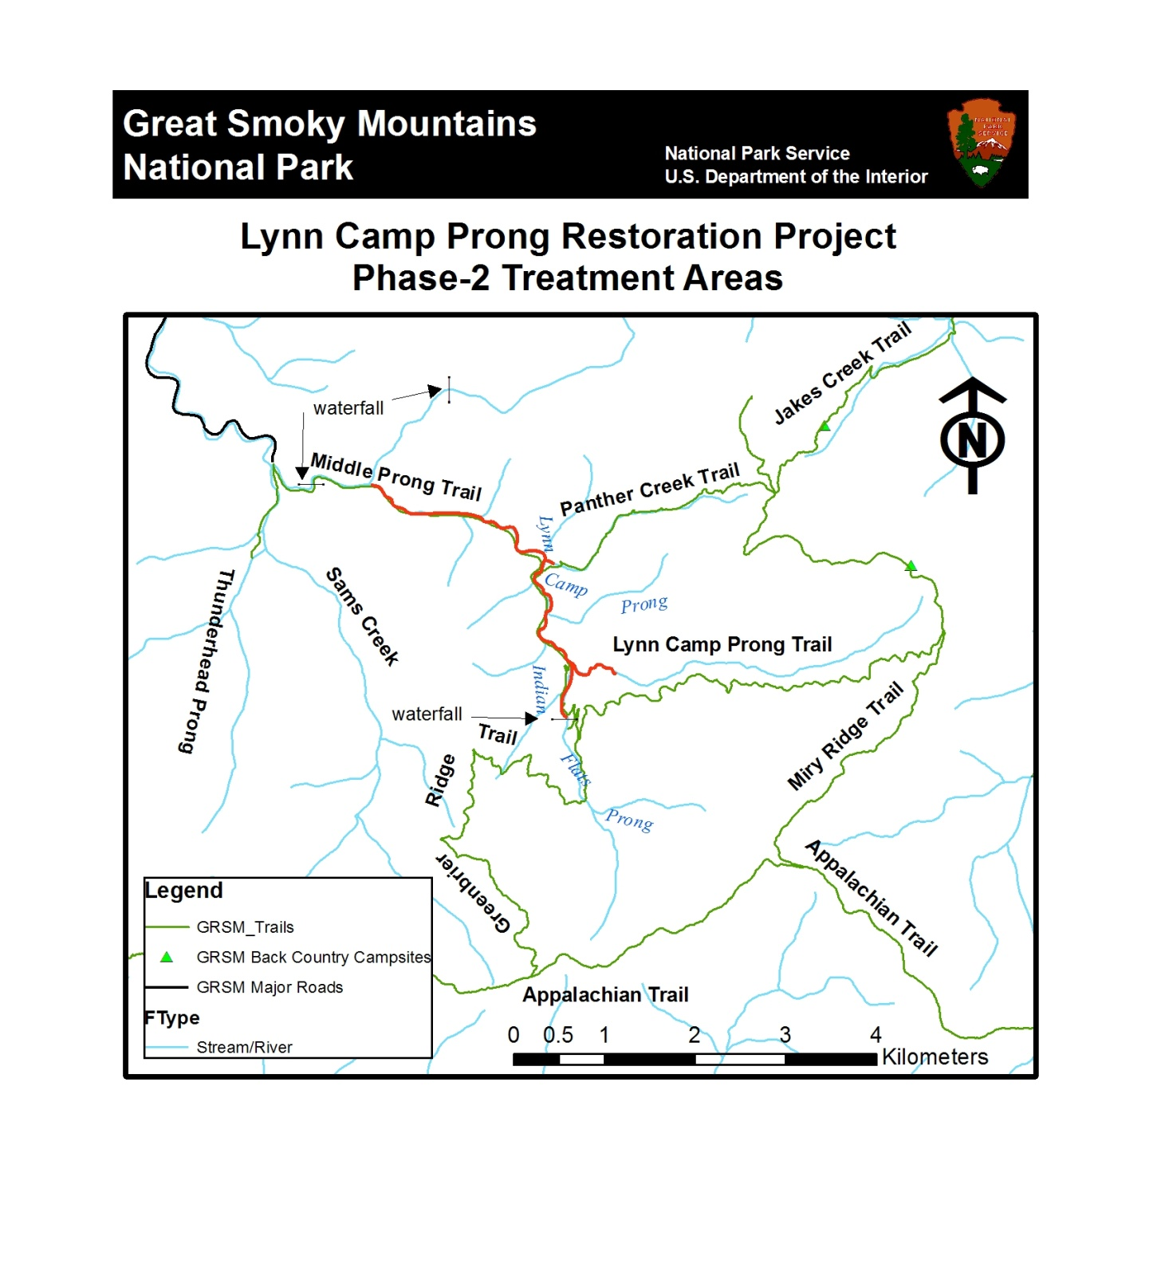

III. PHOTOGRAPH(S) OF PROJECT AREA (no more than 2, please provide credits and attach photo release forms)

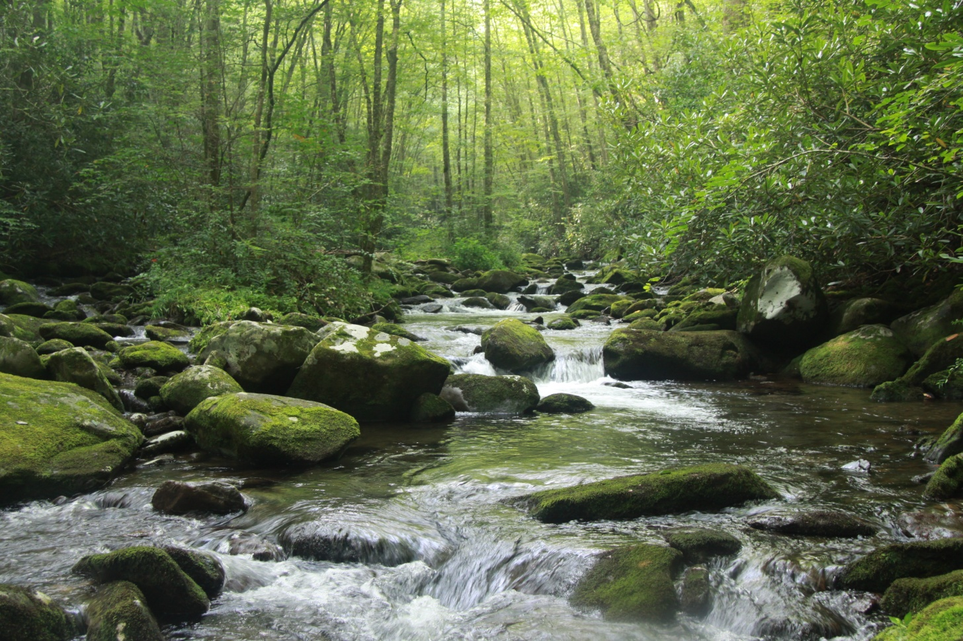

Lynn Camp Prong, NPS photo; photographer Steve Moore, National Park Service, Great Smoky Mountains National Park

Photo Release form is attached.

IV. PROJECT BUDGET

Partner Name | Partner Category* | Activity of Partner ** | Budget Category*** | EBTJV  NFHAP Request | Non-Federal Contribution |  | Federal Contribution |  | Total Contribution | Acres/Miles Affected
 |  |  |  |  | In-Kind | Cash | In-Kind | Cash
USDI-NPS  Fishery Biologist | Federal  Agency | Project planning, field oversight, Data analysis | Personnel |  |  |  | $70,000 |  | $70,000 | Plan retreatment of 5.7 km (3.6 miles) for brook trout restoration
USDI-NPS  2 Temp. Fish  technicians | Federal  Agency | Monitoring, Restoration | Personnel |  |  |  | $35,000 |  | $35,000 | Conduct monitoring and restoration
USDI-NPS  3 Temp.  Fish  Technicians | Federal  Agency | Monitoring, Restoration | Personnel | $49,000 |  |  |  |  | $49,000 | Conduct monitoring and restoration
TWRA | State agency | Restoration, treatment | Personnel |  | $5,000 |  |  |  | $5,000 | Assist with treatment of 5.7 km (3.6 miles) of stream
Little River Chapter of TU | Conservation Group (local) | Restoration and funding | Personnel |  | $9,195 | $45,000 |  |  | $54,195 | Assist with surveys and treatment
TU - National | Conservation Group (National) | Restoration funding and education outreach | Personnel |  |  | $10,000(applied for) |  |  | $10,000 | 2 SCA interns (12 weeks/ea), POD cast production
TN Council of Trout Unlimited | Conservation Group (local) | Restoration Supplies | Supplies and equipment |  |  | $1,000 |  |  | $1,000 | Funds for equipment and supplies
NC Council of Trout Unlimited | NC Council of Trout Unlimited | Restoration Supplies and Equipment | Funds for rotenone and treatment equipment |  |  | $2,500 |  |  | $2,500 | Funds for rotenone equipment and supplies
Federation of Fly Fishers | Conservation Group (National) | Monitoring, Restoration | Personnel |  | $3,600 |  |  |  | $3,600 | Conduct monitoring and restoration
Trout and Salmon Foundation | Conservation Group (National) | Restoration and education outreach | Personnel, education |  |  | $8,000  (applied for) |  |  | $8,000  (applied for) | funds for intern (8 weeks) and Pod Cast production
Friends of GRSM | Non-Profit Organization | Monitoring, Restoration | Personnel, |  |  | $12,000 |  |  | $12,000 | Funds for 2 SCA’s and 1 intern
Total Contribution |  |  |  | $49,000 | $17,795 | $78,500 | $105,000 |  | $250,295

V. EVALUATION QUESTIONS

- Please provide the GPS Coordinates for the project in UTM NAD 83.
NAD 83, 258624.4 E, 3944646.2N

- Please list the type of project. Examples include: in-stream habitat, riparian planting, fencing, AMD, fish passage, reintroduction, assessment, etc.
Removal of illegally introduced and missed rainbow trout from Lynn Camp Prong and reintroduction of native brook trout.

- Does the project include a protection component? If so, explain how the project sufficiently protects brook trout habitat. Does the project include fee simple land purchase or easements?
The project area lies entirely within the GRSM and is thus protected from impacts other than acidic deposition. Approximately 25% of the remaining habitat designated for conservation on public lands occurs in GRSM; therefore, it is critically important that the Park expand the range where feasible.

- What percentage of the watershed above the proposed project is protected in perpetuity?
100%, the project will occur in a national park.

- List the specific regional EBTJV habitat objectives addressed by the project and describe how the project will contribute towards them.
This project fully supports range wide habitat objective 3, which is to improve a reduced watershed to healthy status. It also will meet regional habitat objective 5, by strengthening a brook trout population in a watershed classified as reduced. Brook trout were eliminated from about 90% of the Lynn Camp watershed by historic logging activities and the introduction of non-native rainbow trout. This project will eliminate illegally introduced and missed rainbow trout from the watershed thus reconnecting headwater populations of brook trout that have been isolated for over 75 years.

- List the specific state-level EBTJV habitat objectives addressed by the project and describe how the project will contribute towards them.
Successful completion of this will help meet the strategy identified in Priority 4: Brook Trout Protection, Restoration and Enhancement of the Tennessee Brook Trout Conservation Strategy. Additionally, the successful completion of the project will meet the goals for brook trout restoration identified in the Parks Fishery Management Plan.

- Please state whether the project is an enhancement, restoration or protection project.
This project is a restoration project that will eliminate illegally introduced and missed rainbow trout.

- State which, if any, EBTJV priority the project addresses:
This project supports EBTJV Priority 2. Restore brook trout populations where original habitat conditions exist and where habitats can be restored. The successful completion of this project will reconnect brook trout in tributary streams and the main stream for the first time in approximately 100 years.

- What is the EBTJV priority ranking for the proposed project watershed for the type of project (enhancement, restoration or protection) being proposed?
Watershed # = 470728
Priority Score = 0.26
Map = Tennessee, reduced

- Will the completed project benefit any federally listed threatened or endangered species?
There are no known federally listed species within the project area.

- Will the completed project benefit any state listed threatened or endangered species?
There are no known state listed species within the project area.

- Does the project demonstrate watershed scale planning?
All watersheds adjacent to Lynn Camp Prong are classified as reduced. This project will not provide additional benefits to brook trout populations in the headwaters of adjacent watersheds as is no way to reconnect these populations.

- Please describe how the project will provide for the expansion or improvement of existing habitat?
This project will remove illegally introduced and missed rainbow trout from the main stem of Lynn Camp Prong and a small tributary stream. Brook trout populations in headwater tributaries have already started to expand their range after the initial restoration effort in 2008. Brook trout introduced in the fall of 2008 survived, reproduced and dispersed from the introduction points. Once this project is completed brook trout populations in the tributary streams and the main stream will be reconnected for the first over 100 years.

- What are the root causes of the watershed degradation and which of these are addressed by the project?
The illegal introduction of rainbow trout and missed rainbow trout in a 60 m section of a small tributary are the reason approximately 5.7 km (3.6 miles) of the 2008 project area will need to be treated with rotenone in 2011. In June 2010 project managers selected a small number of sites to sample to assess the survival and reproductive success of the brook trout released in September and October 2009. One of the first sites sampled yielded four large rainbow trout, one of which was a 305 – 330 mm (12 – 13 inch) hatchery fish and another fish that appeared to have been fin clipped (i.e. hatchery origin). These fin clipped fish were definitely illegal introductions. Given the number of additional rainbow trout found in two locations provided additional evidence of the illegal introduction.

During the first 2010 removal effort, project leaders discovered that about a 60 m section of Panther Creek, a small tributary to Lynn Camp Prong had rainbow trout in it and was not treated in 2008. The reason for this oversight was that during the treatment, black bears discovered that fish cages holding sentinel rainbow trout held an easy meal so they destroyed these cages daily. By the time the treatment reached the Panther Creek area the bears had learned to associate treatment stations with food and had become aggressive toward people manning the treatment stations. In the interest of safety for project staff and the bears and haste to get away from a potentially hazardous situation, project managers failed to check the distribution map for Panther Creek, thus it did not get treated.

This effort will remove all remaining rainbow trout from Lynn Camp Prong in 2011. Law enforcement personnel plan to conduct patrols in the area and may place trail cameras in an effort to eliminate illegal activities. Additionally many Trout Unlimited volunteers and concerned citizens have offered to hike the trail occasionally in an attempt to document and report illegal activities.

- Describe the plans for post project monitoring and evaluation.
The proposed project area will be electrofished one to two weeks after treatment to determine the success of the treatment. If rainbow trout are located those stream sections will be retreated. A second evaluation will occur in June or July of 2012. If this effort collects no rainbow trout then brook trout will be returned to the area from upstream refuges and an additional 1,000 to 1,500 brook trout will be collected and released in the stream to supplement the existing population.

- Describe the expected effect on the brook trout population. To what degree will the project strengthen the brook trout population status?
The completion of this project will expand the range of native brook trout in GRSM by about eight miles. This restoration effort will also restore approximately 11.2 km (7 miles) of stream below 1,067m, which is less susceptible to acidic deposition and pH effects on trout. Thus providing a long term low elevation well buffered steam system that will insure long term survivability for this population.

- Please describe the long term benefit of the project and provide an estimate of the length of time the project is expected to be effective. If a plan for long term maintenance is necessary, please describe it.
The presence of multiple barriers to the upstream migration of non-native salmonids insures the long term success of the project. If the illegal introduction issue can be solved and we believe it will be, then there is no need for long term maintenance. Once the population has stabilized the stream will be opened for recreational angling. The successful restoration of this stream for brook trout will result in Lynn Camp Prong being the largest most accessible brook trout stream in GRSM.

- What size stream does the project benefit - tributary stream or mainstem habitats?
The completion of this project will benefit tributary and mainstream habitats by reconnecting them for the first time in about 100 years.
- What competitive non-native or invasive fish are in the watershed with access (no barrier) to the proposed project?
The presence of multiple downstream barriers will prevent the natural upstream movement of non-native salmonids.

- Are other strains of brook trout or other salmonids or other exotics stocked within the proposed project watershed? Where (e.g. upstream, downstream, and distance from project site) does the stocking take place with respect to the project site?
Stocking of non-native fish is a prohibited activity in national park units like GRSM.

- Please describe the current status of the project. Is it planned, permitted and ready to begin? Please identify the targeted month and year for project completion.
During the summer of 2010 GRSM fishery staff aided by TU volunteers removed all adult rainbow trout from the stream using electrofishing techniques. In June or July 2011 the distribution of remaining rainbow trout will be mapped and the treatment area finalized. The EA for the project will be amended during the fall 2010 and all necessary permits obtained by March 2011. The treatment portion of the project will occur in early September 2011.

- Will public access be allowed at the project site? If so, what kinds of recreational activities are allowed - public fishing, nature trails, etc?
The public will be allowed to hike and horseback ride in the project area in 2011. Fishing will not be allowed until monitoring indicates that the brook trout population has expanded and is relatively stable (4 – 6 years after project completion).

- What is the recreational quality of the potential fishery?
The recreational quality of the brook trout fishery in Lynn Camp Prong is anticipated to be high. Historically this stream supported 2,000 – 2,500 rainbow trout to the mile of stream. Past successful brook trout restoration projects have demonstrated that brook densities are higher than those observed for rainbow trout. This stream will be one of the largest in GRSM to support brook trout and has the potential to produce brook trout in the 10 inch range. Many anglers have already stated that they are looking forward to the day the stream is opened to fishing.

- Describe any outreach or educational components of the project and how many individuals / students will be served.
The following product will be created to publicize and support this project:

- A three to five minute pod cast video will be developed that details brook trout restoration efforts, the importance to the Park, surrounding states and visitors. This pod cast will be available at the parks web site and will be downloadable. The logo of all project sponsors will be included in the video.
- A full-color, multi-panel poster display to be used at GSMNP Visitor Centers, Trout Festivals, Boat Shows and other special events.
- An article in the GRSM newspaper, The Smokies Guide, which is free to the 9 million visitors who visit GRSM each year.

The following Personal Services Programs will promote this project:

Park Fishery personnel will present power point talks to Trout Unlimited and Federation of Fly Fishers chapters, community and civic groups and university classes. On request Interviews with local TV and newspapers outlets will be granted when requested.

- If applicable, please briefly describe how this project will promote adaptation to climate change.
Approximately 25% of the remaining habitat designated for conservation on public lands occurs in GRSM; streams in GRSM are fully protected from development. Their location and elevation make them less susceptible to climate change than many surrounding areas thus making long term sustainability more likely.

- Please explain how this project is a good investment of funds, using a quantitative approach where possible and the recreational and / or economic value of the project.
GRSM and partners have already invested about $275,000 in this project. One illegal introduction should not stop the project. The conservation and local community is outraged at this introduction and wishes to see the project completed. Additional funds from EBTJV and partners will insure that EBTJV, GRSM and TN restoration goals for brook trout are met.

Once recreational fishing is allowed, it is projected to have a positive impact on the local economy. Anglers who fish for brook trout in streams currently open for fishing spend $30 - $190 per day for this activity. Anglers who fish for brook trout in Lynn Camp Prong are expected to have similar expenditures.

- Specify the NFHAP tasks upon which you will work. A list of tasks to choose from can be found in the instruction document.
NFHP task that will be worked on are Number: P-6.3, Number: P-6.4, Number: P-7.1, Number: P-7.2, Number: P-7.6, Number: P-7.7 and Strategy 3.

- Please describe the expected Performance Metrics. A list of Service performance measures to select from can be found in the instruction document.
P-5.1.2 Percentage of populations of native aquatic non-T&E species that are at self-sustaining levels in the wild, as prescribed in management plans (Fisheries) 1%

P-12.2.4 Number of activities conducted to support the management and control of aquatic invasive species (Fisheries) Initial removal of rainbow trout from 8 miles of stream and electrofishing removal of illegally introduced rainbow trout (multiple times) in 2010

15.4.9 Number of aquatic outreach and education activities and/or events (FWMA) 4

Number of instream miles enhanced: Approximately 3.6 miles will be re-treated and restored for brook trout
- SUPPORTING DOCUMENTATION:

- Literature Cited
None Cited

- References to published interagency fishery or aquatic resource management plans.
Moore, S.E. 1993. Fishery management plan, Great Smoky Mountains National Park. 48 pp.
Habera, J.W., 2008. Tennessee Brook Trout Conservation Strategy. 5 pp.

