BEFORE DAM REMOVAL: Oblique Air Photo of Site (Mass GIS), Showing dam and impoundment (undated)



Briggsville Dam (Riverways Program) 2006



June 3, 2011 After dam removal (Photo: USFWS, M. Naley)

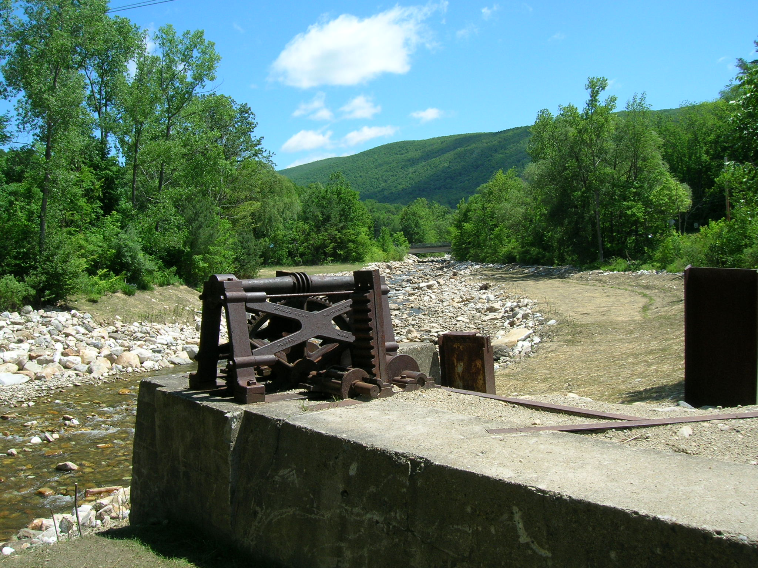

June 3 2011 celebrants trying out the restored river (North Branch of the Hoosic River, Clarksburg, MA)

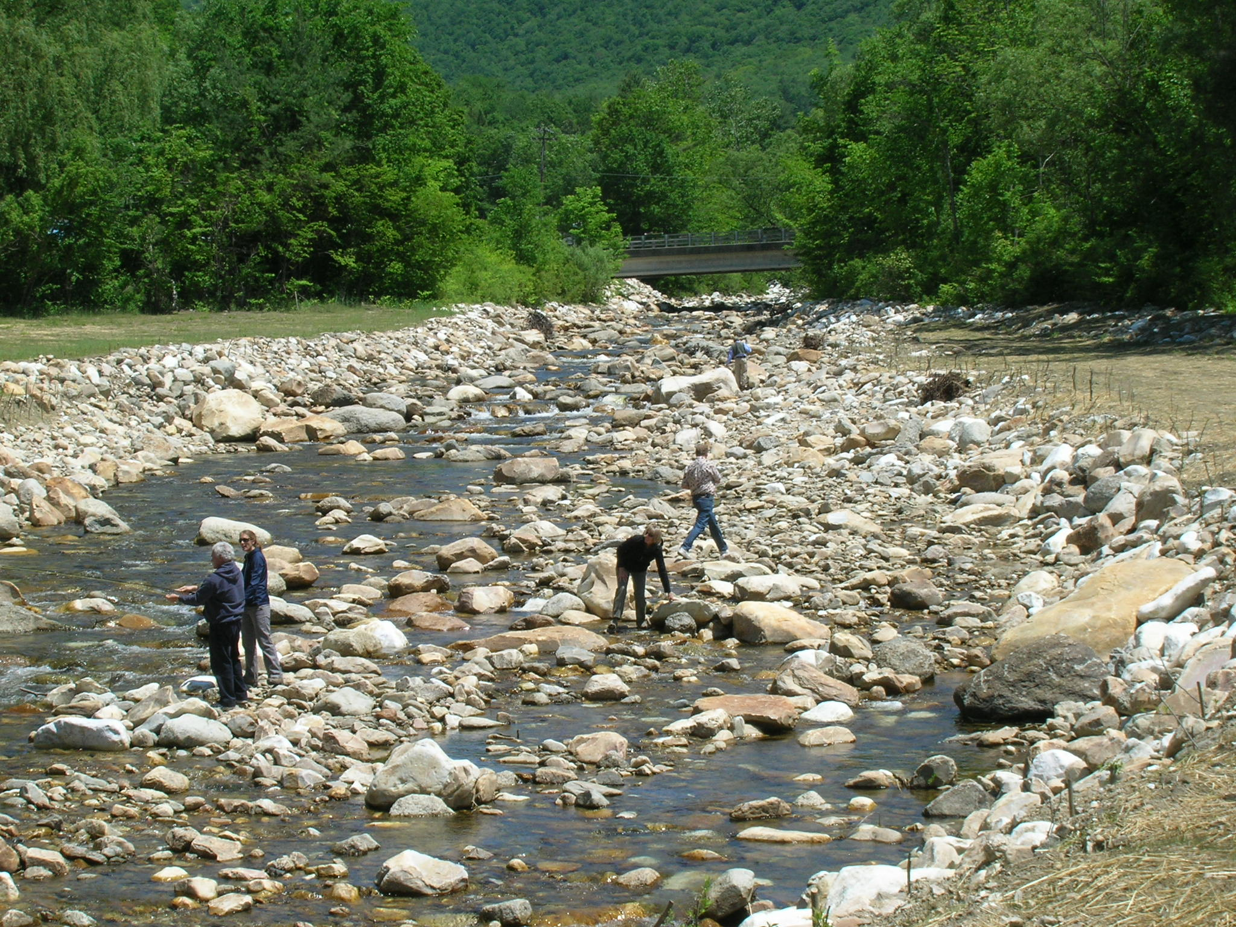

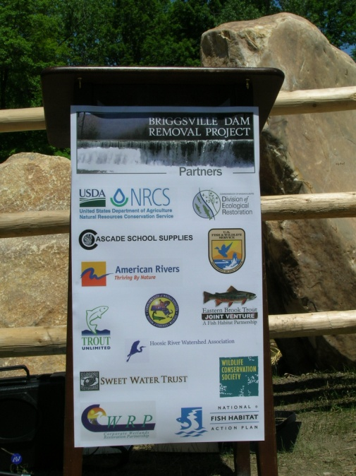

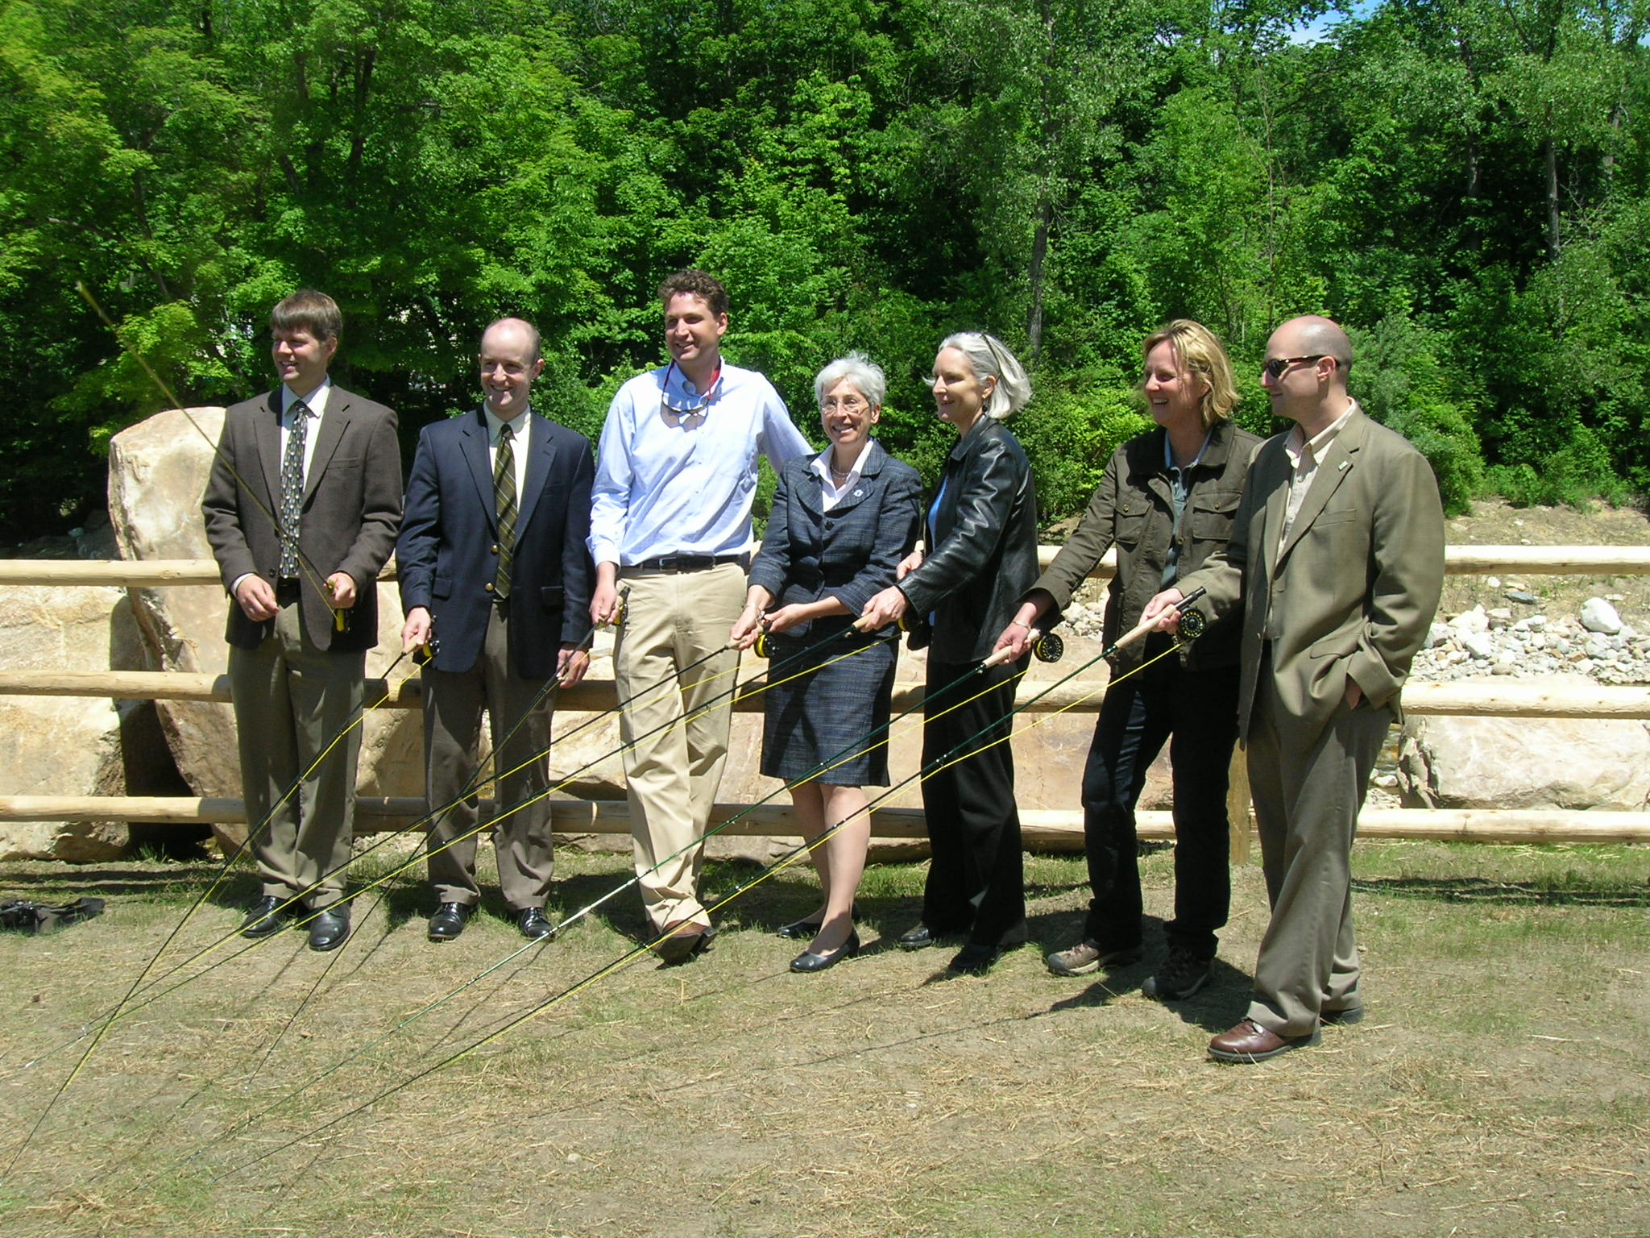

Brian Graber – Director, River Restoration Program, American Rivers, Northeast Region

Benjamin Downing – MA State Senator

Tim Puriton – Acting Director, MA Dept of Ecological Restoration

Gailanne Cariddi, MA State Representative

Ann Mills, Deputy Under Secretary for Natural Resources and Environment, USDA

Commissioner Mary Griffin, MA Department of Fish and Game

Joseph Overlock, President, Hoosic Chapter of Trout Unlimited.