Fish Passage Barrier Removal Template
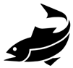
Guidance Document

Hello conservation partner and thank you for your interest in using the fish passage barrier removal template developed by the Eastern Brook Trout Joint Venture (EBTJV), Southeast Aquatic Resources Partnership (SARP), and Atlantic Coastal Fish Habitat Partnership (ACFHP) through our Whitewater to Bluewater Partnership.
This outreach tool has been designed in Microsoft Word, so that it can be easily tailored and customized to your agency/organizational needs. The template allows you to appropriately address specific issues of concern, and examples of fish passage challenges or successes in your area.
Front Side
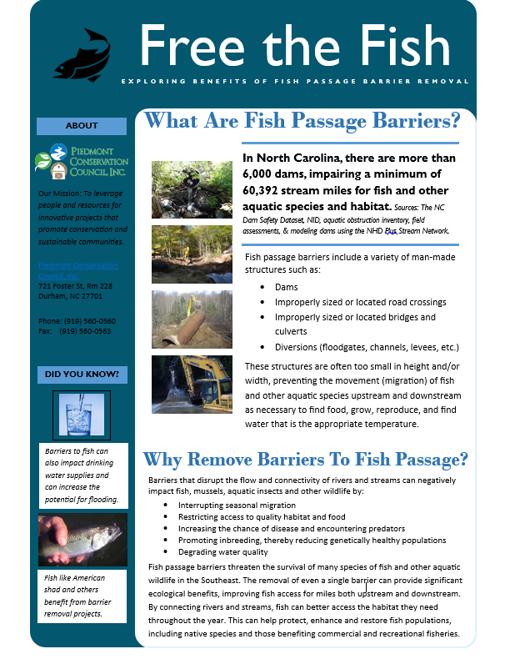
Fixed – We are requesting that the following general areas remain the same for consistency:
- Heading/Title
- Information under the ‘What Are Fish Passage Barriers?’ section
- Information under the ‘Why Remove Fish Passage Barriers?’ section (begins with ‘Fish passage barriers include’)

Customizable – We encourage you to add your own information as appropriate to the following areas:
- Dam data (the section that begins with ‘In North Carolina’ in the template) - This will be provided at the state-level by the Whitewater to Bluewater Partnership. If culvert or other relevant fish passage barrier data is available this can be included here.
- Information under the ‘About’ section. Insert your agency/organization contact information, mission, logo, etc.
- Information under the ‘Did You Know?’ section. The information and photos can be replaced with information about key issues and species that are unique to the places where you work.

Back Side
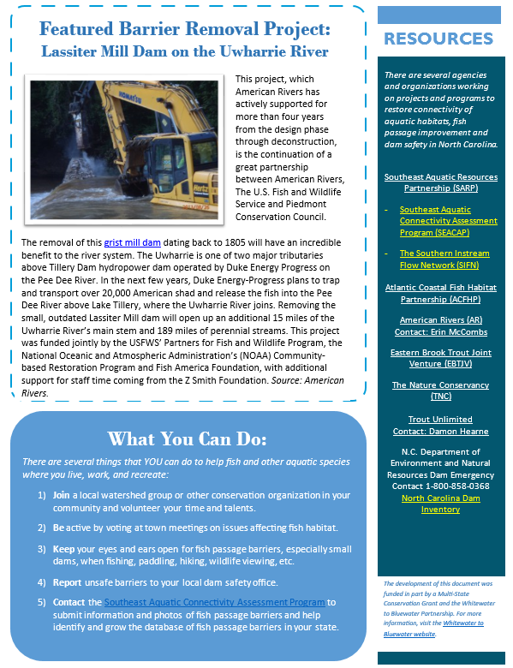
Fixed – We are requesting that the following general areas remain the same for consistency:
- Resources – We request that you please include the reference and links to the Southeast Aquatic Resources Partnership (SARP), Eastern Brook Trout Joint Venture (EBTJV), Atlantic Coastal Fish Habitat Partnership (ACFHP), American Rivers, and The Nature Conservancy, Trout Unlimited, and the North Carolina Department of Environment and Natural Resources.
- The funding clause and reference to the Whitewater to Bluewater Partnership in the lower right-hand corner.

Customizable – We encourage you to add your own information as appropriate to the following areas:
- ‘Featured Barrier Removal Project’ – Please feel free to use the case study for North Carolina as provided or to include a write-up and photograph that highlights a specific barrier or barrier removal project.
- Under the ‘What You Can Do?’ section (#5), we request that you please include the reference to your organization or agency and contact information as appropriate (this can be added in place of the link to the Southeast Aquatic Connectivity Program). We are requesting coordinates (latitude and longitude) and photos of barriers. Should you receive fish passage barrier information, please forward it to Kat Hoenke at the Southeast Aquatic Connectivity Assessment Project (SEACAP), kat@southeastaquatics.net. If you prefer, data can be submitted directly to SEACAP using the link provided.
In exchange for use of the template, we request that you please provide the following:
- Feedback about ways to improve the template.
- Information about how you and/or your organization or agency intend to use the template, and if so, in what capacity (i.e. who will you distribute it to, how many constituents or members will it reach, when do you plan to distribute it, and in what way, such as emails, hard copy mailings, at meetings and/or conferences, outreach events, landowner property visits, etc.).
- An electronic copy of any modified and distributed versions sent to us so that we can post this to the Whitewater to Bluewater website.

Please contact Lindsay Gardner, SARP Program & Communications Manager, at lindsayg@southeastaquatics.net or 615-730-8178 with any questions or feedback and to submit usage information and a copy of your customized publication.

