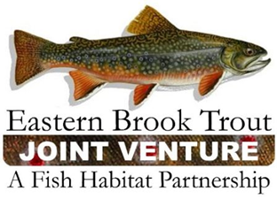
EBTJV Steering Committee Meeting Agenda
March 18, 2025 1-3pm ET

Matt Lawrence | MD DNR | Ross Shramko | NJFW
Brad Fink | VA DFW | Doug Austen | AFS/NFHP *board buddy
Molly McKeon | NH Fish and Game | Eric Sabean, Jr | NH DNR
Merry Gallagher | ME IFW | James Miles | GA DNR
Gregory Kozlowski | NYS DEC | Adam Kautza | MassWildlife
Lee Simard | VT FWD | Bryan Moore | TU/NFHP *board buddy
Jud Kratzer | AFS/VT FWD | Matt Kulp | GSMNP
Lori Maloney | EBTJV | Matt Fairchild | USFS
Nat Gillespie | USFS | Jaime Masterson | USFWS
John Magee | NH Fish and Game | Steve Perry | EBTJV
David Thorne | WV DNR | Will Duncan | USFWS
Brian Eltz | CT DEEP Fisheries | Jason Detar | PFBC
Jacob Rash | NCWRC
Decisions and key action items highlighted

Quorum was achieved with 19 Steering Committee members present.

We also had two NFHP Board Buddies present, Bryan Moore and Douglas Austen.

The Steering Committee voted to approve the December 2024 EBTJV Steering Committee meeting notes
FY26 NFHP Submission Process and voting
Lori Maloney reviewed the project review team membership process, and results for FY26. In a typical year we may fund 3-5 projects. The review team felt that all projects were high quality, and recommended the top 8 for forwarding to NFHP for funding. A document had also been shared prior to the meeting and is available here.
Background and process:
- RFP opened in November 2024; utilized an online form.
- 36 pre-applications received
- 13 full applications received (more on this later)
- Coordination with state biologists, FWS, EBTJV
- Reviewers assigned a 0-100 numeric score based on EBTJV scoring criteria
  - 22 individual scoring elements
  - e.g. potential of the project to benefit recreational fishing for brook trout, appropriateness of methods and budget, applicant readiness, overall quality and potential for the project to benefit EBTJV strategic goals
- March 11, review team finalized project rankings.
  - Stephanie Chance (Tennessee Aquarium)
  - Brad Fink (Virginia Department of Game & Inland Fisheries)
  - Merry Gallagher (Maine Dept. of Inland Fisheries and Wildlife)
  - Adam Kautza (Massachusetts Division of Fisheries and Wildlife)
  - Matt Kulp (Great Smoky Mountains National Park)
  - Lori Maloney (EBTJV)
  - Jaime Masterson (US Fish and Wildlife Service)
  - Jake Rash (North Carolina Wildlife Resources Commission)
  - Mark Staley (Maryland Dept. of Natural Resources)
  - Peter Ten Eyck (Independent; TU volunteer)
Project selection and results:
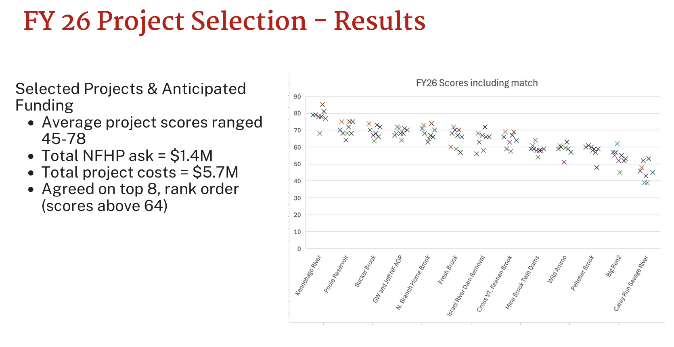
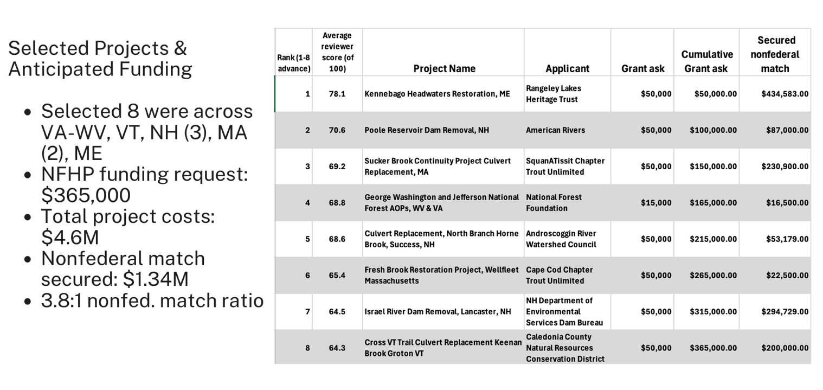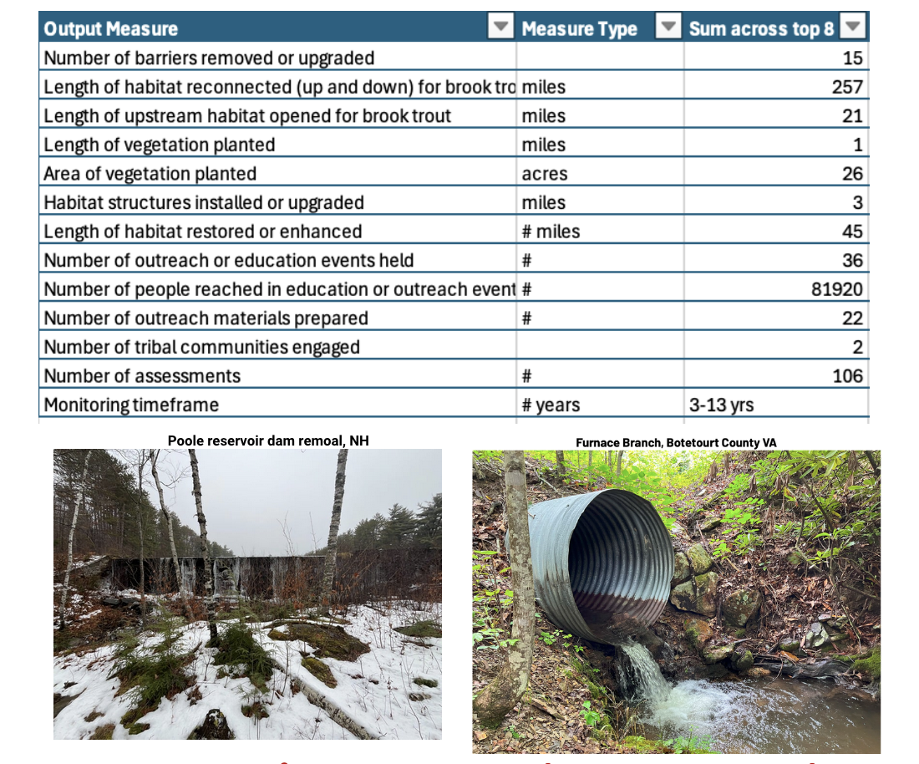
About our funding through NFHP:
- NFHP is and has always been subject to receiving an annual Congressional appropriation.
- We are currently working on our FY26 project list. There is no President’s budget for FY26 and Congress won’t start working on their FY26 budget until later this year.
- In light of this, we must continue to operate as we always have, under the assumption that NFHP will receive funding each fiscal year due to being a non-partisan program that brings value to the American people.
- For FY25 we proposed 6 projects and 1 operational project at $125K, total $424K
- We might expect to fund 4-5 projects and 1 operational project for FY25, FY26
- Nonfederal match at the portfolio level (FWS agreements to reflect this proposed match).
Discussion:
Jake Rash said that scoring this year was fluid, and if we could support all projects we would. Steve Perry mentioned that this was the first year we’ve had a pre-application and it was a worthwhile addition to the process that may have helped gather additional quality proposals. Merry Gallagher said that the EBTJV funding, while a lift to apply for, is the only one that directly addresses wild brook trout habitat. It would be great if we could get more funds than $50K per project but she also supports spreading the funding out. Matt Kulp noted that there is potential to inform biologists with federal agencies that the funding is also available to them. Everyone agrees that it would be good to have more funding and to be able to better spread the projects across the range; there are some states that rarely have awards. Steve Perry recused himself from the vote.
The EBTJV Steering Committee voted and approved the project review team’s recommended ranked list of 8 priority projects for FY26.
Operational costs:
The EBTJV Steering Committee was asked to consider and vote to apply for EBTJV operational funds to NFHP considering the recommendation for a $125,000 request. This is the second year that $125K has been available to FHPs; in prior years it was $85K or less. A draft budget was shared prior to the meeting here. During the meeting Lori Maloney reviewed the budget items:

Requesting $125,000 in base operational funds, including:

- Coordinator Salary and fringe (80% time on NFHP; 20% will come from Delaware project for next 2 or 3 years)
- Nonprofit sponsor indirect and fees (we are in the process of deciding on sponsorship)
- Website
- Travel for Coordinator and Steering Committee members
- Outreach costs (newsletter subscription, mailings, zoom subscription)
- EBTJV Assessment maintenance and cloud storage (Amazon Web Services, monthly)
Discussion:
Nat Gillespie explained how he set up a meeting with the Resources Legacy Fund to “pitch” how EBTJV could assist RFL in the development of an Eastern Open Rivers Fund. He focused on the strength of the EBTJV FY26 cycle and the over 30 pre-applications. We could play a role in accptiong funding, helping select projects, using our data. He urged the SC to look to see what opportunities all of us might have to talk about EBTJV to folks we work with.
Lee Simard noted his involvement in the meeting and his delivery of the EBTJV messaging that he and the Outreach Committee had developed two years ago. We should continue to look for these opportunities, and put ourselves out there as the leaders who work exclusively on wild brook trout habitat. Jake Rash agreed and added that we are the ecological multipliers, affecting everything downstream.

The Steering Committee voted and approved the line item to NFHP for $125,000 in operational funds.

Website proposal:
Lori Maloney reviewed the EBTJV 2025-2026 Website Maintenance Proposal from Ferguson-Lynch for April 1, 2025 – March 30, 2026
In summary, the elements are
- Hosting Server Lease, Backup, and Support; Secure SSL and Register and maintain the site EBTJV website Domain name. Manage DNS for EBTJV Domain Name
- Task 1 $1400.00
- IT Services and Advanced IT Support Task 2 Cost - $ 4000.00
- Day to Day User Support Task 3 Cost - $3550.00
- Project Management, Monitoring Login Requests, User Stats, Reports, Asana task tracking - $900.00
Total Work Costs = $9850.00

Will Duncan asked if any of the proposal’s elements were scalable and if we could ask for any savings. Lori Maloney remarked, and Steve Perry agreed and emphasized, that in some years we ask more of the website team than other years, and the contract reflects an average year over many. Lori said she would ask for more details on website usage/visits.
The Steering Committee voted and approved the 2025-2026 website proposal at $9850.

Member updates
There was a discussion of off highway recreational vehicles and impacts to habitats.
Matt Fairchild noted that the Colorado State University’s ATBC proposal for monitoring brook trout outcomes might be on hold. He also noted a recent publication on streams in the Rocky Mountains, land use effects, OHV use in backcountry effects, if you know of sites in National Forests to look at please let him know.

Doug Austen discussed some issues with federal government funding. If you’ve had funding hold ups, please let him and AFS know.

Jake Rash thanked Merry, Jud Kratzer, John Magee re: post – Helene recovery discussions.
National Fish Habitat Partnership update
Bryan Moore gave an update on NFHP.
FY25 funds appropriation will be step by step, and may still be some time before we know what funding NFHP will get.
There will be a new annual funding timeline, which condenses the time between FHP’s announcing proposal requests and when the funds are available, from about 18 months to about 8 months.
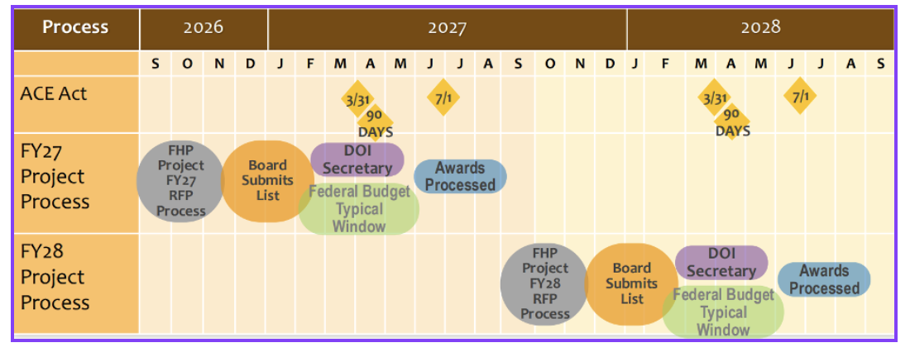
The last board meeting was in Las Vegas in January. They are working on version 3 of the NFHP action Plan with SMART objectives and 4 goals. Steve Perry noted that he and Lori Maloney are both on the team. The NFHP goals align well with EBTJV’s.

EBTJV workplan elements
Lori Maloney reviewed the high level look at some priorities of our organization. Are we meeting needs of members? What are our strengths and deficiencies? What do you want us to work on? This was an introduction not meant to be a long and comprehensive discussion at this meeting.
  - Project funding
  - Sponsorship of EBTJV (currently this is Canaan Valley Institute but we are exploring options through the end of April)
  - Assessment and Strategy
  - Communications/outreach (and audiences)
  - Supporting/developing regional capacity, and our involvement in the Delaware Brook Trout Initiative
We will be seeking your input on these items over the coming months. Your input is not only helpful, but also vital because you and your agency/organization are important members of the EBTJV. Also, if you are interested in understanding or weighing in on any of this please reach out to Lori or Jake.
Meeting adjourned 3pm

