ASSESSMENT AND RESTORATION OF SOUTHERN APPALACHIAN BROOK TROUT IN JOCASSEE GORGES, SOUTH CAROLINA

NFHAP funding requested: $49,000
Project Location: Oconee and Pickens Counties, South Carolina
S.C. Congressional District: 3

Sponsoring Fish and Wildlife Service Fisheries Office
Fish and Wildlife Service Office:
Street: 1875 Century Boulevard, Suite 250
- City, State, Zip: Atlanta, GA 30345
- Project Officer: Tom Sinclair
- Telephone Number: (404) 679-7324
- Facsimile Number: (404) 679-4141
- Electronic Mail Address (if available): Thomas_Sinclair@fws.gov
APPLICANT
Organization: South Carolina Department of Natural Resources
Project Officer: Dan Rankin
Street: 311 Natural Resources Dr.
City, State, Zip: Clemson, SC 29631
Telephone Number: 864-654-6346 ex. 12
Facsimile Number: 864-654-9168
Electronic Mail Address: RankinD@dnr.sc.gov

Date Submitted: September 26, 2008

PROJECT DESCRIPTION, SCOPE OF WORK, AND PARTNER INFORMATION (3 pages maximum)
- Project Description and Scope of Work
The eastern brook trout has been in decline for over a century, not only in South Carolina but throughout the eastern United States. South Carolina’s brook trout resource currently consists of self-sustaining (wild) populations inhabiting only about 95 km in 16 streams, or about 11% of S.C.’s wild trout resource. In S.C. brook trout range lies in the northwestern portion of the state in Oconee, Pickens and Greenville Counties along the Blue Ridge Escarpment and Chattooga Ridge. Few populations are found in the heart of the brook trout’s state range in the mountainous and scenic Jocassee Gorges.

The Jocassee Gorges is a large (43,000 acre) tract of federal and state-protected mountain land that lies in the heart of the brook trout’s range in South Carolina. The majority of the property (38,000 acres) was recently purchased fee simple and is managed by the SCDNR and USFS. An additional 5,000 acres is owned by Duke Energy Corporation. Duke Energy granted a perpetual conservation easement to SCDNR on this remaining parcel, and the property is managed by SCDNR in its Wildlife Management Area Program. The mountain property has numerous streams that are suitable for brook trout through enhancement and restoration, but which are presently devoid of the species. This lack of brook trout in the area makes these sub-watersheds high priorities under the EBTJV (ex. 450100 - 0.77 = Devils Fork, Howard, Limberpole, Corbin Creek, Mill Creek, Wrights Creek, and Coley Creeks; #450129 – 0.75 = Cane Creek, Bully Branch, and Laurel Fork Creeks; (Note – Eastatoe River System 45090 – 0.16 this number must be wrong - brook trout have been extirpated in this entire drainage!). Some of these streams have competitive populations of non-native rainbow and/or brown trout. Many headwater streams are believed to have habitat deficiencies that would limit successful introduction of southern Appalachian brook trout. Prior to SCDNR and USFS purchasing the property the Jocassee Gorges was managed as a commercial forest for a century. Much of the Jocassee Gorges property was heavily cutover throughout the last century and many streams were heavily impacted by sedimentation. Over the last decade SCDNR has stabilized virtually every source of erosion on the Jocassee Gorges property. This included reshaping forest roads to SC Forestry Commission and NRCS BMP standards and vegetating and surfacing as appropriate. Many Jocassee forest roads were closed to public use after being stabilized. Due to the permanent protection of this property, brook trout restoration efforts will be permanent.

The South Carolina Department of Natural Resources (SCDNR), the United States Forest Service (USFS), and Trout Unlimited (TU) are formal signatories to the Eastern Brook Trout Joint Venture, whose goal is to reverse the brook trout’s decline and restore fishable populations throughout its native range. The SCDNR, USFS and SC-TU have partnered to develop an Eastern Brook Trout Conservation Strategy for South Carolina under the EBTJV. These partners propose to conduct comprehensive habitat assessment of streams in the Jocassee Gorges that may be suitable for restoration to southern Appalachian brook trout. Candidate streams will be selected based on factors such as elevation, existence of fish passage barriers, and other relevant information. The Basin-Wide Visual Estimation Technique (BVET), a method well suited for southern Appalachian streams, will be conducted by experienced SCDNR and USFS crews. This habitat analysis will be used to identify features of the aquatic system that limit the ability of streams to sustain populations of southern Appalachian brook trout (ex. Pool habitat, overhead cover, etc.). Habitat features that may be enhanced so streams could support the species will be identified. The inventory will ultimately collect data needed to develop a prioritization of future brook trout restoration projects.
Chemical water quality parameters will be measured using grab water samples collected by SCDNR technicians and trained TU volunteers. Each stream will be sampled quarterly. Analysis will be performed to ensure suitable water quality to sustain brook trout. Concentrations of calcium, magnesium, potassium, sodium, phosphorus, and nitrogen will be measured. Analysis for anions, total soluble solids, total organic content, total kjeldahl nitrogen, and alkalinity (including ANC titration) will be performed. All samples will be collected and analysis conducted under USGS and EPA guidelines in SCDNR’s laboratory. Recording thermometers will be deployed at strategic sites in all streams to ensure water temperatures are suitable for brook trout.

We will complete the assessment of brook trout in-stream habitat, water quality, and fish distribution information in all Jocassee Gorges streams during the first two years of the project. During the third year we will conduct restoration on at least two of the top priority streams identified for restoration. Restoration will likely consist of restoring habitat using proven techniques (i.e. LWD additions, in-stream structure construction), removal of excessive sediments, removal of non-natives (as necessary), and culminating with translocation of pure southern Appalachian brook trout from nearby streams. We will follow restoration guidelines set forth in the AFS Southern Division Trout Committee position paper (Habera 1992). The brook trout restoration plan developed from this project will provide optimum guidance for brook trout restoration on Jocassee Gorges area streams for the future. The initial implementation phase of this project will restore 2-3 Jocassee Gorges streams totaling an estimated 8 miles. Preliminarily, we believe implementation of the plan developed from this project could potentially result in restoration of 64.2 miles of allopatric habitat for southern Appalachian brook trout, with many more miles of sympatric brook trout habitat and connectivity in larger stream systems. Brook trout have essentially been extirpated in the Jocassee Gorges making the majority of the sub-watersheds rank as high priority for enhancement and restoration (ex. 0.77 Whitewater River drainage – #450100, 0.75 for Cane Creek/Eastatoe drainage – #450129). Implementation will result in the restoration of southern Appalachian brook trout in several major river systems (Whitewater, Thompson, Toxaway, Eastatoe, Oolenoy) where brook trout have previously been extirpated in S.C. Annual electrofish sampling will be conducted on all restored streams to assess young-of-year brook trout production. Once stable self-sustaining populations have been established streams will placed on rotational sampling to monitor population levels. Water quality will also be monitored on a rotational plan.

B. Partner Information
Partner Name | Contribution In-Kind | Contribution Cash | Federal or Non- Federal | Partner Category | Role of Partner
SCDNR-Chemist Salary-water qual. analysis | $10,000 |  | Non-Fed. | State Agency | Water quality analysis
SCDNR – Technician Salary (3 Years) |  | $54,000 | Non-Fed. | State | Field BVET, water qual., fish samp., implement.
SCDNR – Hourly (50 Work Days) |  | $4,000 | Non-Fed. | State | BVET, fish, field data, implement.
SCDNR – Fed Aid Biologist | $9,026 |  | 75% Fed.  25% Non- | State | Administrative, planning, field.
SCDNR – Fed Aid Tech. | $5,625 |  | 75% Fed.  25% Non | State | Field asst.
SCDNR – I&E Staff | $4,000
US Forest Service Biologist | $10,250 |  | Fed. | Fed. | Field work, planning, BVET
US Forest Service Technicians | $7,000
Trout Unlimited  (Proposed-Covered by DNR is not funded) |  | $10,000 |  | Cons. Group National and Local | Funding for Tech 3 Salary, field supplies, antimycin (if needed) etc.
Upstate Forever | $1,000 |  |  | Cons. Group Local | Funding for implementation if available – technical assistance.
Foothills Resource Conservation and Development Council | $1,000 |  |  | Local Non-Profit | Tech. Assist. Engineering/contract. on Implementation-Habitat rest. phase
TOTAL MATCHING | $47,901 | $68,000

The SC EBTJV partners above, operating in concert with the EBTJV conservation strategy in South Carolina, have already demonstrated the technical ability and commitment to restore the southern Appalachian brook trout to streams in the state. The S.C. partners have demonstrated the ability to conduct all facets of brook trout restoration including habitat inventories, prioritization, site selection, NEPA compliance and preparation, non-native fish removal using piscicides, translocation of fish to restored habitats, in-depth follow-up monitoring of both habitat and fish after restoration, and in education and outreach.

C. Milestones and Timeline
The assessment of habitat on Jocassee Gorges will be conducted during the first two years. By the end of the second year all analysis will be performed and a management plan or strategy will have been developed outlining restoration opportunities and priorities. During the third year restoration efforts will begin. We anticipate restoration efforts will include habitat improvement by adding large woody debris to streams. This approach has worked very successfully in other restored brook trout streams in S.C. In King Creek, LWD addition has resulted in a two-fold increase in brook trout biomass. Restoration may also require removal of non-native species in some cases. Once streams have been restored, monitoring will be conducted annually to assess the young-of-year brook trout reproduction and population levels. In years after habitat improvement through LWD additions, we will conduct post-treatment BVET surveys to evaluate the success of our habitat improvement efforts. We will also conduct post-treatment water quality monitoring. Once a self-sustaining brook trout population has been re-established in a target stream sampling will continue on a rotational basis to assure maintenance of the new population. SCDNR and partners plan to continue restoration in additional streams identified in the restoration strategy developed under this project well into the future.

III. MAP OF PROJECT AREA

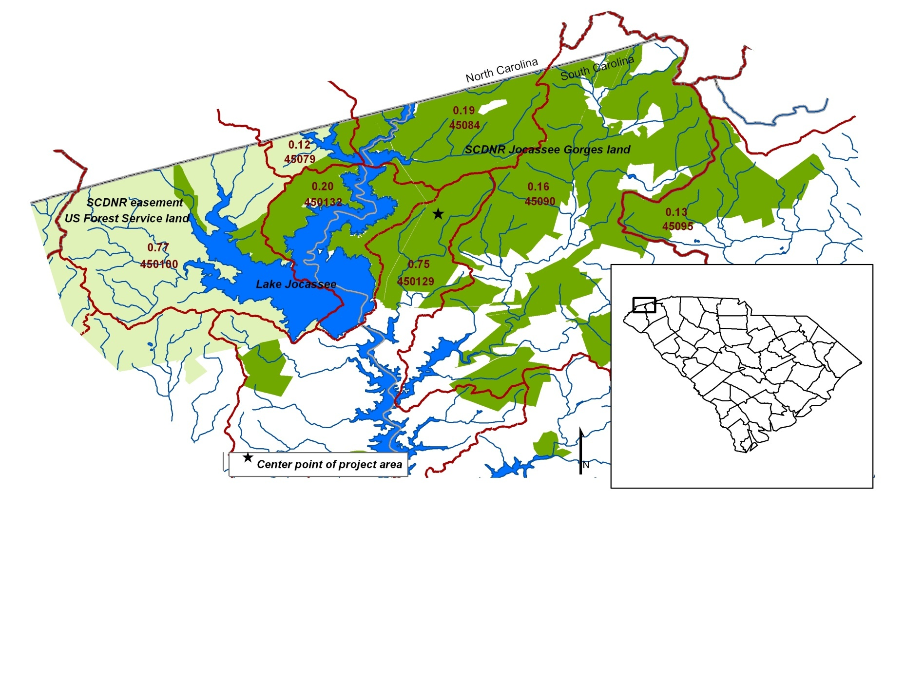

IV. PHOTOGRAPH(S) OF PROJECT AREA

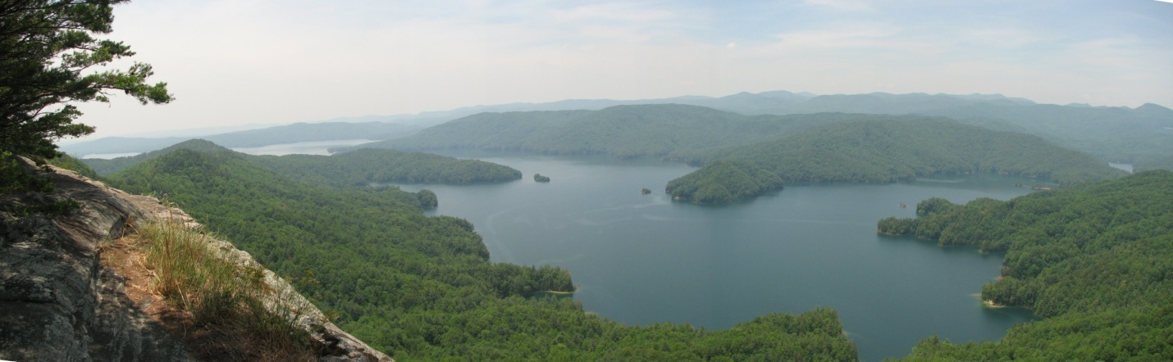
Photo by: Melissa Littleton (SCDNR)
Jocassee Gorges Area viewed from Jumping-off-Rock

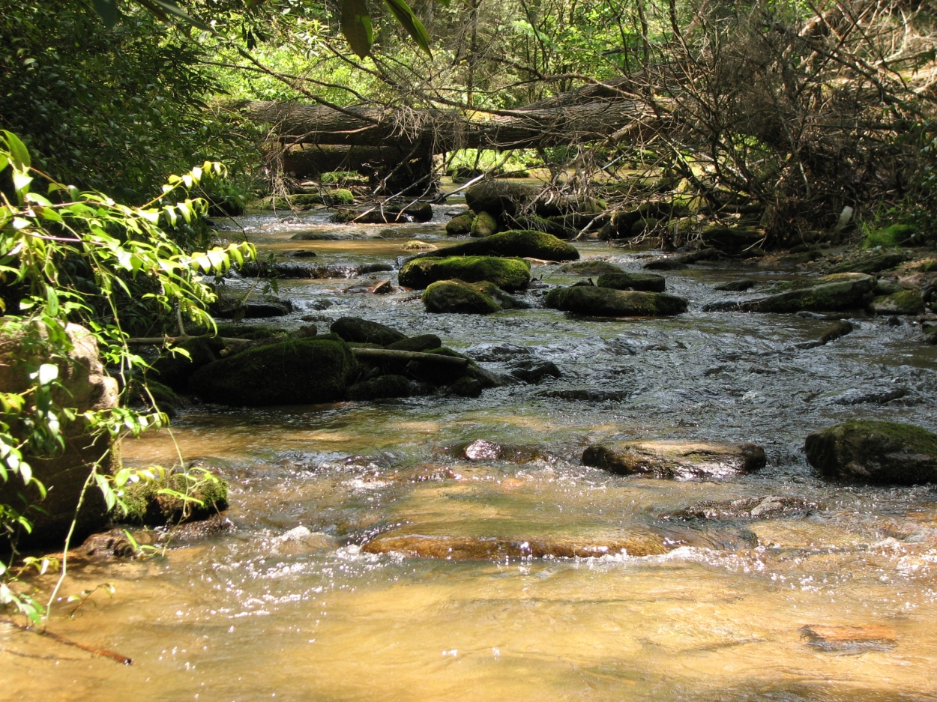

Photo by: Melissa Littleton (SCDNR)
Laurel Fork Creek – A Typical Jocassee Gorges Stream, and Candidate for Brook Trout Restoration.

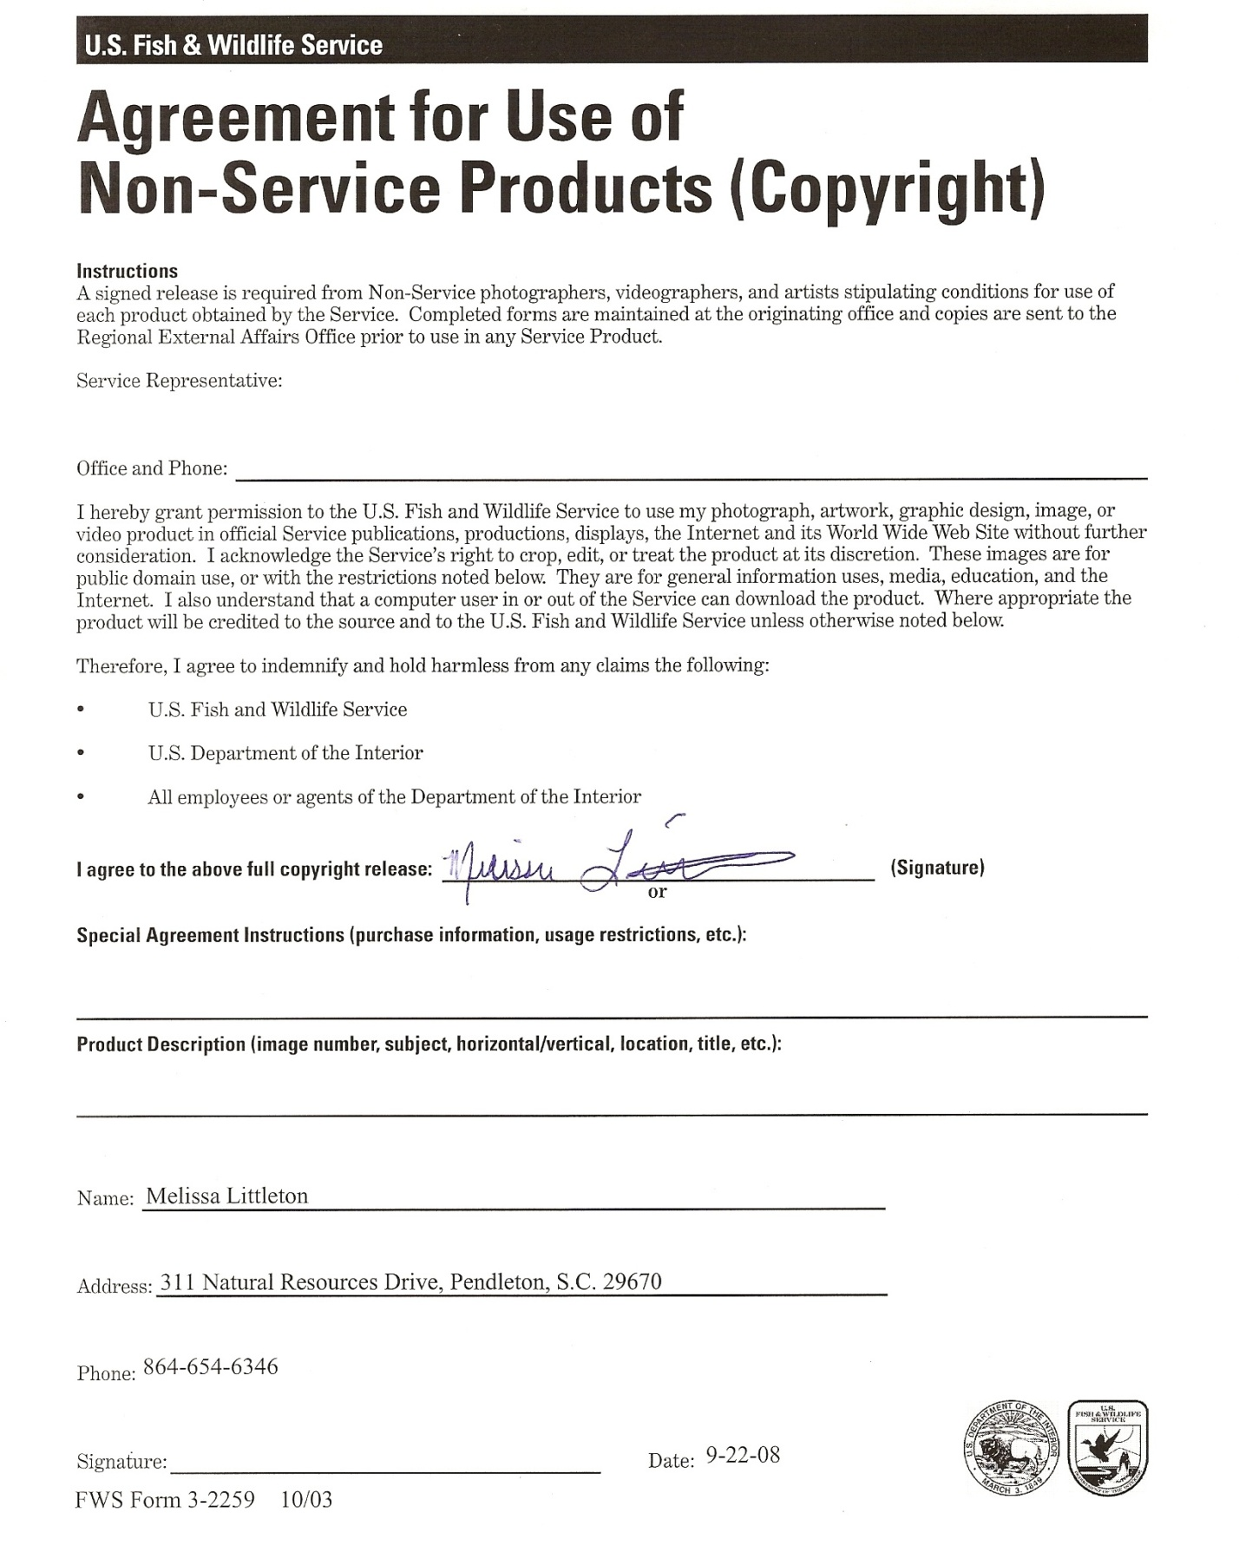

V. PROJECT BUDGET

Partner | Activity | NFHAP Request | Non-Fed. Contribution | Federal Contribution | Total | Acres/Miles Affected
SCDNR – Chemist Salary | Assessment/  Planning - Water Quality Analysis |  | $10,000 |  | $10,000 | Water quality assessment of 200 samples covers approx. 100 miles of potential brook habitat.
SCDNR – Water Quality Equipment | Assessment/  Planning - Water Qual. Analysis | $4,250 | $4,250 |  | $8,500 | Automated Titrator System (Capital Equip.) – 100 miles (this project)
SCDNR – Water Quality Analysis Chemicals, lab supplies.  SCWF will fund $2,000 | Assessment - Water Qual. | $1,175 | $1,175 |  | $2,350 | Supplies to process 200 samples – 100 miles
SCDNR - Temp Grant Technician and Hourly -  includes TU EAS ($10K)-pending. If EAS is not awarded DNR will cover $10K | Assessment - Field collections (BVET, Fish Data, water samples, etc.) Habitat analysis- to establish restoration priorities | $22,656 | $28,191 |  | $50,847 | Habitat inventories on approx. 100 miles of brook trout habitat. Needed planning to guide future restoration.
SCDNR – Fed Aid Tech. (~25 work-days) | Assessment - Field collections (BVET, Fish Data, water samples, etc.) |  | $5,625 |  | $5,625 | Habitat inventories on approx. 100 miles of brook trout habitat. Needed planning to guide future restoration.
USFS Biologist (~15 days) | Assessment - Field collections (BVET, Fish Data, water samples, etc.) |  |  | $6,150 | $6,150 | Habitat inventories on approx. 100 miles of brook trout habitat. Needed planning to guide future restoration.
SCDNR – Biologist | Data analysis/ project planning - field oversight, administrative oversight |  | $1,540 | $4,620 | $6,160 | Plan initial 2-3 streams (~ 10 miles) for restoration and develop management plan for brook trout restor. on entire property (~70-100 miles).
Upstate Forever | Technical Assistance and/or donation |  | $1,000
Foothills RCD Engineer | Engineering Tech Assistance on habitat Enhancement |  | $1,000
SCDNR – Biologist | Restoration - In-stream Hab. Improvement., remove non-natives, shock and stock, etc. |  | $717 | $2,149 | $2,866 | Restore self-sustaining SA brook trout in 2-3 streams – (~10 miles)
USFS – Biologist (10 days) | Restoration - In-stream Hab. Improvement., remove non-natives, shock and stock, etc. |  |  | $4,100 | $4,100 | Restore self-sustaining SA brook trout in 2-3 streams – (~10 miles)
SCDNR – Temp. Grant and hourly - Initial Implementation – Restore 2-3 streams | Restoration - In-stream habitat imp. Piscicide (if necess.), shock and stock, etc. | $16,919 | $25,809 |  | $42,728 | Restore self sustaining SA brook trout in 2-3 streams – (~10 miles)
Restoration equipment and supplies (ex. Chainsaws, chainsaw winches, fuel, safety gear, buckets, etc.) | Restoration - In-stream habitat imp. Piscicide (if necess.), shock and stock, etc. | $4,000 |  |  | $4,000 | Restore self sustaining SA brook trout in 2-3 streams – (~10 miles)
USFS – Habitat Restoration – chainsaw crews, etc. | Restoration - In-stream Hab. Improvement., remove non-natives, shock and stock, etc. |  |  | $7,000 | $7,000 | Restore habitat and SA brook trout in 2-3 brook trout streams (~ 10 miles)
SCDNR – Temp Grant and Hourly | Monitoring – Electrofish, follow up BVET on restored segments |  | $4,000 |  | $4,000 | Monitor restored brook trout pops and conduct followup BVET to appraise habitat improvement efforts.
SCDNR – I&E Staff | Education and Outreach - TV shows, field trip tours, press releases, Magazine articles, Jocassee Journal, Display at Jocassee Visitors Ctr., etc. |  | $4,000 |  | $2,000 | Expansion of overall EBTJV program and exposure for brook trout restoration. Affects entire SC brook trout resource and range-wide implications.
TOTAL |  | $49,000 | $87,307 | $24,019 | $159,326

VI. EVALUATION QUESTIONS (3 pages maximum)

- Conservation of Sustainable Brook Trout Populations:
The Jocassee Gorges is a large (43,000 acre) tract of federal and state-protected mountain land that lies in the heart of the brook trout’s range in South Carolina. The majority of the property (38,000 acres) was recently purchased fee simple by SCDNR and USFS. SCDNR was granted a perpetual non-development easement on the remaining 5,000 acres. The current ownership and easement are will protect eastern brook trout habitat restoration into perpetuity.

This proposed work is entirely consistent with both range-wide and S.C. EBTJV Conservation Strategy goals and objectives. Southern Appalachian brook trout have been extirpated in Jocassee Gorges streams due to past land-use practices. This project will first assess habitat limitations to prioritize and plan major restoration in high priority sub-basins delineated by EBTJV (EBTJV Goal #1). This project fosters an already strong partnership approach to resource brook trout in S.C. We will conduct outreach which will perpetuate support for brook trout restoration (EBTJV Goals #2-4). Past examples of brook trout outreach conducted by our partnership can be viewed at: (News release example - http://www.dnr.sc.gov/news/yr2008/aug11/aug11_partnership.html). A video of our partnership restoring eastern brook trout in S.C. can be viewed at the following link: (http://www.dnr.sc.gov/video/oct_video/octvideo_home.html). This project addresses all five key priorities listed on page 8 of the EBTJV range-wide plan.

This proposal is completely consistent with our EBTJV Conservation Strategy. For example, Item 4.2 in our EBTJV Conservation Strategy calls for a prioritization of brook trout restoration projects in S.C. with emphasis on the Jocassee Gorges area. This project proposal focuses on this important objective. This project is also consistent with the following S.C. Conservation Strategy Goals and Objectives: 1.2 and 1.3 – Baseline in-stream habitat and water quality inventories of brook trout streams in S.C. Developing these baselines will facilitate 1.6 and 1.7 – Long term monitoring of in-stream habitat and water quality; Item 1.8 – Refine knowledge of brook trout distribution; Item 2.2 – Improve brook trout habitat; Item 3.1 – Enhance public interest; Item 3.3 – Develop relations with other agencies and NGO’s to foster brook trout conservation; Item 5.1 – Make brook trout angling more readily available.

The proposal is consistent with the Revised Land and Resource Management Plan (LRMP) for the Sumter National Forest (SNF), 2004. Forest-wide Goal 3 provides for maintenance or restoration of natural aquatic and riparian communities or habitat conditions. Desired conditions for the riparian corridor include maintaining, restoring or enhancing the biological integrity of aquatic communities. Objective 11-OBJ-2 in the Riparian Prescription of the Revised LMRP states that SNF will restore and enhance stream habitat and aquatic communities, including brook trout restoration, in 50 miles of streams. Forest-wide Goal 29 states that eligible rivers will be managed to protect and to the extent possible enhance outstanding remarkable values, such as brook trout.

The proposal is also consistent with the SCDNR’s Long Range Trout Management Plan (Geddings 1998), which places the highest priority on the protection, conservation, and restoration of eastern brook trout. The eastern brook trout is also listed as a priority species in the SCDNR’s Comprehensive Wildlife Management Strategy (http://www.dnr.sc.gov/cwcs/index.html). Restoring eastern brook trout on Jocassee Gorges property is also consistent with the Jocassee Gorges Management Plan (http://www.dnr.sc.gov/managed/wild/jocassee/management.htm).

B. Threatened and Endangered Species and Species of Conservation or Management Concern:
Restoration of eastern brook trout is expected to protect and/or enhance habitat for other species of management concern. Habitat enhancement in Jocassee Gorges streams where diverse, multi-species fish assemblages occur should result in benefits to other fish species of concern. DNR studies in Jocassee area streams (Rankin, 2006, 2007) have shown the following species of conservation concern, as identified in S.C.’s Comprehensive Wildlife Management Strategy (http://www.dnr.sc.gov/cwcs/index.html), occur in subject streams: eastern brook trout Salvelinus fontinalis, stoneroller Campostoma anomalum, fieryblack shiner Cyprinella pyrrhomelas, santee chub Hybopsis zanema, warpaint shiner Luxilus coccogenis, rosyface chub Hybopsis rubrifrons, blacknose dace Rhinichthys atratulus, longnose dace Rhinichthys cataractae, smoky sculpin Cottus bairdii, turquoise darter Etheostoma inscriptum, seagreen darter Etheostoma thalassinum, snail bullhead Ameiurus brunneus, redeye bass Micropterus coosae, and flat bullhead Ameiurus platycephalus.

The Ephemeroptera, Plecoptera, and Trichoptera (EPT; mayfly, stonefly, and caddisfly, respectively) faunas of the Jocassee Gorges are rich in species, including many endemic species. At least 32 species of aquatic insects in the Jocassee Gorges are rarely documented elsewhere (Morse et al., 1989). There are 114 species of caddisflies that have been identified in the Lake Jocassee watershed. Of these five species are found only on Jocassee Gorges property (Floyd et al. 1997). Restoration and maintenance of stream habitat for brook trout is expected to benefit these invertebrates. Studies on King Creek, S.C. indicated aquatic invertebrates increased 50% numerically after brook trout habitat restoration efforts, while richness remained at high levels (English and Pike 2007).

Eastatoe Heritage Preserve, located in the center of the Jocassee Gorges property, harbors three species of rare ferns. The Tunbridge Fern (Hymenophyllum tumbridgense), exists nowhere else in North America. Management of substantial riparian buffers on the property will benefit rare species such as the Tunbridge Fern and help maintain pristine water quality for brook trout.

C. Other Species of Economic Importance not Included Above:
Other economically important species include the native redeye bass, which provides a unique cool-water recreational fishery in reaches downstream of brook trout waters. Wild populations of non-native trout occupying reaches downstream of restored streams will also benefit. Trout fishing in S.C. has been documented to generate approximately 18 million dollars to the state’s economy (Southwick and Associates, 2001). Other economically and recreationally important terrestrial species such as black bear, wild turkey, and whitetail deer should benefit from protective buffers along Jocassee Gorges brook trout streams.
E. EBTJV Targeted Watershed:
Southern Appalachian strain brook trout have been extirpated from the S.C portions of all EBTJV sub-basins (six-digit HUC’s) included in this project. A priority focus will be placed on assessing and restoring streams in sub-basins 450100 and 450129. HUC 450100 (0.77) includes Devils Fork, Howard, Limberpole, Corbin and Coley creeks and several tributaries to the Whitewater and Thompson River systems. We believe we will have the opportunity to restore brook trout in over 20 miles of habitat in this HUC. The Devils Fork basin in this HUC appears suitable for restoration to over 15 miles of brook trout habitat in Limberpole, Howard and Corbin Creeks with connectivity in a large second and third order stream. We will also prioritize assessment and restoration work in HUC 450129 (0.75), which includes Cane Creek and Bully Branch (6 mi brook trout habitat) area of Jocassee Gorges. This stream system lies 100% on SCDNR controlled property. We will also assess potential brook trout habitat in HUC 45090 (0.16) during this project. SCDNR has conducted in-depth stream sampling in this sub-basin (Eastatoe River drainage) in recent years and have found brook trout to be extirpated from the sub-basin. This HUC ranking (0.16) needs updating. The Eastatoe River is a large stream system which we believe with restoration efforts over time could potentially provide approximately 25 miles of high quality brook trout habitat with connectivity in a large stream. We will also assess and may propose restoration in one stream system in HUC 45084 during (0.19) this project. Again, brook trout have been extirpated from this HUC largely due to impoundment of 7,500 acre Lake Jocassee. We believe this HUC’s restoration score should also be re-evaluated.

F. Habitat Connectivity and Enhancing Population Mobility:
Please see comments above. Based on rather extensive sampling across the 43,000 acre Jocassee Gorges property we have found that brook trout are largely absent across the mountain property. Only two populations totaling about 2 miles of habitat are known to occur. Genetics sampling has determined that both populations are not the native genotype. Pure southern Appalachian brook trout are completely extirpated in the Jocassee Gorges. We have the opportunity to restore brook trout in both headwater populations and in larger streams such as Eastatoe River, Devils Fork and Howard Creeks, and the Cane Creek system to name a few. In at least two stream systems (Devils Fork and Eastatoe) on Jocassee Gorges we believe the potential exists to connect over 15 miles of contiguous brook trout habitat (in each) through long-term restoration efforts. In two other situations (Cane Creek and Laurel Fork) we see the potential to conduct restoration in streams which could result in over 5 miles of contiguous habitat for each. In three of these four situations 100% of the watersheds are in public ownership. In the case of Eastatoe over 95% of the watershed is in public ownership. Also, many (approximately 12-14) headwater streams on Jocassee Gorges could provide from 1-5 miles of contiguous allopatric brook trout habitat once restored.

G. Management Assets:
We firmly believe it is imperative to assess habitat on such a large area prior to initiating restoration efforts. We have restored over 11 miles of brook trout recently. These projects required a combination of removal of non-natives and habitat enhancement. Through these experiences we learned how imperative planning is to successful brook trout restoration. Monitoring data collected in the assessment phase will follow standard protocol. Fish sampling will follow guidelines establish by the Southern Division of the American Fisheries Society’s Trout Committee and SCDNR’s standardized wadeable stream sampling protocol. All in-stream habitat assessment and monitoring will follow the BVET standard procedure (Dolloff et al. 1993). All water quality sampling will follow standard USGS and EPA techniques. The assessment phase of this project will factor in habitat along with partner and EBTJV priorities to assure future restoration efforts are successful. This information will be vital to implement an adaptive management approach for Jocassee Gorges brook trout restoration. Brook trout restoration is an expensive endeavor. Failure is not an option if EBTJV is to succeed. A failed restoration demonstration project could result in a catastrophic loss of constituent buy-in. Our assessment will produce a science-based prioritized management plan for brook trout restoration on Jocassee Gorges. Once that plan is completed we will begin implementation to restore 2-3 streams.

All streams on the Jocassee Gorges property are in the SCDNR’s Wildlife Management Area Program and are open year round for public fishing with a state license. Jocassee Gorges public access roads afford reasonable angling access to all streams.

We are confident we can restore self-sustaining fishable populations of brook trout to many streams on the Jocassee Gorges property. To date we have successfully restored four eastern brook trout streams in S.C. All restorations were successful and all streams are now open to public fishing. We attribute our success to effective planning similar to the level of planning we propose in this project.

H. Supporting Documentation and Management Plans:
Literature Cited:
Dolloff, C.A., D.G. Hankin, and G.H. Reeves. 1993. Basinwide estimation of habitat and fish populations in streams. General Technical Report SE-83. Southeastern Forest Experiment Station, United States Forest Service, Asheville, N.C.
English, W.R. and J. W. Pike. 2007. Short and long-term impacts of antimycin (Fintrol) on non-target organisms including: benthic macroinvertebrates, crayfish, salamanders, and periphyton. Clemson Univ. Study conducted under contract to SCDNR and USFS.
Floyd, M.A., J.C. Morse, and S.C. Harris. 1997. Aquatic insects of Lake Jocassee Catchment, North and South Carolina, part II: caddisflies (Trichoptera) of six additional drainages, with a description of a new species. Journal of the Elisha Mitchell Scientific Society 113(3): 133-142.
Geddings, W.R. 1998. Long Range Trout Management Plan for South Carolina. South Carolina Department of Natural Resources (SCDNR). Division of Wildlife and Freshwater Fisheries. P.O.Box 167, Columbia, S.C.
Guffey, S. Z. 1993. Allozyme Genetics of South Carolina Brook Trout Populations. Technical Report Prepared by University of Tennessee Genetics Lab, Knoxville, TN for the South Carolina Department of Natural Resources, P.O. Box 167, Columbia, S.C.
Habera, J. W. 1992. Standardized Sampling Guidelines for Wadeable Trout Streams. Southern Division of American Fisheries Society - Trout Committee. 12 pp.
Hankin, D.G. and G.H. Reeves. 1988. Estimating total fish abundance and total habitat area in small streams based on visual estimation methods. Canadian Journal of Fisheries and Aquatic Science 45:834-844.
Morse, J.C., S.W. Hamilton, and K.M. Hoffman. 1989. Aquatic insects of Lake Jocassee Catchment, North and South Carolina, with descriptions of four new species of caddisflies (Trichoptera). Journal of the Elisha Mitchell Scientific Society 105(1): 14-33.
Rankin, D. M. 2006 and 2007. Fisheries Investigations in Lakes and Streams, South Carolina Department of Natural Resources, Federal Aid Project F-63-12 and F-63-11, Coulmbia, South Carolina.
Southwick and Associates. 2001. The 2001 economic benefits of freshwater fishing in South Carolina. Southwick Associates, P.O. Box 6435 Fernandina Beach, FL 32035. 14 pp.
USDA Forest Service. 2004. Final Environmental Assessment: Brook Trout Restoration, Andrew Pickens Ranger District, Sumter National Forest, Oconee County, South Carolina. 5 pp.
Williams, L.R., M.L. Warren, Jr., S.B. Adams, J.L. Arvai, and C.M. Taylor. 2004. Basin visual estimation technique and representative reach approaches to wadeable stream surveys: Methodological limitations and future directions. Fisheries 29(8):12-22 http://www.srs.fs.usda.gov/pubs/viewpub.jsp?index=7294

