PROJECT TITLE
Batten Kill Restoration near Eagleville NY in Compliance with EBTJV State Conservation Strategy (NFHAP)
Project Location: New York, Washington County
- Congressional District: NY-20
EBTJV / NFHAP Funding Requested: $50,000
- Total Project Cost: $154,000
- Total Federal Matching: $59,000
- Total Non-Federal Matching: $45,000
- Type of Project: Stream Restoration

APPLICANT
Organization: Batten Kill Watershed Alliance of New York and Vermont
Project Officer: Cynthia Browning, Executive Director
Street: P.O. Box 734
City, State, Zip: Arlington, VT 05250-0734
Telephone Number: (802) 375-9019
Fax Number:
EMail Address: exdir@battenkillalliance.org

Sponsoring Fish and Wildlife Service Fisheries Office
Fish and Wildlife Service Office: Sunderland Fish and Wildlife Conservation Office
- Project Officer: Martha Naley
Street: 103 East Plumtree Road
- City, State, Zip: Sunderland, MA 01375
- Telephone Number: (413) 658-7674
Fax Number: (413) 548-9622
EMail Address: Martha_Naley@fws.gov

Date Submitted: September 29, 2009
I. PROJECT DESCRIPTION, SCOPE OF WORK, AND PARTNER INFORMATION
A. Project Description and Scope of Work (not to exceed 500 words)

Stream restoration at 5 sites along the Batten Kill in New York using principles of fluvial geomorphology to enhance a total of 2 miles of the Batten Kill for the purposes of: improving brook trout habitat, removing fish passage barriers, stabilizing and restoring streambanks and riparian areas, increasing large woody debris in the river system, providing demonstration projects for the community, improving fishing access and recreational opportunities.

Habitat and hydraulics will be restored by building in-stream structures such as cross veins, J-hooks and engineered log jams that will narrow over-widened portions of the stream, deepen and cool the thalweg (low flow channel). These structures will improve hydraulics and stream dimension, pattern and profile. All river-work will be undertaken according to the principles of fluvial geomorphology so that the overall health and stability of the river system will be improved. Designs will be created and project oversight provided by trained U.S. Fish and Wildlife Service experts.

Cover habitat: Historically riparian areas along the Batten Kill provided large quantities of Large Woody Debris (LWD) to the river channel and created diversity habitats for the wide array of aquatic organisms inhabiting the river. Unfortunately, poor land use practices including riparian deforestation, stream clean outs and dredging removed much of this critical feature from the river. This project will restore natural LWD quantities to the river channel. It will also add critical protective cover for fish and other aquatic species (e.g., wood turtle, salamanders, aquatic insects), which has been identified by area biologists as a limiting biological factor. Habitat features providing refuge cover for native trout were studied by Kenneth Cox, Vermont Fish and Wildlife Department to determine the relationship between trout abundance and cover. Many reaches of the Batten Kill in New York are below desired cover conditions/habitat suitability which exposes trout to additional environmental and predator stressors. The placement of LWD in the river channel will also restore valuable ecosystem functions such as sediment storage and transport, nutrient enrichment from coarse and fine particulate organic matter, and will increase available protective cover for fish and other aquatic species;

Re-establish riparian buffers with native species where needed by hand planting with volunteers and re-planting scoops of vegetation with the excavator.

Evaluate the “as built” projects for effectiveness (i.e., were project goals met and objectives achieved) and apply results/findings to future projects (adaptive management). Traditional pre/post habitat, channel morphology, and fisheries monitoring studies will be conducted by Trout Unlimited.

Demonstrate the benefits of habitat restoration to surrounding landowners and general public through the Batten Kill Watershed Alliance Newsletter with the intent of extending interest in river restoration along the river.

Provide recreational opportunities for fishing, rafting, canoeing.

B. Partner Information (not to exceed 100 words)

Partner Name | Contribution  In-Kind | Contribution  Cash | Federal or Non- Federal | Partner  Category | Role of Partner
EBTJV - application | 0 | $50,000 | Fed | Fed Agency | Cash for design and implementation
Private Landowners | $3,000 | 0 | Non-Fed | Private Landowners | Root wads, tree vanes, equipment operation
Batten Kill Watershed Alliance | $6,000 | 0 | Non-Fed | Local Conservation Group | Project administration, outreach, community contacts
U.S. Fish and Wildlife Service – Partners for Fish and Wildlife Program | $15,000 | 0 | Fed | Fed Agency | Design and oversight
U.S. Fish and Wildlife Service – Fisheries Program | $15,000 | 0 | Fed | Fed Agency | Design, logistics, permitting, partner communication.
U.S. Fish and Wildlife Service - Refuges | $15,000 | 0 | Fed | Fed Agency | Equipment Operator
Trout Unlimited | $30,000 | 0 | Non-Fed | Local Conservation Group | Surveying, monitoring
Natural Resources Conservation Service | 0 | $10,000 | Fed | Fed Agency | Cash for materials
Washington County | $5,000 | 0 | Non-Fed | Local Government | Equipment and rock.
Washington County Soil and Water Conservation District | $1,000 | 0 | Non-Fed | Local Government | Technical Assistance
Green Mountain National Forest | $4,000 | 0 | Fed | Fed Agency | Technical Assistance
Subtotal | $94,000.00 | $60,000.00
Total | $154,000

C. Project Timeline: Planning & Design= Feb-April 2010; Permitting = May-July 2010; Baseline Assessment (shocking) = July 2010; In-stream Implementation = Aug-Sept 2010; Post Restoration Monitoring (shocking, creel survey, invertebrate assessment) = 3-5 years post-project.

II. MAP OF PROJECT AREA (one only)

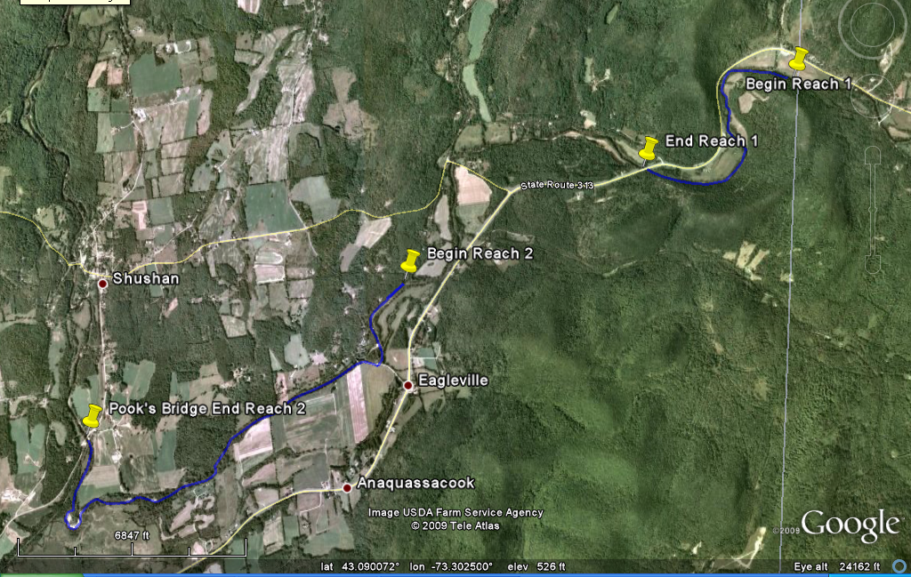

Eagleville, Washington County, NY lat 43.090072 long -73.302500

III. PHOTOGRAPH(S) OF PROJECT AREA (no more than 2, please provide credits and attach photo release forms)

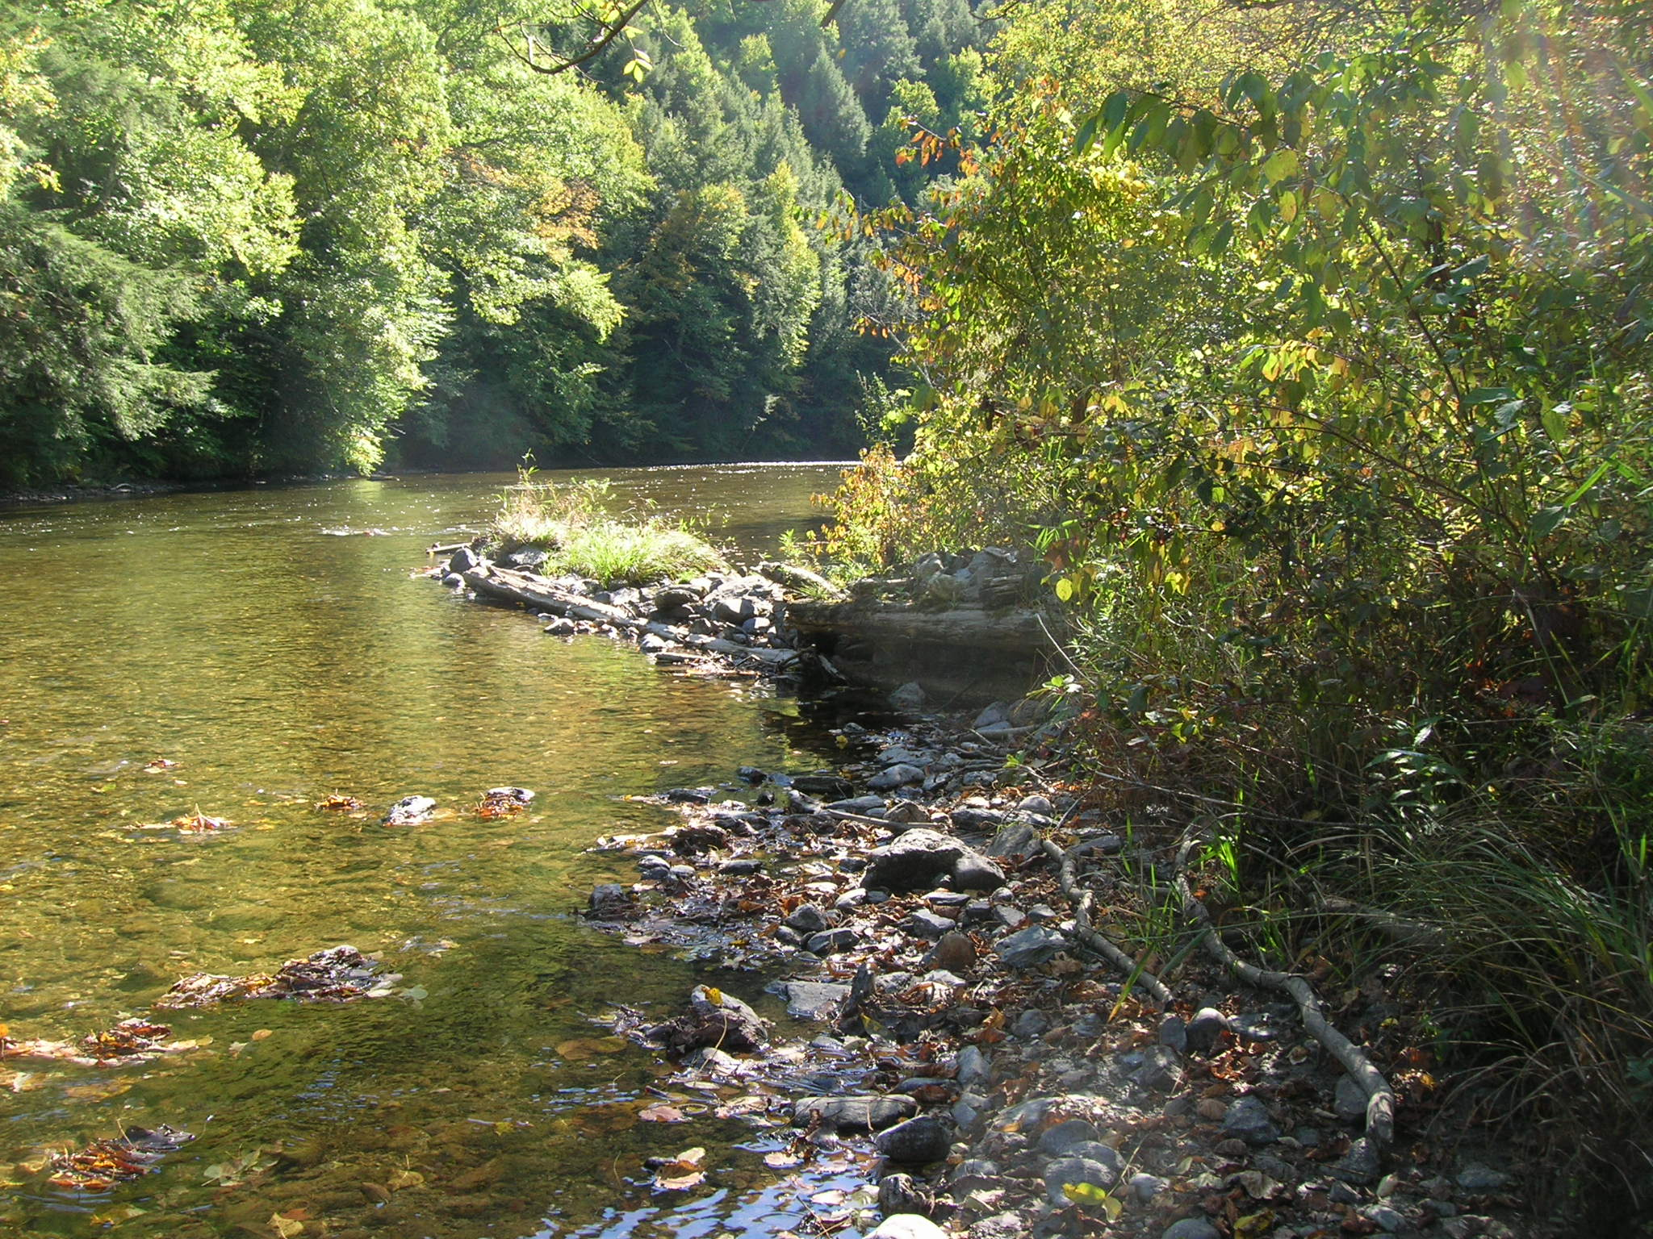
1 Old water management structure built in 50's (pointing downstream) causing widening of the stream (not intended). These structures will be removed and stream narrowed and deepened with J-hooks and large woody debris. Credit: Martha Naley, US FWS.

IV. PROJECT BUDGET

A. General Requirements See table below for details.

B. Budget Table

Partner | Activity | NFHP Request | Non-Fed Contribu-tion | Federal Contribu-tion | Total | Acres or miles Affected
 |  |  |  |  |  | 2 miles
Private Landowners | Equipment, equipment operation, site prep, tree trunks for vanes | 0 | 3,000 | 0 | 3,000
Batten Kill Watershed Alliance | Project administration, outreach community contacts, materials | 45,000 | 6,000 | 0 | 51,000
U.S. Fish and Wildlife Service – Partners for Fish and Wildlife Program | Design, oversight, travel, salaries, outreach, supplies | 0 | 0 | 15,000 | 15,000
U.S. Fish and Wildlife Service – Fisheries Program | Design, oversight, logistics, project tracking, salaries, outreach, supplies | 0 | 0 | 15,000 | 15,000
U.S. Fish and Wildlife Service - Refuges | Equipment operation, salaries | 0 | 0 | 15,000 | 15,000
Trout Unlimited | Monitoring, creel survey, shocking, invertebrate studies, outreach | 5,000 | 30,000 | 0 | 35,000
Natural Resources Conservation Service | Technical Assistance, materials | 0 | 0 | 10,000 | 10,000
Washington County | Equipment, material transport | 0 | 5,000 | 0 | 5,000
Washington County SWCD | Technical Assistance, landowner contact | 0 | 1,000 | 0 | 1,000
Green Mountain National Forest | Technical Assistance (design assistance) | 0 | 0 | 4,000 | 4,000
Subtotal |  | 50,000 | 45,000 | 59,000
Total |  | $154,000

V. EVALUATION QUESTIONS (4 pages maximum)

- Conservation of Sustainable Brook Trout Populations:
- Explain how the project sufficiently protects brook trout habitat. Without the project, existing habitat will be degraded by excessive streambank erosion, overwidening, increasing temperatures, and reduced microinvertebrates and cover. The project protects the existing habitat and improves the degraded habitat. Does the project include fee simple land purchase or easements? Long term protection of the site is provided by State and Federal regulations. In addition, the project is also in a “Right to Farm” area that supports agricultural land uses. The project is requested by an agricultural producer who wishes to reduce erosion threatening his fields.
- List the specific regional or range wide EBTJV habitat objectives addressed by the project and describe how the project will contribute towards them. REGIONAL: 1. Protect brook trout populations across the eastern United States. 2. Restore brook trout populations where original habitat conditions exist and where habitats can be restored. 3. Monitor and evaluate brook trout population responses to habitat protection, enhancement and restoration projects. 5. Increase recreational fishing opportunities for wild brook trout. This project is a partnership driven restoration project on private land with the intimate cooperation of the landowners, Federal, city and county governments and NGOs. The restoration of the stream habitat will use structures to restore the fluvial geomorphology to provide habitat and cover for brook trout. The structures also enable stream access for anglers and small water craft. Our partners will publicize our activities in their newletters. Trout Unlimited will monitor the project for fisheries response. Existing habitat will be protected by preventing degradation by sedimentation and overwidening downstream.
- List the specific state-level EBTJV habitat objectives addressed by the project and describe how the project will contribute towards them. NEW YORK: Priority 2.2-Identify and conduct habitat improvement projects. Priority 2.3-Protect brook trout habitat. Priority 3.4-Restore stream populations of naturally reproducing brook trout. Priority 4.1-Enhance angler and public awareness of wild brook trout. This project is a partnership driven restoration project on private land with the intimate cooperation of the landowners, Federal, city and county governments and NGOs. The restoration of the stream habitat will use structures to restore the fluvial geomorphology to provide habitat and cover for brook trout. The structures also enable stream access for anglers and small water craft. Our partners will publicize our activities in their newletters.
- List the State Wildlife Action Plan habitat conservation goals that are addressed by the project. NY WAP-Restoration. Reduce habitat loss and fragmentation. Reduce incompatible agricultural and silvicultural practices. Improve water quality. Repair altered hydrology.

- Threatened and Endangered Species and Species of Conservation or Management Concern:
- Will the completed project benefit any federally listed threatened or endangered species? Bald eagle – forage and habitat.
- Will the completed project benefit any state listed threatened or endangered species? Tomah mayfly (T) , frosted elfin (T)
- Will the completed project benefit any State or Federal species of conservation or management concern? BOTH : Fed trust species = eastern brook trout. State Species of Concern=common nighthawk, whip-poor-will, Cooper’s hawk, northern goshawk, red-shouldered hawk, sharp-shinned hawk, eastern spadefoot toad, blue-spotted salamander.
- Will the project benefit other species of economic importance not included above? Other species identified in NY Wildlife Action Plan = stoneflies/mayflies – Eurylophella bicoloroides; mammals – American marten, river otter, Indiana bat, Eastern red bat, Hoary bat, Silver-haired bat; mollusk – Alewife floater, eastern pearlshell; breeding waterfowl – blue-winged teal, American black duck; boreal forest birds – Cape May warbler, olive-sided flycatcher, rusty blackbird, Tennessee warbler; breeding waterfowl – American black duck, blue-winged teal; nighthawk – common nighthawk; deciduous/mixed forest breeding birds – black-throated blue warbler, scarlet tanager, wood thrush; early successional forest / shrubland – black-billed cuckoo, brown thrasher, Canada warbler, whip-poor-will, willow flycatcher; turtles - northern map turtle, wood turtle, snapping turtle; grassland birds – bobolink, eastern meadowlark, vesper sparrow; osprey – osprey; herpetofauna – eastern ribbonsnake, Jefferson salamander; butterflies – silvery blue.
- How does the project contribute to the conservation of genetically distinct populations or species? In-stream restoration provides forage, cover, access to habitat, cooler water to eastern brook trout. Riparian plantings provide additional habitat to birds, mammals, herpetofauna.

- Project Benefits:
- What is the status of the brook trout population (intact, reduced, extirpated) in the watershed (see www.easternbrooktrout.net)? Intact
- What is the EBTJV priority ranking for the proposed project watershed (see www.easternbrooktrout.net)? (VT5005) Restoration=1.31; Protection=1.31; Enhancement=1.31
- Does the project connect to a watershed that is identified as intact or reduced? Intact
- Will the project provide expansion of existing habitat? YES, Restoration provides additional habitat for forage, cover, reproduction.
- Will the project restore tributary stream or mainstem habitats? BOTH
- What is the probability of long-term success in supporting a sustainable fishable brook trout population in the project area? HIGH

- Endurance of Benefits:
- What percentage of the watershed above the proposed project is protected in perpetuity? 20%
- What are the root causes of the watershed degradation and which of these are addressed by the project? Poor Land Management, High Water Temperature, Sedimentation, Riparian Habitat, Stream Fragmentation will be addressed. Dam Inundation, Non-native species will not be addressed.
- Are there competitive non-native or invasive fish in the watershed with access (no barrier) to the proposed project? Yes, brown trout.
- What species of trout or other aquatic species are currently stocked within the proposed project watershed? Brown trout.

- Management Assets:
- Describe the plans for monitoring and evaluation. Standard protocols used by NYDEC for trout assessment (500 ft reach, block nets and minimum of 3 passes). Once pre-project; 3 times post project.
- Describe the plans for public fishing access at the project site. The Batten Kill has Public Fishing Rights.
- Describe any outreach or educational components of the project. On-site demonstration project presentations for other landowners presented by U.S. Fish and Wildlife Service, Trout Unlimited, Batten Kill Watershed Alliance. Newsletter by Batten Kill Watershed Alliance. PowerPoint presentations to interested groups by FWS.
- How will the project improve the recreational fishery? Improve opportunities by increasing fish populations, angler access.
- Describe the long-term maintenance plan for the project. Long-term maintenance will be minimal because we will be building structures that will be stable (once vegetated) and will work with the river rather than against it. If the structure is stressed beyond its limits prior to the vegetation taking hold, U.S. FWS will repair the damage and our partners will replant the structures and streambanks.
- Other Special Considerations:
The Batten Kill Watershed Alliance was created in 2001 to promote good stewardship of the river and its tributaries in both Vermont and New York. Alliance activities have been dedicated to conservation and restoration of the river and its trout fishery, resolution of conflicts among river users and landowners, and educating the public about river-friendly behavior. Alliance accomplishments have included small and large restoration projects, erosion control and bank stabilization projects, riparian planting projects, River Steward programs in 2004 and 2005, and numerous public presentations on river-related topics. Now that the scientific studies have concluded that the lack of sufficient cover and shelter is the likely cause of the problems of the trout population, the Alliance will focus on the restoration of such cover and shelter through in-stream structures and riparian buffer zones along extended reaches of the Batten Kill.

- Supporting Documentation and Management Plans:
- Literature Cited: Steve Roy, pers comm., USDA, Green Mountain National Forest, Rutland, VT; Greg Cuda, pers comm., Adirondack Chapter Trout Unlimited; Batten Kill Watershed Alliance (2009) Batten Kill Restoration and Conservation: Short Term Steps & Long Run Strategy; State of Vermont Agency of Natural Resources (2006) Batten Kill Trout Management Plan 2007-2012; Google Earth map.
- References to published interagency fishery or aquatic resource management plans. New York State Comprehensive Wildlife Conservation Strategy, (2005), Division of Fish, Wildlife and Marine Resources of NYSDEC; U.S. Fish and Wildlife Service, NYS DEC, TU (Adirondack & Clearwater chapters), Washington Co. Soil and Water Conservation District, Village of Salem (2006), White Creek Stream Restoration;
- Please attach a letter of support from the state fishery management agency responsible for the project area. The letter must show state support for the project, identify how the project meets the state’s goals and objectives and address how the recreational value of the population will be affected. ATTACHED letter from NYDEC

/tmp/in/input.doc

