EBTJV/NFHAP Carloe Brook ME Fish Passage Restoration

Project Location: T27ED BPP Washington County, Maine
- Congressional District of Project: 2
- Congressional District of Applicant: 1
EBTJV / NFHAP Funding Requested: $18,000
- Total Project Cost: $36,000
- Total Federal Matching: $2,000
- Total Non-Federal Matching: $16,000

APPLICANT
Organization: Maine Forest Service
Project Officer: Keith Kanoti
Street: 22 SHS
City, State, Zip: Augusta ME 04333
Telephone Number: 207 287-1073
Fax Number: 207 287-8422
EMail Address: keith.kanoti@maine.gov

U.S. Fish and Wildlife Service Sponsoring Office
Fish and Wildlife Service Office: Maine
- Project Officer: Scott Craig
Street: 403 Hatcher Road
- City, State, Zip: East Orland, Maine 04431
- Telephone Number: 207 469-7300 ext 226
Fax Number: 469-6725
EMail Address: Scott_Craig@fws.gov

USFWS FONS Database Project Number:
53371-2010-363

Coordination Completed with US Fish and Wildlife Service Fisheries Office (Check One):
X Yes, 8-31-2010 Date Coordination Began
No
I. PROJECT DESCRIPTION, SCOPE OF WORK, AND PARTNER INFORMATION

A. Project Description and Scope of Work This project will replace an undersized and failing stream crossing on Carloe Brook a major tributary to Clifford Lake a wild brook trout water. This stream crossing currently limits passage for trout and other aquatic organisms. The current crossing is also a significant sediment source do to improper construction and overtopping. The crossing will be replaced with a 1.2 bankfull open bottom arch culvert designed to allow passage at all flows. This will open approximately 3 miles of stream habitat.

B. Proposed Methods The project will use a 1.2 bankfull width open bottom arch culvert to replace the existing multiple round culvert stream crossing. Crossing will be designed using stream simulation techniques to ensure proper sizing and placement of the new structure.

C. Project Timeline

April 2011 - Permitting
May - June 2011 - Site survey and design
August 2011 - Construction
September 2011 - Reporting

D. Proposed Accomplishment Summary The project will restore access from Clifford lake to approximately 3 miles of stream habitat for brook trout and native species. It will also fix a chronic sedimentation problem.

E. State the Importance of the project to the Resource The project will restore access to approximately 3 miles of stream habitat in the Clifford Lake sub watershed. Clifford Lake is a wild brook trout water and restoring this crossing will serve to protect and maintain the resource.

F. Problem and Specific Cause of the Problem The current stream crossing in place was not properly designed to allow fish and aquatic organism passage. High flow velocities limit passage at some time of the year and low flows limit passage at others. Over topping, blockages and improper end treatment of the existing culverts also leads to chronic sedimentation inputs from the road bed at the site.

G. Objective of the Project with Reference to the Problem Replacement of existing crossing with one properly sized for the stream and with properly installed erosion and sedimentation control Best Management Practices to allow passage at all flows and fix sedimentation issue.

H. Partner Information Maine Forest Service, Maine Department of Inland Fisheries and Wildlife.

Partner Name | Contribution  In-Kind | Contribution  Cash | Federal or Non- Federal | Partner  Category | Role of Partner
Maine IFW | 1000 |  | Non- Federal | State | Monitoring
Wagner Forest Management | 4,000 | 10,000 | Non-Federal | Landowner | Landowner,  Construction materials
Maine Forest Service | 1000 |  | Non-Federal | State | Project management
US Fish and Wildlife service GOMC | 2000 |  | Federal | Federal Gov’t | Design and Survey

II. MAP OF PROJECT AREA (one only)

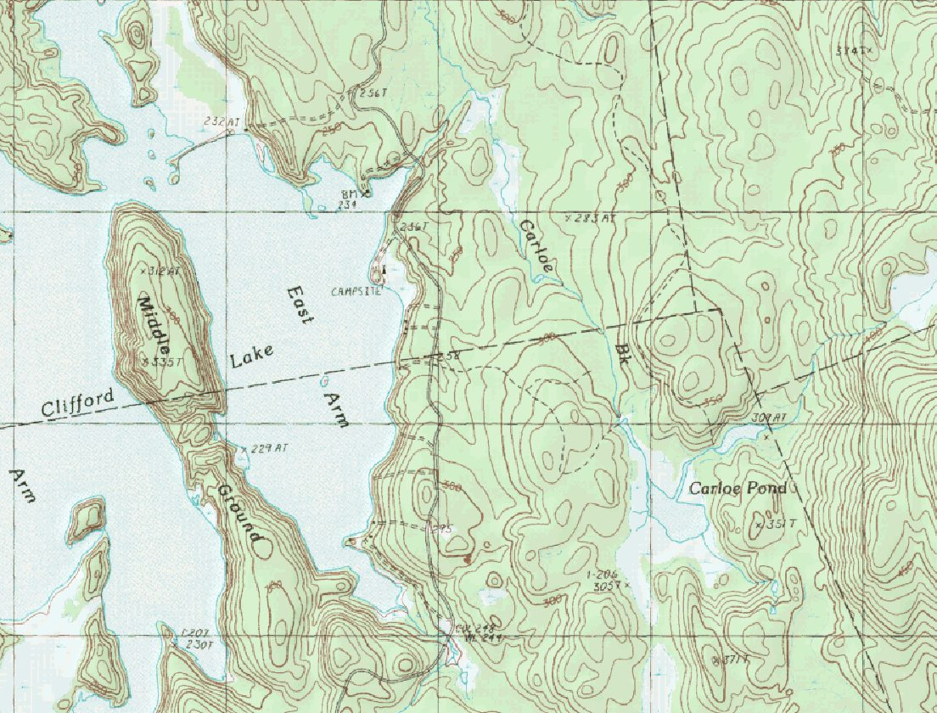
Crossing site
Figure 1 Map of Crossing Location

III. PHOTOGRAPH(S) OF PROJECT AREA (no more than 2, please provide credits and attach photo release forms)

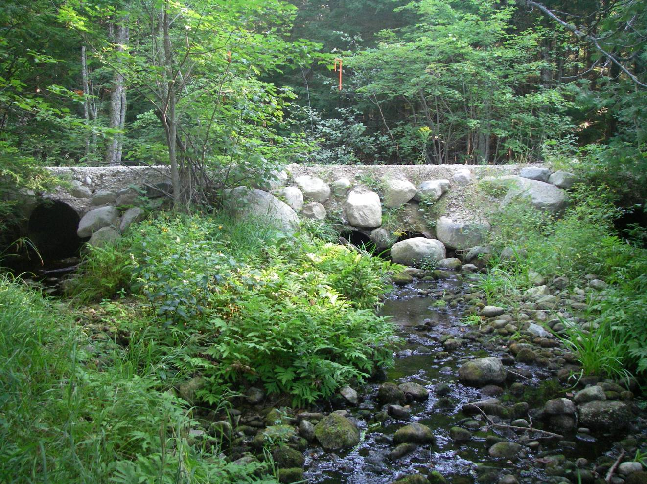
Figure 2 Current crossing

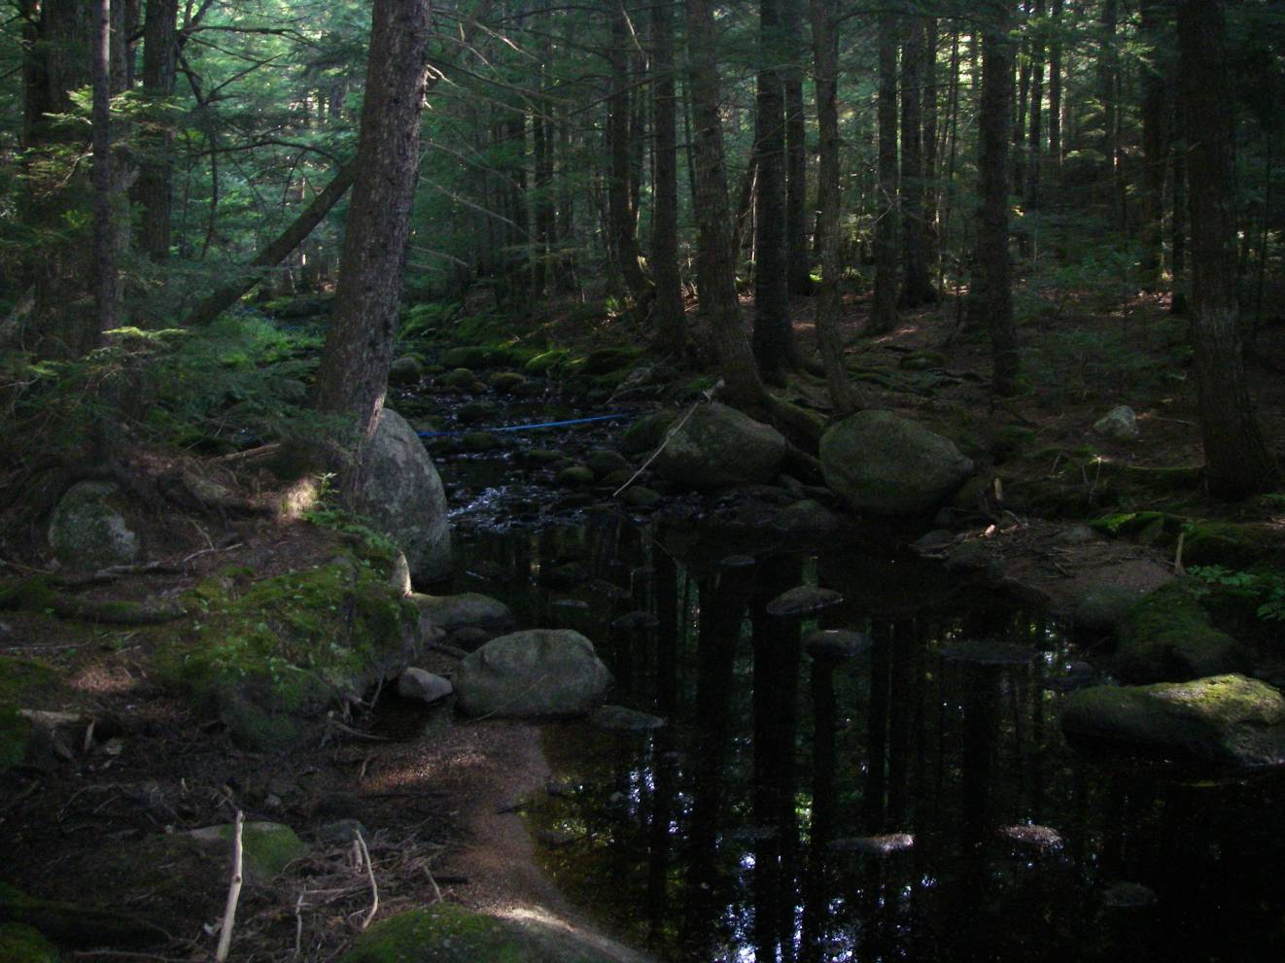
Figure 3 Upstream view

IV. PROJECT BUDGET

A. General Requirements

B. Budget Table

Partner Name | Partner Category * | Activity of Partner ** | Budget Category*** | EBTJV  NFHAP Request | Non-Federal Contribution |  | Federal Contribution |  | Total Contribution | Acres/Miles Affected
 |  |  |  |  | In-Kind | Cash | In-Kind | Cash | Total Contribution | Acres/Miles Affected
Wagner Forest Management | Private Landowner | Culvert Removal | Construction | 15,000 | 3,000 | 10,000 |  |  | 28,000 | ~3 Miles
Wagner Forest Management | Private Landowner |  | Personnel |  | 1,000 |  |  |  | 1,000
Maine Forest Service | State Agency | Arch Culvert installation on site management. | Personnel | 1,500 |  |  |  |  | 4,000
Maine Forest Service | State Agency | Permitting | Other |  | 1,000
Maine Forest Service | State Agency | Grant and Project Management | Other | 1,500
Maine IFW | State Agency | Culvert E-fishing and monitoring | Personnel |  | 1,000 |  |  |  | 1,000
USFWS GOMC | Federal Agency | Stream survey | Personnel |  |  |  | 2,000 |  | 2,000
Total Contribution |  |  |  | 18,000 | 6000 | 10,000 | 2000 |  | 36,000 | ~3 Miles

- EVALUATION QUESTIONS

- Please provide the GPS Coordinates for the project in UTM NAD 83.
UTM Zone 19N
Northing |  | 4,991,479 -67.680
- Easting |  | 497,036 45.069

- Please list the type of project. Examples include: in-stream habitat, riparian planting, fencing, AMD, fish passage, reintroduction, assessment, etc.

Fish passage

- Does the project include a protection component? If so, explain how the project sufficiently protects brook trout habitat. Does the project include fee simple land purchase or easements?

The watershed is already completely protected form development by a conservation easement.

- What percentage of the watershed above the proposed project is protected in perpetuity?

100% of the watershed is protected by a development easement. The easement requires public access including fishing and hunting.

- List the specific regional EBTJV habitat objectives addressed by the project and describe how the project will contribute towards them.

This project addresses Regional Habitat Objectives: 1 – Maintain the status of 477 Northern subwatersheds classified as Healthy; 2 – Strengthen brook trout populations in 20 Northern subwatersheds classified as Healthy; 7 – Validate the predictive status model by contributing toward the assessment of 700 Northern predicted status subwatersheds.

- List the specific state-level EBTJV habitat objectives addressed by the project and describe how the project will contribute towards them.

This project addresses Maine State Habitat Objectives: 2.1.2 – Identify degraded stream habitats and prioritize for restoration efforts – Identify barriers to fish passage and re-establish habitat connectivity where possible; 2.2.2 – Identify critical areas and habitats for conservation planning and land protection, identify critical spawning, nursery, thermal, and winter refuge areas. The marine environment is a vital thermal refuge for coastal brook trout populations. 2.4.1 – Restore degraded habitats, establish collaborative partnerships with State, Federal, Tribal, and private entities to implement stream restoration projects. 2.4.2 Restore degraded habitats, monitor efficacy of implemented projects for ecological responses and indicators of success.

- Please state whether the project is an enhancement, restoration or protection project.

Restoration/rehabilitation. Protection of a 1.63 “best of the best” subwatershed (230467).

- State which, if any, EBTJV priority the project addresses:

This project improves and reconnects habitats within an area of the ‘best of the best’ brook trout habitat. The drainage supports a healthy, self sustaining population of brook trout although current access to the upper watershed is blocked by the existing culvert.

- What is the EBTJV priority ranking for the proposed project watershed for the type of project (enhancement, restoration or protection) being proposed?
Watershed # = 230467
Priority Score = 1.63
Map = Protection

- Will the completed project benefit any federally listed threatened or endangered species?

No. American eel has been petioned to be listed under the Endangered Species Act.

- Will the completed project benefit any state listed threatened or endangered species?

Yes – American eel

- Does the project demonstrate watershed scale planning?

The project subwatershed is surrounded by predicted intact sub watersheds.

- Please describe how the project will provide for the expansion or improvement of existing habitat?

The project will remove a passage barrier near the mouth of Carloe Brook that now limits access to stream habitat from Clifford Lake.

- What are the root causes of the watershed degradation and which of these are addressed by the project?

The primary threat in this forested watershed are road-stream crossings that were not designed to allow fish passage and maintain stream connectivity.

- Describe the plans for post project monitoring and evaluation.

The Maine IFW does not currently have survey data for Carloe Brook. Brook Trout survey data will be collected by IFW staff pre and post restoration.

- Describe the expected effect on the brook trout population. To what degree will the project strengthen the brook trout population status?
Replacing the crossing structure on Carloe Brook with an open bottomed arch culvert with the standard 1.2 times the bank-full width span will continue to allow and improve access for wild eastern brook trout in Clifford Lake to their historic headwater spawning, nursery and cold-water refugia areas. Improving this crossing will increase the wild brook trout status in Carloe Brook especially on periods of high flows when the previous four smaller culverts increased velocities making it impossible for trout to access even at burst speeds. Improving this crossing structure will help increase trout numbers slightly because of the few numbers of wild brook trout present in Clifford Lake. It will also help terrestrial organisms move along the riparian zone under the road.

- Please describe the long term benefit of the project and provide an estimate of the length of time the project is expected to be effective. If a plan for long term maintenance is necessary, please describe it.

Bottomless arch culverts of the type proposed have and estimated life span of 50-75 years. Arch culverts require occasional inspection to ensure there are no blockages and the footing armor is still in place. This crossing is located on the ownership of a major forest landowner that has a regular road maintenance inspection schedule detailed below:

Wagner Forest Management Ltd.
Annual Road Planning Procedure

Wagner’s road evaluation is done on an on going basis to prioritize road work activities. An assessment inspection of roads is completed using the WFM Road Evaluation Form. Road assessments can be completed by a variety of methods such as walking, driving, soliciting information from other users, or in special cases by interpreting aerial photography. This preventative maintenance program identifies and prioritizes significant road maintenance needs. This is an ongoing process that continues year round.

- Road Evaluations are completed based on the described importance class below. They are defined in terms of safety, potential environmental impact, or future operational needs.

  - First Priority Roads should be assessed on an ongoing basis for safety issues, potential environmental impact, or heavy traffic use. These should be assessed first.
  - Second Priority Roads, where harvest operations are planned, should be completed before trucking commences.

The Tree Farm Manager shall determine at his/her discretion if there is need for more frequent assessments of certain roads or at certain times, such as after major weather events. A road evaluation must be documented by using the WFM Road Evaluation Form. Any road that a forester determines should be closed out or put to bed must be designated as such on the evaluation form. This not only minimizes environmental impact to water bodies but will also save money over time.

- What size stream does the project benefit - tributary stream or mainstem habitats?

2nd order tributary stream

- What competitive non-native or invasive fish are in the watershed with access (no barrier) to the proposed project?

Currently there are non-native smallmouth bass in Clifford Lake. These fish have unrestricted downstream access through the proposed crossing. Improving upstream access will be neutral for smallmouth and positive for brook trout..

- Are other strains of brook trout or other salmonids or other exotics stocked within the proposed project watershed? Where (e.g. upstream, downstream, and distance from project site) does the stocking take place with respect to the project site?

There are no other salmonids or exotic species stocked within the project watershed.

- Please describe the current status of the project. Is it planned, permitted and ready to begin? Please identify the targeted month and year for project completion.

Wagner Forest Management has obtained initial cost estimates from a contractor for the proposed project based on structure sized form field measured bankfull. MFS will procure all necessary environmental permits over winter/spring 2011. This project should comply as category 2 Army Corp of Engineers permitting. The project will also require that the land use regulation commission be notified. This will be done as part of the landowners forest operations notification. This is standard procedure for crossings on forestry roads in the Unorganized Territory. MFS will also consult with the Maine Historic Preservation Commission to assure that the project poses no threats to resources of historic or cultural significance.
Final design work and Survey will be completed by USFWS in early summer 2011
Construction will be scheduled for low water during August 2011. Final project reporting will be finished by September 2011.

- Will public access be allowed at the project site? If so, what kinds of recreational activities are allowed - public fishing, nature trails, etc?

Yes – The property is managed by Wager Forest Management and is open to hunting and fishing by the public. The conservation easement on the property also requires public access for traditional uses be maintained at the site.

- What is the recreational quality of the potential fishery?

The recreational quality of the potential fishery will improve modestly.

- Describe any outreach or educational components of the project and how many individuals / students will be served.

None planned

- If applicable, please briefly describe how this project will promote adaptation to climate change.

The replacement stream crossing will be significantly larger than the existing crossing. This will allow greater storm events to pass. 1.2 bankfull arch structures are often large enough to pass q100 flows.

- Please explain how this project is a good investment of funds, using a quantitative approach where possible and the recreational and / or economic value of the project.

The Project is located on an unpaved land management road. These crossing replacements are typically much less expensive than equivalently sized projects on public roads. The landowner also has good access to back fill and rip rap material for construction on their land base further reducing cost.

- Specify the NFHAP tasks upon which you will work. A list of tasks to choose from can be found in the instruction document.
- Number: Strategy 3 – Reconnect fragmented river, stream, reservoir, coastal, and lake habitat to allow access to historic spawning, nursery and rearing grounds. | Type: Habitat
Project or action works towards reconnecting habitats within a system. This would include, but are not limited to, actions such as barrier removal.
- Number: Strategy 4 – Reduce and maintain sedimentation, phosphorus and nitrogen runoff to river, stream, reservoir, coastal, and lake habitats to a level within 25% of the expected natural variance in these factors or above numeric State Water Quality Criter | Type: Habitat
Project or action identifies area whose sediment, phosphorus or nitrogen inputs have been modified by more than 25% above numeric State Water Quality criteria or from the natural and expected inputs. Project or action actively reduces sediment loading and nutrient inputs. Examples of such activites inlcude, but are not limited to, riparian corridor plantings or installation of rain gardens.

- Please describe the expected Performance Metrics. A list of Service performance measures to select from can be found in the instruction document.

    - Number of miles re-opened to fish passage
~3 Miles

- SUPPORTING DOCUMENTATION:
None

