Bureau of Fisheries
Habitat Management Division
P.O. Box 356
Revere, PA 18953
(610) 847-5983; Fax: (610) 847-8424

September 28, 2009

Maidencreek Township
1 Quarry Road
P.O. Box 319
Blandon, PA 19510

Dear Ms. Hollenbach:

I understand Maiden Creek Township is applying for a National Fish Habitat Action Plan, Eastern Brook Trout Joint Venture grant to implement a habitat improvement/stabilization project on 1-mile+ reach of Willow Creek, Berks County.

This stretch of Willow Creek was added to the Commission’s approved trout stocking waters in 2006 and our Area Fisheries Manager has documented a large brook trout population downstream of the project site. The transient status has to do with warming water temperatures in the summer months. Several limiting factors have been identified including lack of in-stream fish cover, eroding stream banks and lack of a wooded riparian buffer.

Division of Habitat Management staff has invested close to 70 man-hours in designing and permitting a habitat improvement plan for this 1-mile+ stretch of Willow Creek. It is anticipated that Habitat Management staff will also be involved with construction oversight during the implementation stage of this project. I have worked closely with Maiden Creek Township on the planning of this project and I know that there are other partners who have obligated their services including Tulpehocken Trout Unlimited, Berks Co. Conservation District and Fleetwood High School.

Willow Creek is a valuable natural resource, especially in this highly developed location. Completion of this project will not only enhance the fisheries resource, but will create greater public fishing opportunities as well. This project supports the overall mission of the PFBC and meets the goals and objectives of Pennsylvania’s Brook Trout Conservation Strategies. If I can be of any further assistance, please feel free to contact me by phone.

Sincerely,

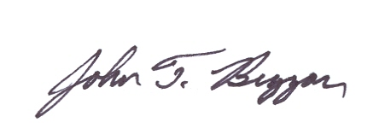
John Buzzar
Regional Habitat Biologist,
PA Fish & Boat Commission

