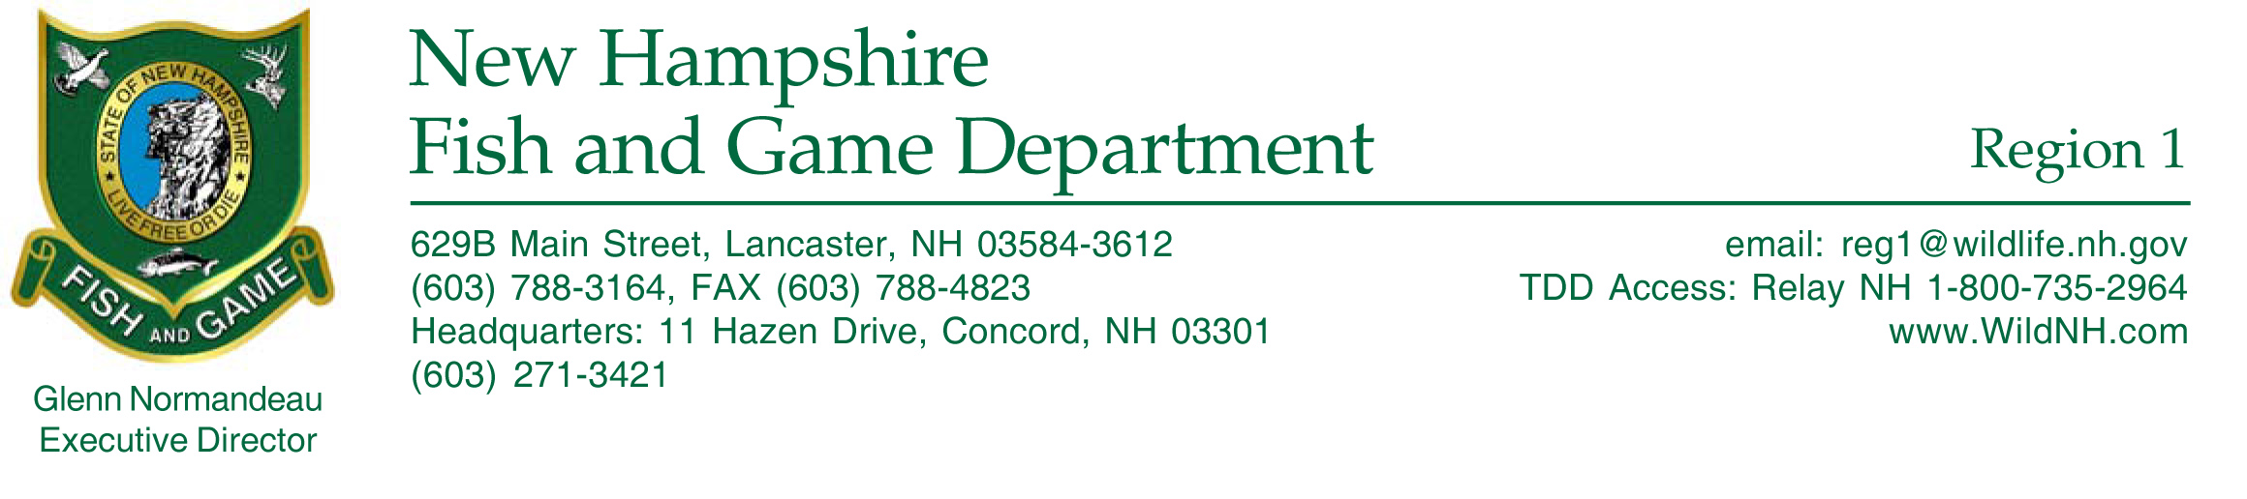

September 28, 2008

Callie McMunigal
U.S. Fish and Wildlife Service
Appalachian Partnership Coordination Office
400 East Main Street
White Sulphur Springs, WV 24986

Dear Ms. McMunigal:

I am writing in support of the Indian Stream Fish Habitat Restoration Project submitted by Joseph Norton of Trout Unlimited. This stream is located in northern New Hampshire (NH) and is a major tributary to NH’s best destination fishery, the Upper Connecticut River.

The Upper Connecticut is a unique and valuable resource in many ways. It is a true destination fishery and accounts for thousands of annual recreational hours by a variety of users. Cooperation by private landowners and power companies afford access to much of the river and angling opportunities are abundant. Many anglers consider this section to be one of the finest coldwater fisheries in New England. A bottom-fed dam on Lake Francis (Murphy Dam) creates a tailwater fishery where year-round water temperatures are conducive to all stages of a salmonid lifecycle.

Some major threats have been identified in Indian Stream including a lack of riparian buffers and habitat, limited instream habitat diversity and complexity, and an overall lack of watershed connectivity due to undersized stream crossings which are fish passage barriers. Most threats are the result of the historic logging practices that have occurred in this region for two hundred or more years. Trout Unlimited’s proposal to gather data that will remedy these problems will benefit this entire region’s fishery. The NH Fish and Game Department (NHFGD) is in full support of Trout Unlimited’s proposed work in Indian Stream.

We are currently working on a similar project at Nash Stream, about forty miles away, and Trout Unlimited is one of the Project Partners. We are using the same approach at Nash Stream as is proposed for Indian Stream. We understand these projects take time and data collection is a critical step to yield positive results. If you have any questions or need further information, please feel free to contact me.

Sincerely,

Dianne M. Timmins
Fisheries Biologist

