PROJECT TITLE

NFHAP funding requested: Eastern Brook Trout Joint Venture

Project Location: Augusta County, Virginia

Congressional District: Sixth

APPLICANT Sponsoring Fish and Wildlife
Service Fisheries Office
Organization: Virginia Department of
Game & Inland Fisheries
Project Officer: Larry Mohn Fish and Wildlife Service
Street: 517 Lee Highway Office: APCO
City, State, Zip: Verona, Virginia 24482
Telephone Number: (540) 248-9360 Street: 400 E Main Street
Facsimile Number: City, State, Zip: WSS, WV 24983
Electronic Mail Address:
Larry.Mohn@dgif.virginia.gov Project Officer: Callie McMunigal
Telephone: (304) 536-4760

Date Submitted: September 26, 2008

II. PROJECT DESCRIPTION, SCOPE OF WORK, AND PARTNER
INFORMATION (3 pages maximum)

A. Project Description and Scope of Work

The project will advance restoration on a .75 mile reach of North River in Augusta County, Virginia, within the George Washington National Forest. The purpose of the immediate project is to install a series of cross-vein and J-structure in-stream devices to stabilize flows and to create and maintain low-water pools that will serve as essential brook trout habitat during droughts and seasonal low-flow periods.

This portion of North River was channelized in the 1950’s and 1960’s. Gabions were also installed in the past; but due to improper installation, these devices served to accelerate water velocity and down-cutting. The result of these cumulative actions was a loss of pool/riffle association. Consequently, large sections of stream bed go dry even during normal summers. The proposed project will continue a long-term program to restore pool habitat to a historically important brook trout fishery.

The land is owned and managed by the George Washington National Forest, North River Ranger District. The goal of the restoration is to restore the hydraulics of the stream to enhance the river’s capacity for self-repair.

It is anticipated that the newly restored segment will support and sustain native brook trout populations, just as similar restored reaches upstream of the project site have. Long-term monitoring will be carried out by Forest Service and Virginia Department of Game & Inland Fisheries staff. In-stream devices installed will provide immediate capture and retention of subterranean flows, allowing for repopulation by brook trout within the following year.

B. Partner Information

Partner Name | Contribution  In-Kind | Contribution  Cash | Federal or  Non-Federal | Partner Category | Role of Partner
Virginia  Dept. of Game & Inland Fisheries | $5000 | $10,000 | Non-Federal | State Agency | Co-partner for project oversight
George Washington National Forest | $5000 |  | Federal | Federal Agency | Co-partner for project oversight
Virginia Council Trout Unlimited | $2000 |  | Non-Federal | Conservation group | Cash support, with some in-kind field work

C. Milestones and Timeline

This overall North River project began in 2004, with the long-term goal of re-establishing native brook trout in a six-mile stretch (+/-) immediately downstream from the federally designated road-less area. To date, more than 4,000 linear feet of stream above the current proposed project site have been restored, and brook trout re-established. The proposed project for 2009 funding would restore 1,100’ of stream. The project would be carried out during low flow of late summer, at a time when the heavy equipment essential to this type of undertaking can be safely maneuvered within the dry stream bed. Ultimately, the goal is to restore a native brook trout fishery in the North River between the road-less area boundary down to Elkhorn Reservoir.

III. MAP OF PROJECT AREA (one only)

North River Project Area – proposed work for 2009 would be a 1,100’ reach upstream from the junction of the tributary, just upstream from the Trout Run tributary, to the Forest Road 95 bridge crossing.

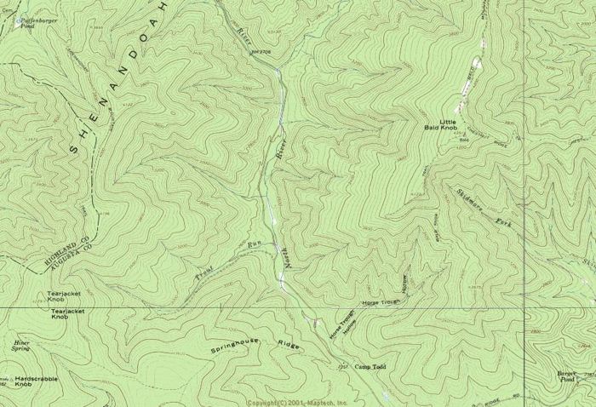

IV. PHOTOGRAPH(S) OF PROJECT AREA (no more than 2, optional)

(Note, these are 640 x 480 jpeg’s – actual size of each image is approximately 2.8 MB; photography by M. L. Smith, VA Dept. of Game & Inland Fisheries volunteer.)

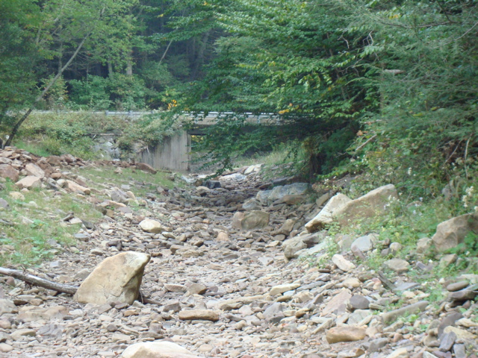

North River, proposed project area, looking upstream. Channelization
and subsequent down-cutting have rendered long stretches of stream dry in summer.
Below, a view of restored pool/riffle .5 mile upstream. This section already supports a restored population of native brook trout.

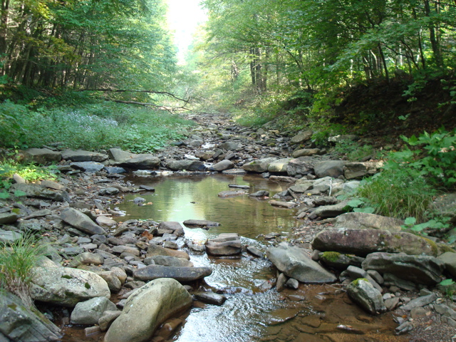

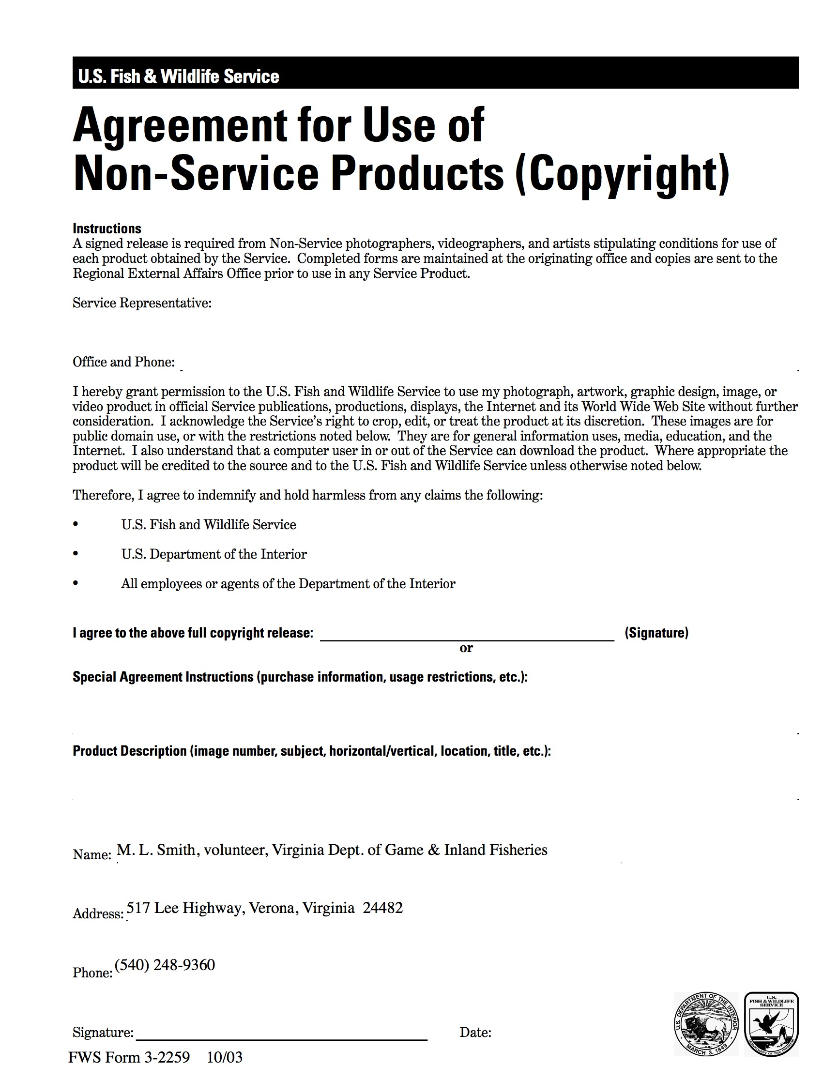

V. PROJECT BUDGET

A. General Requirements

The total cost of the proposed project will be $ 37,000. Of this amount, no money will be required for acquisition since all of the project will be accomplished on public land.

The projects costs can be divided into three major categories:
1. Onsite planning and assessment
2. Heavy equipment deployment and operation
3. Site inspection and evaluation

Of the three major categories, the greatest costs will accrue to hiring heavy equipment with skilled operators. This type of stream bed restoration cannot be undertaken without use of heavy equipment, and fuel costs (particularly diesel) may equal or exceed hourly wage costs for skilled operators.

B. Budget Table

Partner | Activity | NFHAP  Request | Non-Fed.  Contribution | Federal  Contribution | Total | Acres/miles  Affected
VA DGIF | Installation of instream devices via heavy equipment | $15,000. |  | $10,000. | $25,000.
Forest Service | [same as above] |  |  | $10,000. | $10,000.
VA Council TU |  |  | $2,000.  (cash) |  | $2,000.
TOTAL |  | $15,000. |  |  | $37,000. | 1,100’

VI. EVALUATION QUESTIONS (3 pages maximum)

A. Conservation of Sustainable Brook Trout Populations:

The proposed project would not involve any land acquisition. Rather, it would restore historically significant brook trout habitat on public (National Forest) lands that has been identified as one of the highest priority sites in the Virginia brook trout conservation strategy. When the overall North River restoration is complete, put-and-take stocking in lower reaches of the river will be stopped; and the entire upper river will be managed as a wild, self-sustaining native brook trout fishery, one of the largest in the Commonwealth.

Earlier projects completed upstream of the proposed project site have already shown rapid re-colonization by wild brook trout stocks. Because of favorable overall environmental factors of the North River drainage (95%+ in permanent forest cover, high mean average elevation of the stream ( + 1,800’ msl), it is anticipated that suitable habitat will rapidly be occupied by brook trout as soon as it is restored and accessible to upstream stocks.

B. Threatened and Endangered Species and Species of Conservation or Management Concern:

At the present time there are no known Federally listed species within the immediate North River drainage. There is, however, the following Virginia Species of Special Concern:

Cow Knob salamander (Plethodon punctatus)
Species characteristics: This is a medium-sized salamander with a length of 100-157 mm. It is slender with relatively thin legs. The snout is rounded to slightly blunt. The body is dark gray or brownish with a row of white or yellow spots along the sides. There is a tendency to have numerous white or yellowish-white spots on the back. The belly is uniformly gray and the underside of the throat is pinkish.
Species distribution: This species is found only on the Shenandoah, North and Great North Mountains of Virginia and West Virginia between 2400 and 4300 feet (above 735 meters). It is known from Augusta, Rockingham, and Shenandoah counties in Virginia. This species is terrestrial and lives under rocks, logs, and other surface debris, where it is moist and cool. It retreats underground with hot or dry weather. This species occurs in mixed hardwood stands, hardwood mixed with Eastern Hemlock (Tsuga canadensis), and hemlock stands on Shenandoah mountain.

Restoration of brook trout habitat in the upper North River will help restore environmental integrity in a remote portion of the George Washington National Forest. The stabilized flow regimen and permanent pools the project would establish will help restore aquatic and riparian biological diversity to a stream channel and flood plain subjected to decades of channel straightening and down-cutting.

C. Other Species of Economic Importance not Included Above:

There are a number of neotropical migratory songbird species, which could derive immediate benefit from a stabilized flow regimen and permanent pools along the North River. Species such as the cerulean warbler would benefit, as would green herons.

There is a significant number of birders in Augusta and Rockingham Counties. Additionally, avid birders from Northern Virginia, Richmond and the Tidewater often travel to the mountainous portion of western Virginia to see forest species not commonly available in the more developed eastern portion of the state. A restored and near-intact stream ecosystem in a montane setting would encourage additional non-consumptive recreation uses in the National Forest, with attendant economic benefits to local communities.

D. Special Considerations:

Historically, North River was an exceptional brook trout fishery in western Virginia. Because of ill-advised channelization endeavors after flood events in the 1950’s and 1960’s, the rivers value as a wild self-sustaining native brook trout fishery rapidly declined. Restoration of natural flows and pool/riffle habitat will provide compelling evidence to interested anglers and conservationists throughout Virginia that stream habitat restoration is a beneficial and cost-effective endeavor with multiple, long-term resource dividends.

E. EBTJV Targeted Watershed:

North River is currently regarded as a greatly reduced in its capacity to sustain brook trout -- though historically, even into the mid-twentieth century, it was regarded as one of the best and largest river systems (total stream miles) in Virginia for native brook trout.

F. Habitat Connectivity and Enhancing Population Mobility:

The proposed project will greatly assist the long-term restoration of the upper North River. When this restoration is complete, connectivity will be restored for six Order I tributaries that have or could again sustain native brook trout populations.

There is clear indication from the recreational angling public that a restored high-quality native brook trout fishery would be strongly supported and protected, especially one with special protective regulations.

G. Management Assets:

The project area is on public land and will be open to recreational angling. Informal input and angler attitude surveys in the past indicate strong support for special regulation, high quality wild trout angling experiences. This stream would be able to sustain a significant number of angler days, especially under a no-kill or limited harvest management regimen.

Angler access is generally very good due to easy Forest Road access (via FR 95). Some limited portions of the drainage afford hike-in/near-wilderness experience. Other locales may be developed at some point in the future for accessibility for special needs anglers.

No fee beyond normal Virginia recreational fishing license and National Forest license fee would be charged. It is anticipated that the DGIF/Forest Service/TU partnership would develop on site signage explaining the purposes and methods of stream restoration and native brook trout management. Moreover, the North River project is of such a scale that it could be the definitive EBTJV education/outreach tool for the foreseeable future within Virginia.

H. Supporting Documentation and Management Plans:

- Letter from Virginia Department of Game & Inland Fisheries (attached)

Literature:

Mohn, Larry O. & Paul E. Bugas. 1979. Virginia Trout Stream and
Environmental Inventory. Virginia Dingell Johnson Project F-32. 70
pages

Mohn, Larry O. Virginia Brook Trout Conservation Strategies. 2007. 6
pages

Reference:

Hudy, Mark and Teresa Theiling. 2006. Distribution, status, and
perturbations to brook trout within the eastern United States. James
Madison University.

Rosgen, Dave. 1996. Applied River Morphology. Wildland Hydrology.

Virginia Department of Conservation and Recreation. 2004. The Virginia
Stream Restoration and Stabilization BMP Guide. 211 pages.

