Partnering with the NFHAP and EBTJV to restore aquatic organism passage within Tipton Creek, NC

Project Location: Nantahala National Forest, Cherokee County, NC
- Congressional District: 11
EBTJV / NFHAP Funding Requested: $50,000
- Total Project Cost: $355,000
- Total Federal Matching: $255,000
- Total Non-Federal Matching: $100,000
- Type of Project: culvert replacement: native fish community restoration

APPLICANT
Organization: U.S. Forest Service, National Forests in North Carolina
Project Officer: Sheryl Bryan, Fish and Wildlife Biologist
Street: 160a Zillicoa Street
City, State, Zip: Asheville, NC 28801
Telephone Number: 828-257-4271
Fax Number: 828-257-4263
EMail Address: sbryan@fs.fed.us

Sponsoring Fish and Wildlife Service Fisheries Office
Fish & Wildlife Service Office: Wadmalaw Island Fish & Wildlife Mgmt. Assistance Office
- Project Officer: Walter (Tripp) Boltin
Street: P.O. Box 69
- City, State, Zip: Wadmalaw Island, SC 29487
- Telephone Number: 843-819-1229
Fax Number:
EMail Address: Walter_Boltin@fws.gov

Date Submitted: 29 September 2009
I. PROJECT DESCRIPTION, SCOPE OF WORK, AND PARTNER INFORMATION

A. Project Description and Scope of Work

Tipton Creek is located within the Upper Tellico Off-Highway Vehicle (OHV) Area on the Tusquitee Ranger District of the Nantahala National Forest. The entire watershed is in public ownership except for several small private inholdings, one of which is along a middle reach of Tipton Creek (Figure 1). Currently, the Forest Service is evaluating alternatives for future management of the OHV area because of significant resource damage, particularly to streams and resident brook trout populations. This project will be the first of several designed to reconnect and restore brook trout habitat and populations within the Tellico River watershed.

Two crossings on Forest Service Road 420 (FSR 420) have been identified as barriers to the upstream movement of brook trout (Figure 1). Improvement of these two crossings will reconnect existing populations of southern strain brook within approximately 4 miles of suitable habitat. This proposal addresses the crossing over Tipton Creek (Figure 4). The crossing over the unnamed tributary to Tipton Creek will be addressed in future proposals.

Figure 1. Project map highlighting the crossing to be improved and brook trout habitat restored.
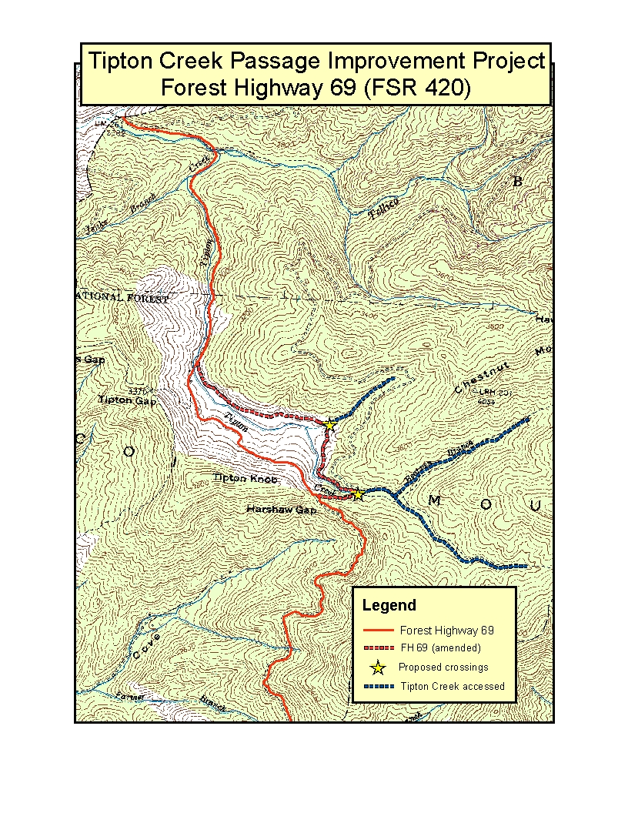
Based on site-specific surveys of aquatic organism passage, culvert slope and length have been determined to be the primary barrier to the upstream movement of brook trout at the Tipton Creek crossing. Culvert outlet drop is also a barrier to the resident nongame fish community.

This project proposes to replace the existing culvert with a bottomless structure to provide passage for brook trout and native nongame species. Based on hydrologic and engineering analyses, bankful width at this crossing is 19 feet. The drainage area for this structure is approximately 600 acres (Figure 2), which contributes to Q50 and Q100 values of 578 and 716 cfs, respectively. This data suggests that a bridge would be the best hydrologic and engineering option to provide passage for aquatic organisms within Tipton Creek. However, upon completion of site-specific surveying for project design, should a bottomless arch become a feasible option, it will be considered. Based on other Forest Service passage projects on streams of this size, there is not a significant difference in cost between installing a bridge or a large bottomless arch, so site-specific data and terrain needs will play a part in determining the appropriate crossing.

Figure 2. Drainage area map for the Tipton Creek crossing on FSR 420.

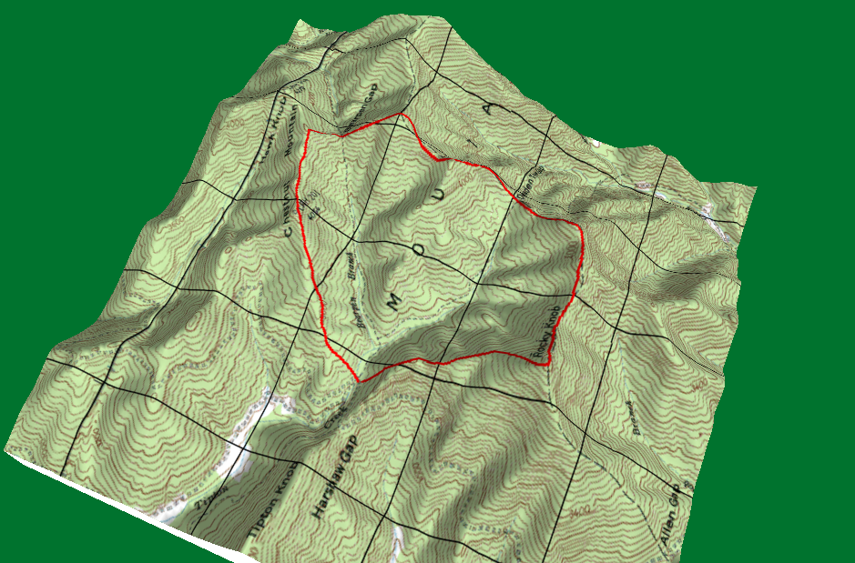

Resident fish communities will be inventoried prior to project implementation to validate existing condition and monitored for at least three years following project implementation to evaluate project success. Part of this process is the identification of natural barriers along middle reaches of Tipton Creek. Rainbow trout have been documented below the private land, but not above.

B. Partner Information

Partner Name | Contribution  In-Kind | Contribution  Cash | Federal or Non-Federal | Partner  Category | Role of Partner
U.S. Forest Service | $5,000 |  | Federal | Federal Agency | Permitting, NEPA documentation
U.S. Forest Service |  | $50,000 | Federal | Federal Agency | Project design
HTAP*/Legacy Roads** funding |  | $200,000 | Federal | Federal Agency | Project implementation
EBTJV/NFHAP Grant |  | $50,000 | Non-Federal | Joint Venture | Project implementation
North Carolina Wildlife Resources Commission | $50,000 |  | Non-Federal | State Agency | Target species inventory & monitoring
*HTAP = Highway Transportation Aquatic Passage program that allocates Federal Highway Administration
funding to the Eastern Federal Lands program by regional priority. The NFsNC has received an average of
$150,000/year in HTAP funding for the last several years. This project is the Forest’s top priority for HTAP funding proposals.
**Legacy Roads funding is derived from Congressional earmarks targeted at reducing road maintenance backlogs, specifically addressing reconnection of fisheries populations and clean water initiatives. The NFsNC has received an average of $350,000/year for the last several years. If HTAP funding is not received, the project will be become the Forest’s top Legacy Roads project.

C. Project Timeline
Project design will begin October 1, 2009, and is expected to take approximately six months to complete. Crossing replacement will begin following contract award around March 2010 (including EBTJV/NFHAP funds), and take approximately nine months to complete. It is anticipated that post-project monitoring could begin as early as the fall of 2010, and continue into at least 2013.

II. MAP OF PROJECT AREA

This project is located within the Tellico River watershed (HUC 06010204030). This watershed originates in Cherokee County, North Carolina and flows northwest into Tennessee. The town of Murphy is located just south of the project area. Several designated wilderness and backcountry areas surround the upper Tellico area. The Tipton Creek project is within the Tellico River corridor proposed for designation under the Wild and Scenic Rivers Act.

The center of this project is: UTM meters NAD 83
North 3904017.892
East 767505.784

The headwaters of this watershed, located in North Carolina, contain one of the highest densities of southern strain brook trout populations (number/square mile) in North Carolina. Many of these populations have been impacted by excess sedimentation from area trails or bisected by roads.

Figure 3. Tellico OHV Area (including the Tipton Creek Project) vicinity map.

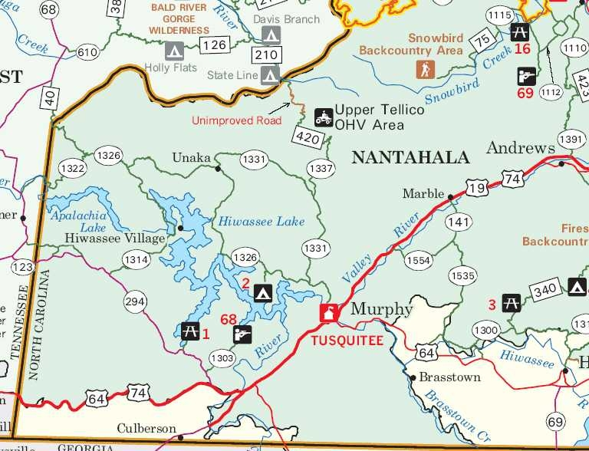

III. PHOTOGRAPH(S) OF PROJECT AREA

Figure 4. Culvert outlet, existing crossing at Tipton Creek, Forest Highway 69 (FSR 420).

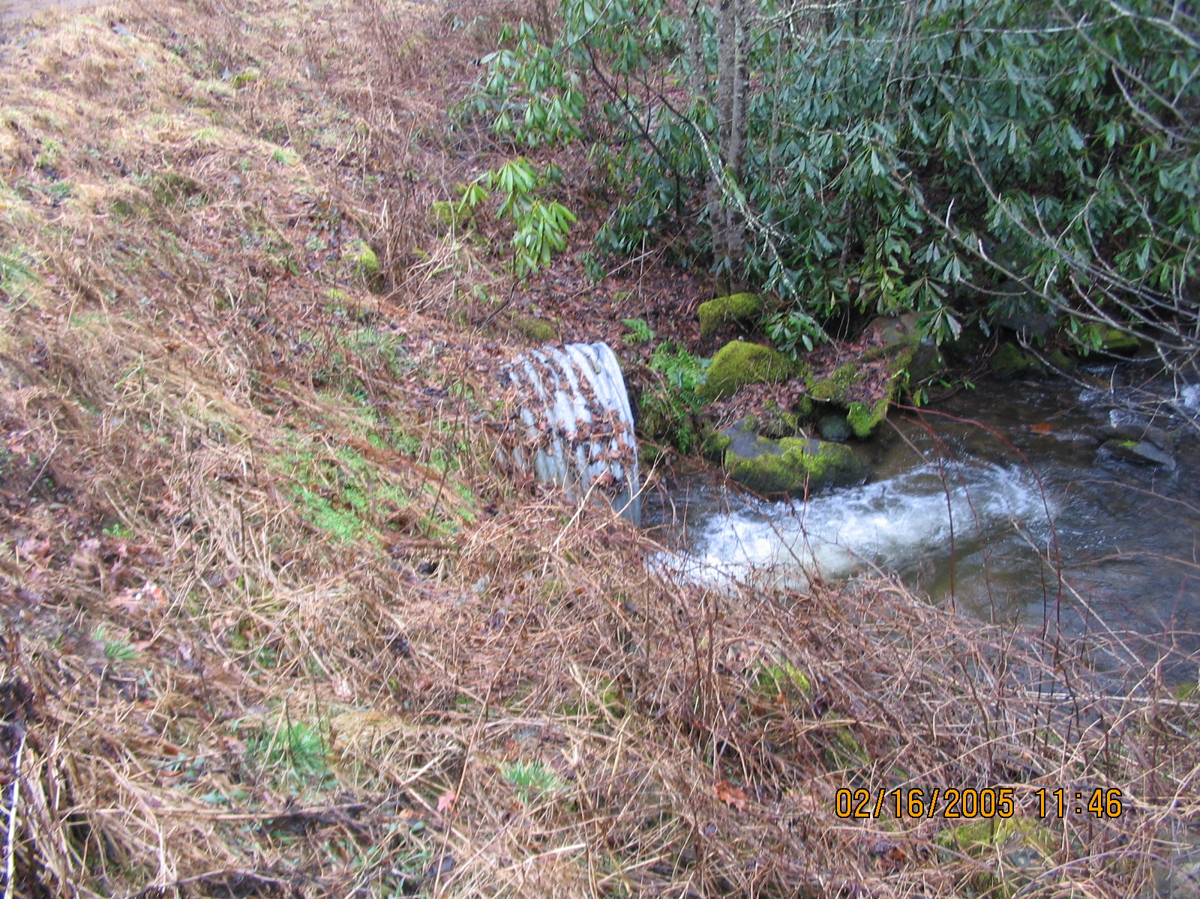
Photo by U.S. Forest Service, February 18, 2005, as part of project
files constructed during post-flood assessments of the 2004 hurricane season.
IV. PROJECT BUDGET

A. General Requirements

U.S. Forest Service cash contributions ($50,000) will be used to initiate project design on October 1, 2009. Concurrently, U.S. Forest Service in-kind contributions ($5,000) will be used to complete the appropriate NEPA documentation and appropriate USACE and NCDWQ permits and certifications. These tasks will be completed by March 30, 2010. HTAP/Legacy and EBTJV/NFHAP funds will be used to implement the project (replace the crossing) through September 30, 2010. NCWRC in-kind funds will be used to complete initial population inventory and post-implementation monitoring through at least 2013.

B. Budget Table

Partner | Activity | NFHAP Request | Non-Federal Contribution | Federal Contribution | Total | ac/mi  Affected
USFS | Bridge design |  |  | $50,000 | $50,000
USFS | NEPA & permitting |  |  | $5,000 | $5,000
EBTJV/NFHAP | Culvert replacement | $50,000 |  |  | $50,000 | 4+ mi total
HTAP/Legacy | Culvert replacement |  |  | $200,000 | $200,000 | 4+ mi total
NCWRC | Inventory & monitoring |  | $50,000 |  | $50,000

V. EVALUATION QUESTIONS

- Conservation of Sustainable Brook Trout Populations: The Tellico River watershed has been identified by the EBTJV as one of the last intact populations of brook trout in North Carolina. This status is despite ongoing impacts to populations from excessive sedimentation of habitat from heavy OHV use and bisected populations from the road and trail network in the area. The Forest Service is currently setting future management objectives for the area, with restoring and maintaining brook trout populations at the top of that priority list.

This project will be the first step towards restoring and reconnecting these southern strain brook trout populations to ensure that the upper Tellico River remains a brook stronghold into the future. There is no land purchase required, although future projects may involve cooperation with several private landowners in the watershed. No rights-of-way or easements are required. The Forest Service is the primary landowner in the watershed.

This project moves towards all four of the EBTJV’s Conservation Goals by:

- Restoring brook trout populations that have been impacted by habitat modification;
- Involving partnerships to seek solutions to ecological threats;
- Educating the public about challenges that brook trout face; and
- Developing support for native species conservation, particularly brook trout, throughout this stronghold in it’s historical range.

This project specifically supports EBTJV range-wide objective I by restoring bisected brook trout populations within Tipton Creek to ensure that the watershed remains intact (green). It is the first of several projects in the upper Tellico watershed that will support range-wide objective IV by curbing population loss.

Addtionally, this project contributes to achieving Priorities 3.1, 3.2, 4.2, and 4.3 in the North Carolina Brook Trout Conservation Strategy.

- Threatened and Endangered Species and Species of Conservation or Management Concern: This project will not directly impact nor benefit any federally- or state-listed species. In addition to brook trout and other native fish species, this project will provide passage for the Santeeetlah dusky salamander (Desmognathus santeetlah) and Southern water shrew (Sorex palustric punctulatus), species of management concern to the Forest Service. Reconnection of the southern brook trout populations within Tipton Creek will strengthen the genetic diversity of this distinct subspecies.

- Project Benefits: The upper Tellico watershed is currently identified as supporting intact (green) brook trout populations, although at the local scale, habitat sedimentation and passage barriers threaten this status.

This project will reconnect and restore brook trout to approximately 4 miles of stream within the upper Tellico River watershed, specifically within Tipton Creek and its tributaries. Forest Service experience with similar passage projects shows that replacing culvert barriers with bottomless structures is successful at reconnecting populations, facilitating reproductive success, and expanding then range of native species. Project summaries for the Long Branch (brook trout), Cathy’s Creek (brook trout), South Toe River (brook trout, dace) and Griffith Branch (greenhead shiners) projects are available upon request.

- Endurance of Benefits: The entire drainage area for this project (approximately 600 acres, Figure 2) is owned by the U.S. Forest Service. Existing Forest Plan requirements and future restoration and enhancements will protect the brook trout within Tipton Creek in perpetuity.

Excessive habitat sedimentation and bisection of populations by road and trail crossings are major causes of watershed degradation, both of which are addressed by this project. Additionally, within the upper Tellico River watershed, the Forest Service will implement additional road, trail, and watershed restoration projects in the future to remediate damage to water quality and aquatic habitats and populations caused by overuse of the area. For example, in the last twelve months, several miles of trail have been closed to eliminate severe stream sedimentation, several more miles have been closed temporarily to correct drainage eliminate stream sedimentation, and several miles of open road have been paved to reduce runoff and sedimentation from highly used transportation corridors.

No trout are stocked into the Tellico River or its tributaries (including Tipton Creek) by the North Carolina Wildlife Resources Commission (NCWRC). However, the Tellico River mainstem is stocked with trout by the Tennessee Wildlife Resources Agency downstream. Tipton Creek is a tributary to the Tellico River approximately 1 mile upstream of the Tennessee state line. There are no natural barriers to the upstream migration of stocked fish with the mainstem Tellico River. There is at least one potential barrier on lower Tipton Creek on Forest Service land. This project proposes to identify additional natural barriers to upstream movement of nonnative trout within Tipton Creek.

- Management Assets: The NCWRC will assist the USFS in monitoring the brook trout population in Tipton Creek. Prior to the existing culvert removal, and for five years after replacement, the brook trout population will be sampled at multiple locations above and below the culvert using backpack electrofishing to determine relative population size and reproductive success. The natural barrier on lower Tipton Creek will also be identified prior to culvert removal.

This project location is in the Nantahala National Forest and is currently open for angling. There are no plans to restrict public access during the project implementation or monitoring phases.

The NCWRC and USFS will partner to develop an educational kiosk at the Tipton Creek culvert replacement location, or other suitable location, to showcase the importance of restoring brook trout habitat in the Tellico River watershed, the species and habitats being restored, and the partnerships used in that process.

This project will reconnect two populations of Southern Appalachian strain brook trout. This will allow for improved genetic flow across the current culvert location and should result in a more robust population. After periods of drought, brook trout will be able to recolonize the upper sections of Tipton Creek above the current culvert much quicker. This will result in more consistent fishing opportunities for anglers along the length of Tipton Creek.

USFS hydrologists and engineers will periodically evaluate the integrity of the new spanning structure. No other long term maintenance will be required.

- Other Special Considerations: The Tellico River watershed has a history of extensive off-highway vehicle (OHV) use that predated acquisition of the property by the USFS in 1980. The USFS and NCWRC have jointly been involved in monitoring aquatic communities in the Tellico River Watershed since 1994 (Besler 2007). The USFS recently closed some of the OHV trails which were causing severe erosion, degrading habitat, and impacting aquatic communities. A broad Environmental Assessment has been completed which will identifies additional USFS actions to reduce impacts from OHV use in the watershed. This project represents an early attempt to improve habitat in Tipton Creek, enhance an impacted population of brook trout, and represents an important first step towards complete Tellico River watershed restoration.

- Supporting Documentation and Management Plans:

Besler, D. A., A. P. Wheeler, and M. G. Martin. 2007. A summary of wild trout population monitoring in the Tellico River watershed, 1994−2006. North Carolina Wildlife Resources Commission, Raleigh.

NCWRC. 1989. Casting the future of trout in North Carolina: A plan for managing North Carolina’s trout resources. Division of Boating and Inland Fisheries, Raleigh.

NCWRC. 2003. Brook trout management in North Carolina. North Carolina Wildlife Resources Commission, Raleigh.

