St. Mary’s Liming, St. Mary’s River, Vesuvius, Virginia, EBTJV

Project Location: Virginia, Augusta County, Vesuvius, VA 6th Congressional District

Congressional District of Project: VA 6th

Congressional District of Applicant: VA 6th

NFHAP / EBTJV Funding Requested: $50,000

Total Project Cost: $143,000

Total Federal Matching: $13,000

Total Non-Federal Matching: $80,000

Applicant:
- Project Officer: Dawn Kirk
- Organization: USFS, George Washington and Jefferson National Forest
- Street: PO Box 10, 27 Ranger Lane
- City, State, Zip: Natural Bridge Station, VA 24579
- Telephone Number: 540/291-5211
- Fax Number: 540/291-1759
- EMail Address: dkirk@fs.fed.us

U.S. Fish and Wildlife Service Sponsoring Office:
Project Officer: Keith McGilvray
U.S.Fish and Wildlife Service Office: Appalachian Partnership Coordination Office
Street: 400 East Main Street
City, State, Zip: White Sulphur Springs, WV 24986
- Telephone Number: (304) 536-1361 X152
Fax Number:
EMail Address: keith_mcgilvray@fws.gov

USFWS FONS Database Project Number: 53374-2011-367

Coordination Completed with Sponsoring U.S. Fish and Wildlife Service Office (Check One):
X Yes 7/6/2011 Date Coordination Began
No

I. PROJECT DESCRIPTION, SCOPE OF WORK, AND PARTNER INFORMATION

A. Project Description
The streams of the Saint Mary’s Wilderness, located on the western slopes of Virginia’s Blue Ridge Mountains, have been severely compromised by anthropogenic atmospheric acid deposition. The Forest Service (FS) and partners are proposing to add limestone sand using a helicopter to headwater streams of St. Mary's River within St. Mary's Wilderness. This would be a repeat of the project that was implemented in 1999 and 2005. The watershed is within the George Washington National Forest.

B. Proposed Methods (Max Characters: 350)
Approximately 230 tons of limestone would be transported by helicopter during low use times over a 1 to 2 day period. Limestone sand would be added to Sugartree Branch, Mine Bank Branch, Bear Branch, Chimney Branch, Hogback Branch, and an unnamed tributary and the upper St. Mary's River.

C. Project Timeline
Activity | Responsible Person | Start date | Completion Date
Grant applications | USFS & partners | March 2012 | December 2012
NEPA | Dawn Kirk, USFS | January 2011 | December 2011
Contract for helicopter | Dawn Kirk, USFS | November 2012 | March 2013
Purchase/deliver limestone | Dawn Kirk, USFS | January 2013 | March 2013
Monitor Fish and Insects (annual) | Paul Bugas, VDGIF | June 1986 | June 2013 on-going
Monitor water chemistry (annual) | Dr. Dan Downey, JMU | March 1999 | June 2013 on-going
Monitor water chemistry (quarterly) | Rick Webb, VTSSS-UVA | January 1989 | July 2013 on-going

D. Proposed Accomplishment Summary (Max Characters: 500)
Approximately 12 miles of stream water will be buffered from the effects of human induced acid deposition. This project will maintain the positive steps that were gained from the 1999 and 2005 limings. The pH of the river at the downstream Wilderness boundary will stay at a level of around 6.2, allowing wild brook trout and other native aquatic species to thrive, restoring a class I native trout stream. This project is in alignment with the EBTJV mission, Virginia’s State Wildlife Action Plan, and the George Washington National Forest Plan.

E. State the Importance of the project to the Resource (Max Characters: 350)
Wild brook trout and other indigenous fish species such as the mottled sculpin and fantail darter, were eliminated from most of the St. Mary's Wilderness, but were able to re-colonize portions of the river following the 1999 liming. These fish will be able to survive in the Wilderness if it is re-limed in 2013.

F. Problem and Specific Cause of the Problem (Max Characters: 350)
There is detailed and historical documentation of the decline of the biological community of the stream dating back to the 1930's. Approximately 20 fish and macroinvertebrate species were extirpated from the St. Mary's Wilderness due to acidification. Previous limings have allowed acid sensitive species to re-colonize the river, and re-establish a brook trout fishery.

G. Objective of the Project with Reference to the Problem (Max Characters: 350)
St. Mary’s River and five tributaries were limed in 1999, a treatment that was designed to last 5-8 years. Extensive chemical and biological monitoring has showed dramatic improvement following the limestone treatment, with a decline after about 6 years. The river and six tributaries were re-limed in 2005. Chemical and biological monitoring following the 2005 liming showed similar response.

H. Partner Information

Partner Name | Contribution  In-Kind | Contribution  Cash | Federal or Non- Federal | Partner  Category | Role of Partner
Dominion Power |  | $25,000 | non | corporate | Cash for helicopter contract and limestone
VDGIF | $10,000 | $30,000 | non | State agency | Cash for helicopter and in-kind monitoring
James Madison University | $7,000 |  | non | University | Monitoring
Virginia Trout Stream Sensitivity Study (VTSSS) at University of VA | $1,000 |  | non | University | Monitoring
US Forest Service | $13,000 |  | Fed | Federal Agency | Planning, implementation & monitoring
Trout Unlimited | $5,000 |  | non | Conservation Group (National) | Monitoring & educational outreach
Skylark Farms | $1,000 |  | non | Private landowner | Allow use of land for helibase and limestone loading
Blue Ridge Parkway | $1,000 |  | Fed | Federal Agency | Coordination and traffic control during implementation

II. MAP OF PROJECT AREA

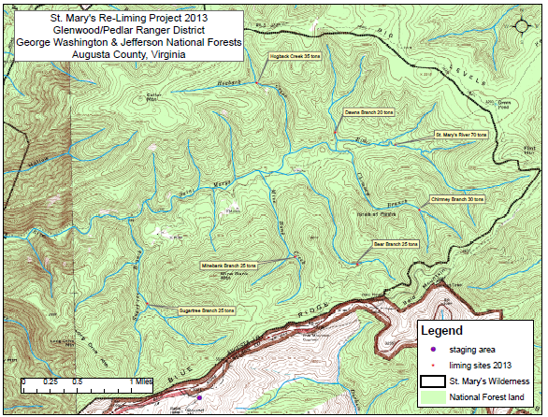

III. PHOTOGRAPH(S) OF PROJECT AREA
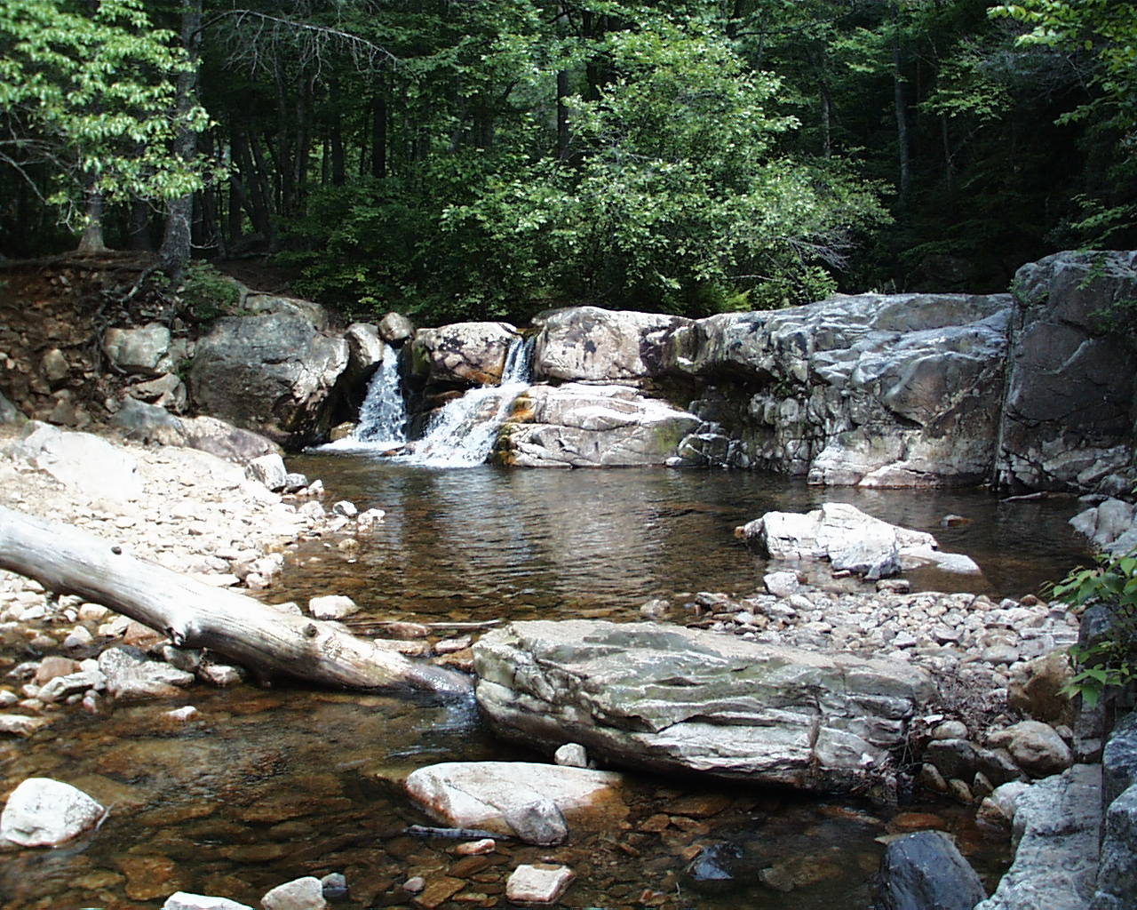
Upper Falls, St. Mary’s River. Photo by Dawn Kirk, June 2007.

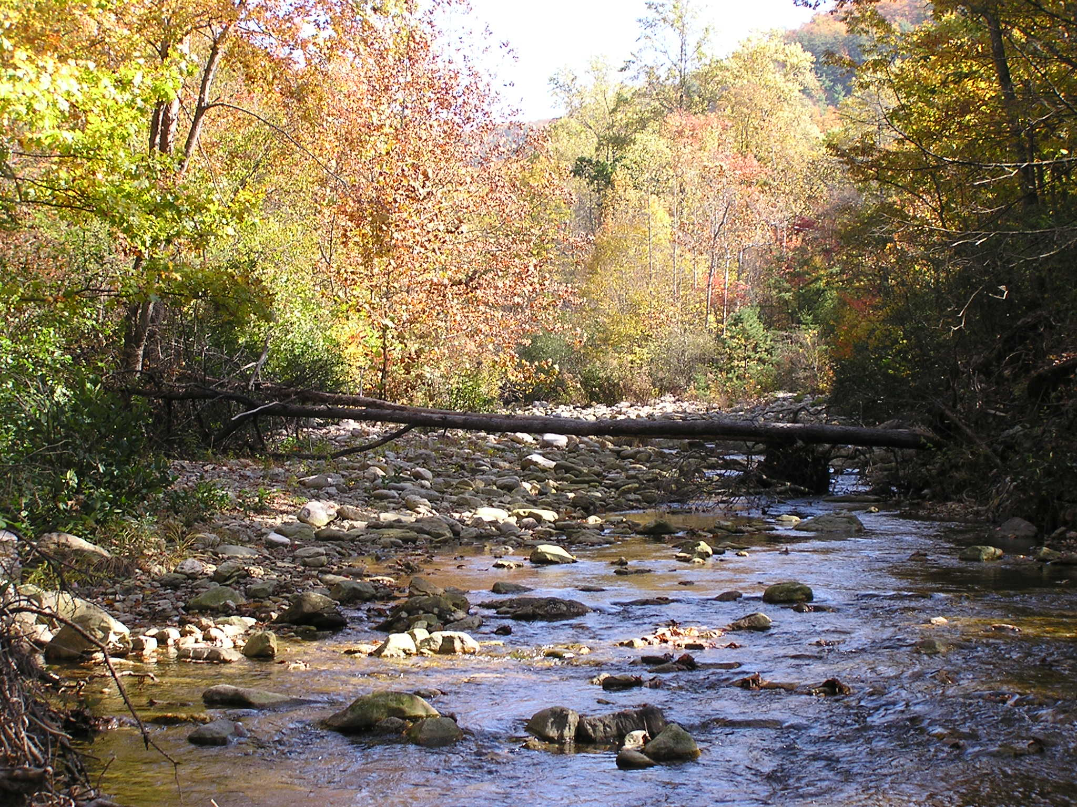
Pool/riffle habitat, St. Mary’s River. Photo by Dawn Kirk, November 2005.

IV. PROJECT BUDGET See project budget table below

  - B. Budget Table Example
Partner Name | Partner Category * | Activity of Partner ** | Budget Category*** | EBTJV  NFHAP Request | Non-Federal Contribution |  | Federal Contribution |  | Total Contribution | Acres/Miles Affected
 |  |  |  |  | In-Kind | Cash | In-Kind | Cash
Dominion Power | Corporate | restoration | contractual |  |  | $25,000 |  |  | 25,000 | 12 miles
VDGIF | State agency | restoration | contractual |  |  | $15,000 |  |  | 15,000 | 12 miles
 |  | monitoring | personnel |  | $10,000 |  |  |  | 10,000 | 12 miles
 |  | restoration | supplies |  |  | $15,000 |  |  | 15,000 | 12 miles
James Madison University | State University | monitoring | personnel |  | $7,000 |  |  |  | 7,000 | 12 miles
US Forest Service | Federal agency | restoration | personnel- planning |  |  |  | $3,000 |  | 3,000 | 12 miles
 |  | restoration | personnel-implementatino |  |  |  | $3,000 |  | 3,000 | 12 miles
 |  | monitoring | personnel-monitoring |  |  |  | $7,000 |  | 7,000 | 12 miles
Trout Unlimited | Conservation Group (national) | monitoring | personnel |  | $2,500 |  |  |  | 2,500 | 12 miles
 |  | education | supplies |  | $2,500 |  |  |  | 2,500 | 12 miles
Skylark Farms | Private Landowner | restoration | other |  | $1,000 |  |  |  | 1,000 | 12 miles
Blue Ridge Parkway | Federal agency | restoration | other |  | $1,000 |  |  |  | 1,000 | 12 miles
VTSSS - UVA | State University | monitoring | Personnel and supplies |  | $1,000 |  |  |  | 1,000
USFWS/EBTJV | Federal agency | restoration | contractual | $50,000 |  |  |  |  | 50,000 | 12 miles
Total Contribution |  |  |  | 50,000 | 25,000 | 55,000 | 13,000 |  | 143,000 | 12 miles

*Partner Categories - Federal Agency, State Agency, Local Government, Conservation Group (Local), Conservation Group (National), Native American Tribe, Private Landowners, Corporations/Businesses

**Activity - Acquisition, Fish Ladder, Dam Removal, Culvert Removal, Restoration, Monitoring

***Budget Categories - Equipment, Construction, Contractual, Personnel, Travel, Supplies, Other.

NOTE: This is not a Federal Grant program and therefore does not exclude non-federal match used here from being matched to other Federal Grant sources to leverage funds for the project. Indicate if partnering contributions are in-kind or new cash. NFHAP requests should illustrate how the dollars will be spent and by what organization. Overhead such as utilities, office space, and salary to prepare applications and develop partnerships will not be funded with NFHAP funds and should not be a line item or built into the project. Activities that directly relate to completion of the project such as travel and salary to do design work let and/or monitor contracts are allowable expenses with NFHAP funds but should not constitute more than 10% of the funding request. For more information on the use of NFHAP funds, please see http://www.fws.gov/policy/717fw1.html.

V. EVALUATION QUESTIONS

- Please provide the GPS Coordinates for the project using UTM NAD 83.
Sugartree Branch (25 tons) Lat/Long N 37 55' 8.6", W 79 06' 50.1"
Mine Bank Creek (25 tons) Lat/Long N 37 55' 16.1", W 79 05' 14.0"
Bear Branch (25 tons) Lat/Long N 37 55' 11.4", W 79 04' 36.7"
Chimney Branch (30 tons) Lat/Long N 37 55' 36", W 79 03' 56.3"
Hogback Creek (35 tons) Lat/Long N 37 56' 40.0", W 79 05' 35.4"
Dawn's Branch (20 tons) Lat/Long N 37 56' 14.2", W 79 04' 47.1"
Upper St. Mary's River (70 tons) Lat/Long N 37 56' 8.9", W 79 04' 11.6"

- Please list the type of project.
Acid deposition remediated through limestone mitigation (carbonate buffering).

- Are brook trout currently present at the project site or in the project stream? If not, were brook trout historically present? Is the habitat known to be suitable for restoration / reintroduction of brook trout?
Brook trout are currently present in the project stream and tributaries.

- Please describe how the project will provide for the expansion or improvement of existing habitat?
The project will maintain water quality to sustain brook trout populations and other aquatic organisms for 12 miles of a Wilderness River and tributaries where stream acidity has historically depressed and/or extirpated populations.

- Does the project include a protection component? Is the project footprint located on private or public land? Is the land currently protected? Does the project include land purchase or easements as match?
The project is completely within a designated Wilderness within the National Forest; it is on public land, protected in perpetuity.

- What percentage of the watershed above the proposed project is protected in perpetuity?
100%
- List the specific regional EBTJV habitat objectives addressed by the project and describe how the project will contribute towards them.
Regional Habitat Objective #5: Strengthen brook trout populations in 63 subwatersheds classified as reduced by 2012.
Regional Habitat Objective #6: Maintain 713 reduced subwatersheds in existing condition by 2012.

The project will maintain and strengthen suitable water quality in a subwatershed classified as reduced. It mitigates the only reason the watershed is classified as reduced (acidification); otherwise the physical habitat, water quantity, and temperature are excellent.

- State which, if any, EBTJV priority the project addresses:
(3) The project enhances impacted or unstable brook trout populations by first targeting brook trout habitat that have the capacity of being enhanced to intact streams. The project improves water quality throughout a watershed that already has fantastic physical habitat; the streams have abundant perennial, cold water, free of sediment and watershed impacts other than acid deposition.

- What is the EBTJV subwatershed number and associated priority ranking for the proposed project?
Watershed # = 510428
Priority Score = .46
Map = VA Best for Protection Map

- Will the completed project benefit any federally listed threatened or endangered species?
NO

- Will the completed project benefit any state listed threatened or endangered species?
Yes. The water fan lichen (Peltigera hydrothyria), a Virginia S1 species, is found downstream from liming sites in the tributaries and will benefit from improved water quality.

- Will the project provide or enhance connectivity to or within an intact subwatershed?
NO, the entire subwatershed has been classified as reduced.

- What are the root causes of the watershed degradation and which of these are addressed by the project?
Stream acidification caused by acid deposition and diminished soil & forest buffering capacity.

- Describe the plans for project monitoring and evaluation.
Water chemistry will be monitored throughout the watershed following project implementation as part of a cooperative agreement between James Madison University and the Forest Service. Water samples will be collected throughout the Wilderness upstream and downstream of liming sites, before and following limestone addition and returned to the laboratory at JMU for analysis. These sites were identified in previous reports on earlier liming projects (Norman et al. 2004, Williams and Downey 2010). Water samples will be analyzed for pH, acid neutralizing capacity (ANC), base cations, acid anions and total aluminum which are parameters necessary for evaluation of the chemical effectiveness of the limestone treatment. Fish and macroinvertebrates will be monitored at two permanent sampling stations every year and six permanent sampling stations every other year (VDGIF and Forest Service cooperative project funded with Forest Stamp dollars). Stream pH and indicator parameters will also be monitored quarterly at one location as part of the long-term Virginia Trout Stream Sensitivity Study 1989- present (Cooperative project of the University of Virginia, Trout Unlimited and the US Forest Service funded by grants to University of VA).

- Describe the expected effect on the brook trout population. To what degree will the project strengthen the brook trout population status?
The brook trout population was reduced to only a few, older fish, and little successful reproduction prior to the 1999 liming. The population increased in abundance, individual fish size, and recruitment resulting in multiple age classes, following treatment.

- Please describe the long term benefit of the project and provide an estimate of the length of time the project is expected to be effective. If a plan for long term maintenance is necessary to maintain project benefits, please describe it.
The proposed liming is designed to last 5-8 years; the stream will have to be re-limed to maintain water quality until the point that air quality improves.

- Are other strains of brook trout, salmonids, or exotics present in the proposed watershed? Do stockings of other strains of brook trout, salmonids, or other exotics occur, and if so, where does the stocking take place with respect to the project site (in HUC, in HUC but below barrier, or in adjacent HUCs)?
The brown and rainbow trout that had naturalized in the watershed are no longer present because of they are less tolerant to acidity than brook trout; they will not be re-stocked.

- Please describe the current status of the project. Is it planned, permitted and ready to begin? NEPA was completed in December 2011. It is planned, permitted, and ready to begin if funding is available; implementation is planned for March 2013.

- Will public access be allowed at the project site? If so, what kinds of recreational activities are allowed – public fishing, nature trails, etc?
The project is on public land within a National Forest Wilderness area and adjoins the Blue Ridge Parkway. Non-motorized activities are allowed, including fishing, hiking, camping, and hunting.

- What is the recreational quality of the potential fishery?
There is currently a 9-inch minimum special regulation on the St. Mary’s River and tributaries. It is a very popular wilderness fishery for it dramatic scenery, high gradient pool & riffle habitat, and accessibility by foot trail.

- Describe the outreach or educational components of the project and how many individuals / students will be served.
Virginia Council Trout Unlimited (VCTU) will conduct at least one event to publicize the project and educate its members and the public on the use of limestone sand interventions as a plausible means to control stream acidification. VCTU has about 4,000 members state- wide and frequently cites well researched St. Mary’s watershed as both as a prime example for the detrimental effects of stream acidification and the benefits of limestone sand acid mitigation. The project and results will be in TU and VDGIF publications. They will be available on a website dedicated to the St. Mary’s project. http://csm.jmu.edu/st.marys/index.html

- If applicable, please briefly describe how this project will promote adaptation to climate change.
This project will maintain suitable water quality throughout the St. Mary’s watershed; thus maintaining chemical habitat connectivity between the lower reaches (more likely to go dry and warm-up in a warming climate with extreme weather events) and the cooler headwater stream reaches. Recent research has shown that connectivity between main stem rivers and their more stable tributaries is essential for brook trout populations in the face of changing climate (Petty et. al. 2012).

- Please explain how this project is a good investment of funds, using a quantitative approach where possible and the recreational and / or economic value of the project.
With a total cash contribution of $105,000 for over 12 miles of federally protected quality trout habitat over the expected 7+ year life of the project, the cost per mile per year is about $1250; much less than most restoration projects.

- SUPPORTING DOCUMENTATION:

- Literature Cited

Bugas, P.E. 2011. Personal Communication. Virginia Department of Game and Inland Fisheries, Verona, Virginia.

Kirk, D.M. and J.C. Mitchell. 1999. Streamside salamanders in an acidic Blue Ridge Mountain stream: historical comparisons and relative abundance. Banisteria, No.13: 201-207.

Mohn, L.O., P.E. Bugas Jr., D.M. Kirk, and D.M. Downey. 2000. Mitigating Stream Acidification in a Wilderness Watershed Using Limestone Sand. Wild Trout VII Symposium. Old Faithful Inn, Yellowstone National Park, October 1-4. Pages 176-184.

Mohn, L.O., P.E. Bugas Jr., D.M. Kirk, and D.M. Downey. 2004. Long-term Results of Mitigating Stream Acidification Using Limestone Sand in St. Mary’s River, Virginia.
Wild Trout VIII Symposium. Yellowstone National Park.

Moran, J.D. and C.N. Roghair. 2003. Condition of Fish Populations and Habitat in the St. Marys River and Selected Tributaries Before and After Limestone Sand Treatment. Report to the George Washington and Jefferson National Forest from the Center for Aquatic Technology Transfer, Coldwater Fisheries Research Unit, FS Southern Research Station at Virginia Polytechnic Institute and State University, Blacksburg, VA.

Norman, C., R. Elliot, D. Downey. 2004. St. Mary’s Stream Water Chemistry (1999-2004). Interim Project Report on Cooperative Project Between US Forest Service and James Madison University. JMU. Harrisonburg, VA.

Petty, J.T., J. L. Hansbarger, B. M. Huntsman & P. M. Mazik. 2012. Brook Trout Movement in Response to Temperature, Flow, and Thermal Refugia within a Complex Appalachian Riverscape, Transactions of the American Fisheries Society, 141:4, 1060-1073

Surber, E. Bottom fauna and temperature conditions in relation to trout management in St. Mary's river, Augusta County, VA. VA Journal of Science. 2(3): 190-202. 1951.

Webb, J.R., P.E. Bugas, B.J. Cosby, J.N. Galloway, G.M. Hornberger, J.W. Kauffman, L.O. Mohn, P.F. Ryan, and P.P. Smith. 1989b. Acidic Deposition and the Status of Virginia's Wild Trout Resource, Wild Trout IV, Proceedings of the Symposium, Yellowstone National Park, pp.228-233.

Webb, J.R., F.A. Deviney, J.N. Galloway, C.A. Rinehart, P.A. Thompson and S. Wilson. 1994. The Acid-Base Status of Native Brook Trout Streams in the Mountains of Virginia, A Report Submitted to Va. Dept. of Game and Inland Fisheries, Charlottesville, VA, May.

Weigmann, D.L., L.A. Helfrich and D.M. Downey. 1993. Guidelines for Liming Acidified Waters and Streams, VPI Water Resources Research Center, Blacksburg, VA.

Williams, N.C. and D.M. Downey. 2010. St. Mary’s Acid Mitigation Project: Is it time for another dose of medicine? Project Report on Cooperative Project Between US Forest Service and James Madison University. JMU. Harrisonburg, VA.

- References to published interagency fishery or aquatic resource management plans.

George Washington National Forest Plan. 1993. Chapter 3, Management Area 18. Roanoke, Virginia.

Draft George Washington National Forest Plan. 2012. Chapter 4, Management Prescription 11. Roanoke, Virginia.

