Eastern Brook Trout Joint Venture
Completed Project Report Form
Project Title: Umpire Brook Culvert Replacement

- Location: Victory, VT

- Lat / Long Coordinates: -71.840430, 44.564449

- Sponsor: VT Fish and Wildlife Department

- Completion Date: September 2009

- Partners involved: VT Fish and Wildlife Department, VT Department of Forest, Parks, and Recreation, and VT Department of Environmental Conservation

- Project costs:
- Total cost: $19,700
- Non federal amount: $10,500
- Federal amount: $9,200

- Final Funding:
NFHAP Funding Through EBTJV: $9,200
Total Federal Contributions: $9,200
Total Non-Federal Contributions: $10,500

- Action strategy implemented in the project (according to EBTJV range wide, regional, or state level habitat strategies). Reduce habitat fragmentation.

- Priority score of the sub-watershed where the project took place. Yellow

- Describe any additional species of greatest concern or the state wildlife action plan listed habitat conservation goal (s) supported by the project. Naturally reproducing brook trout

- Description: project objective(s):

Umpire Brook is a small second order stream in the town of Victory, Vermont. It sustains a wild brook trout population and its watershed is almost entirely forested, with nearly the entire watershed falling within the Victory State Forest. Other than the limited runoff from forest roads, the only significant human-induced impact on this brook was a culvert on Umpire Brook Road. This culvert, which was made from an old boiler tank, was undersized, perched about 10”, and was probably impassable by brook trout throughout the entire year. This culvert also had many maintenance issues because it was often plugged by beavers. Replacing this culvert with a structure that is passable by brook trout would allow them to access the upper two miles of Umpire Brook, which is a large beaver flowage. There are no other barriers to fish passage downstream until a dam on the Passumpsic River in St. Johnsbury, Vermont, roughly 23 river miles downstream.
The goal of this project was to replace the culvert with a bridge that will allow for upstream passage of fish and require less maintenance.

- Methods used:

An excavator was be hired to remove the old culvert, do site work for the bridge, and place the bridge beams. Vermont Forest, Parks, and Recreation staff installed the decking. Most of this work took place in September of the performance year. The land and road are owned by the Vermont Department of Forest, Parks, and Recreation.
This project allowed brook trout to pass upstream of Umpire Brook Road. Results were monitored by visually inspecting the stream channel under the new bridge. The improvement of fish passage was obvious. Fish sampling is very difficult upstream of the project site because it is an extensive beaver dam complex. Thus, electrofishing or any kind of efforts to monitor changes in brook trout abundance upstream of the project are not practical.

- Project outcomes: Describe outcomes and whether or not the objectives were met. If not why? What lessons were learned?

The project was a big success. It looks even better than I thought it would. This road crossing is now passable to all aquatic organisms, and the geomorphology of the stream has been restored. Upstream of the road crossing, the stream looks like a stream again for the first time in several decades. Up until now, the undersized, perched culvert made this portion of the stream look more like an impoundment.

- What is the Brook trout population response to the project outcome?

They now have access to more and better habitat.

- If applicable, what is the number of stream miles and or acres of brook trout habitat?:
A Protected:
B.Restored/Enhanced: ~0.1 miles (restored geomorphology)

- If applicable what is the number of stream miles and or lake/pond acres of brook trout habitat gained access to as a result of removing a fish barrier. Include the # of fish barriers removed? They’ve gained access to 2 miles of habitat with the removal of this one barrier. The next barrier downstream of this one is about 23 miles downstream.

- If applicable, what is the number of stream miles and or lake or pond acres of brook trout habitat with sediment, phosphorous, or nitrogen inputs that were rehabilitated to within 25% of natural or other desired levels such as numeric state water quality criteria?

*******Please include before and after photos of the project with a photo release form and appropriate credit line for the photos.*********

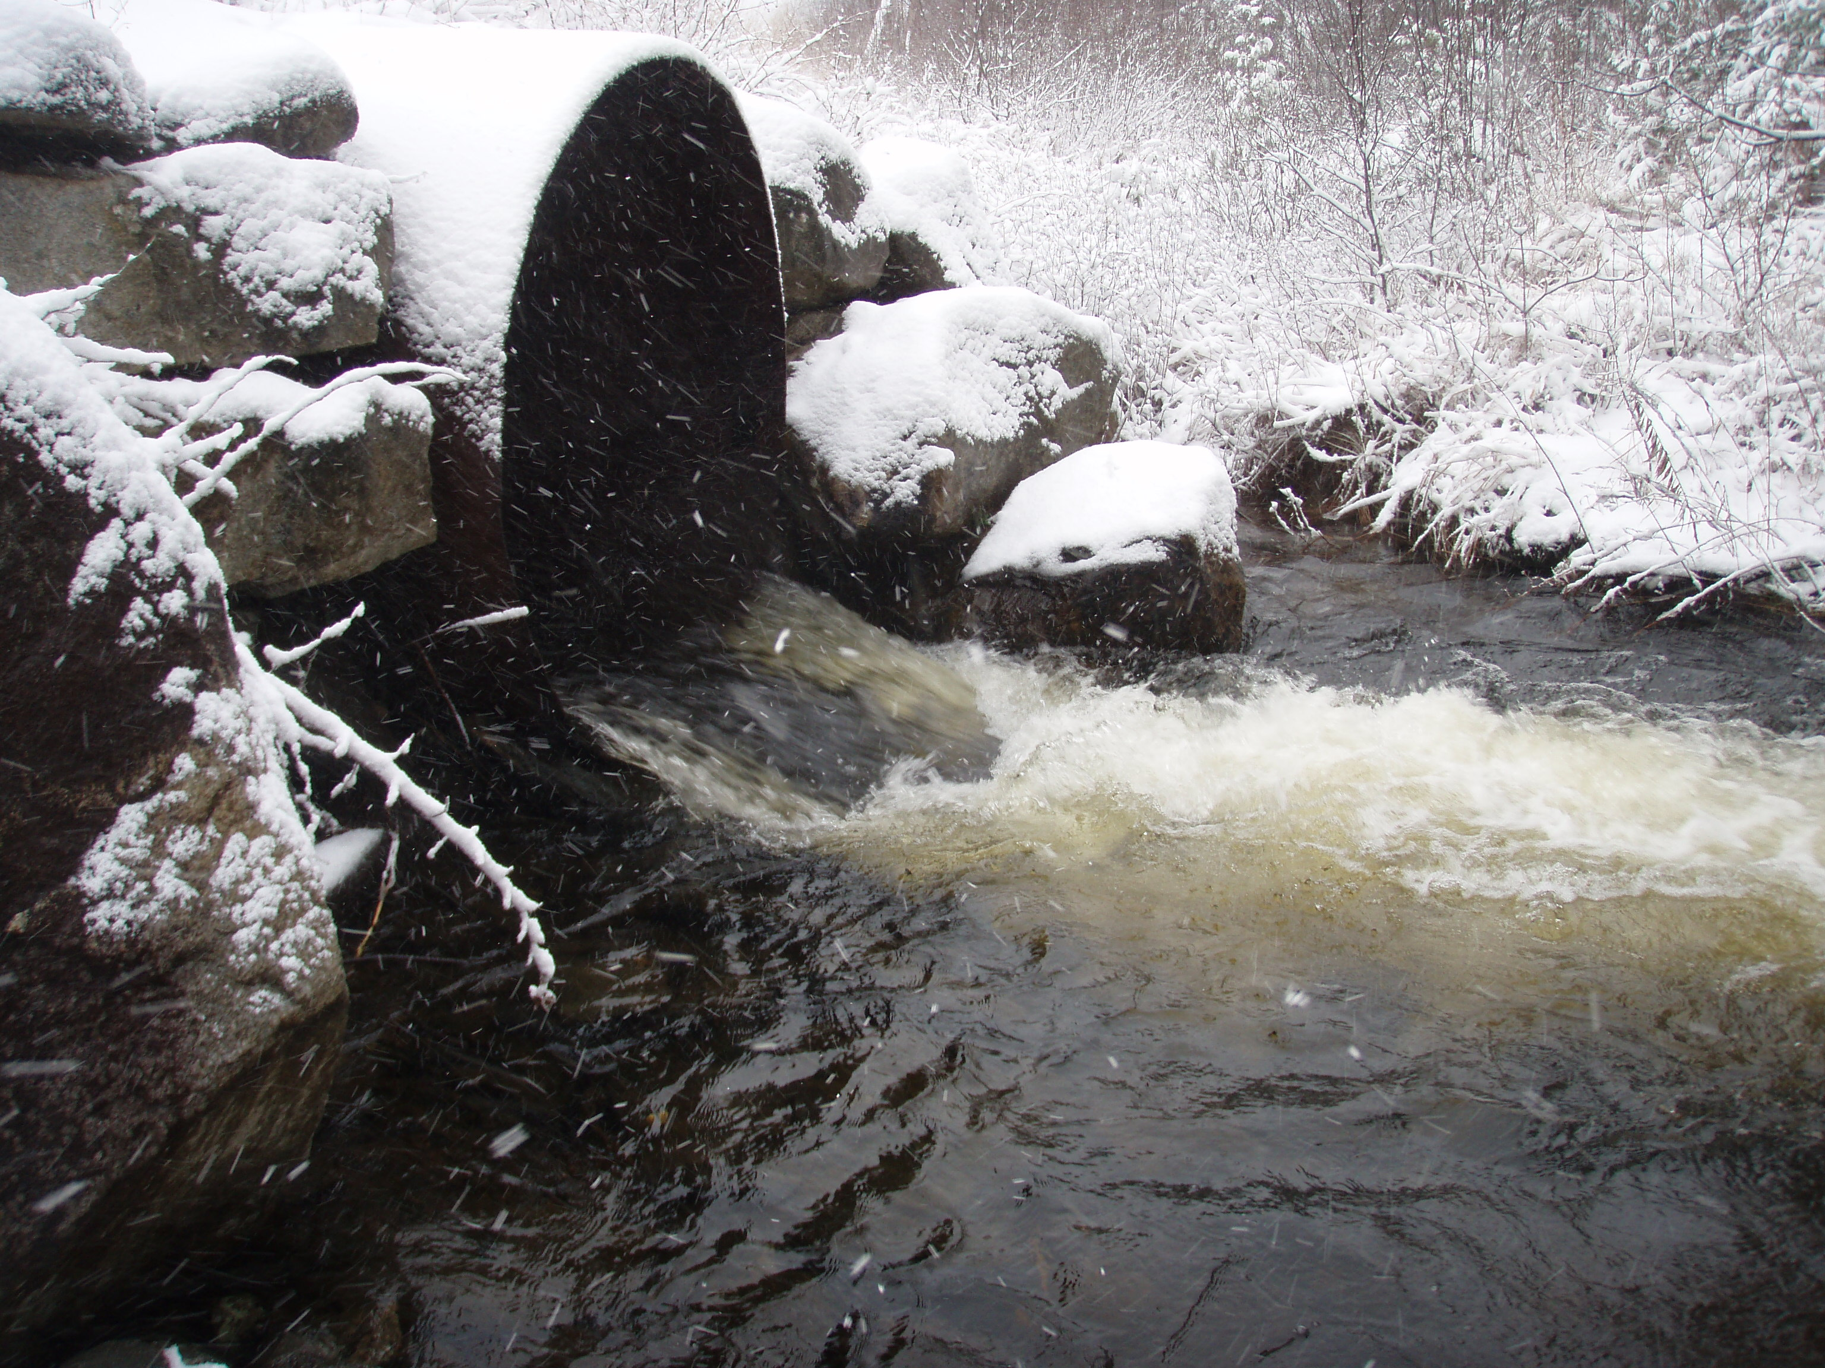
Jud Kratzer, VT Fish and Wildlife
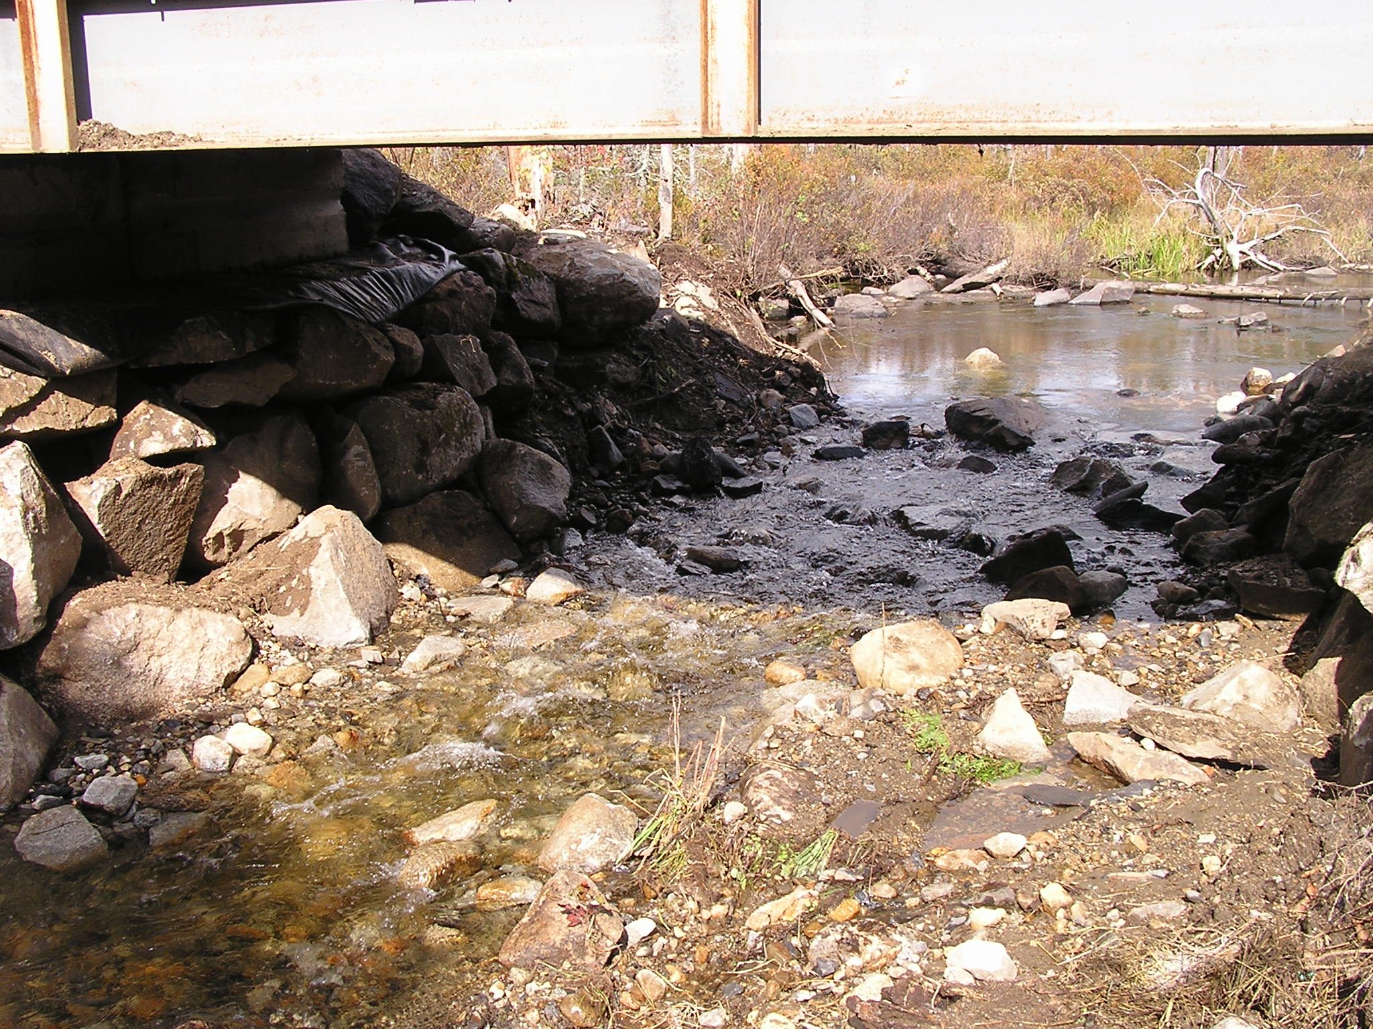

Neil Montieth, VT Forest, Parks, and Recreation

Feel free to use these photos. If you need a photo release form, please send one.

