Division of Natural Resources
324 4th Street
South Charleston WV 25303
Telephone (304) 558-2754
Fax (304) 558-2768
Joe Manchin III TDD (304) 558-1439 FrankJezioro
Governor TDD 1-800-354-6087 Director

September 17, 2010

Keith McGilvray
Appalachian Partnership Coordinator
US Fish and Wildlife Service
400 E Main St
White Sulphur Springs WV 24986

Dear Mr. McGilvray,

I am writing this letter on behalf of the WV Division of Natural Resources (DNR) in support of a project funding request submitted by Steve Brown – Program Manager for the WV Division of Natural Resources’ Stream Restoration Program. The funding is being requested through the National Fish Habitat Action Plan and the Eastern Brook Trout Joint Venture (EBTJV) for the Beaver Creek and Lamothe Creek Watershed Aquatic Passage Program in the Shavers Fork of Cheat River drainage of West Virginia.

Removal of the two fish passage barriers will allow free movement of brook trout from Beaver Creek and Lamothe Creek into Shavers Fork, where food resources are greater, and then back to the tributaries during summer months when temperatures may become lethal in the mainstem. Barrier removal will increase genetic diversity and has the potential to reconnect many miles of brook trout habitat, resulting in a more secure population.

As you know, West Virginia has participated in the EBTJV from its beginning in 2004. Previous funding secured through the EBTJV has allowed projects on several streams in West Virginia that have enhanced their ability to support brook trout.

West Virginia is committed to restoring and enhancing native brook trout populations in degraded streams where feasible and when funding is available. Evidence of this commitment can be found in DNR’s long history of treating acid impacted streams with limestone sand. Currently, over 300 miles of stream are being treated annually to improve the water quality of impacted streams to support trout. Approximately 80% of the treated stream miles support native brook trout. In addition we are currently working with several entities to improve habitat for native brook trout in the upper Shavers Fork watershed.

Mr. Keith McGilvray
Page 2
September 17, 2010

I would like to add that the two barrier removal projects are just a part of a much larger and comprehensive plan to restore native brook trout to the upper Shavers Fork watershed.

I am requesting your favorable consideration of the Beaver Creek and Lamothe Creek barrier removal projects. Should you have any questions, please contact me.

Sincerely,

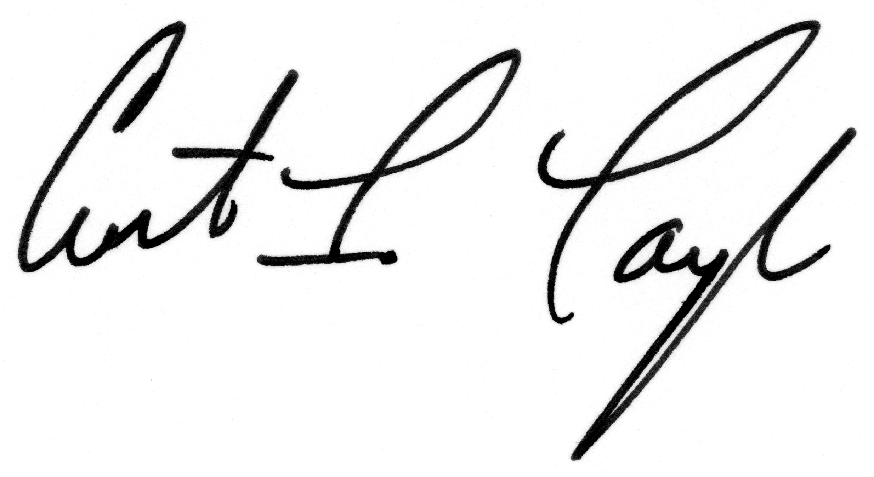
Curtis Taylor, Chief
Wildlife Resources

CIT:ms

