Wood additions into the Sheepscot, Narraguagus, Machias, and East Machias Watersheds, ME.

EBTJV/NFHAP

NFHAP Funding Request: $37,000
Total Project: $74,200
Federal Matching Contributions: $0
Non-Federal Match Contributions: $37,200

Washington County, Maine

U.S. Congressional District: Maine 2nd District

Applicant Organization:
Project SHARE
14 Boyton Street
Eastport, ME 04631

Project Officer:
Steven Koenig
Executive Director
skoenig@salmonhabitat.org
207 853-0931

Submitted On:
September 30, 2009

Sponsoring U.S. Fish and Wildlife Service Fisheries Office:
Maine Fishery Resources Office
East Orland, Maine 04431Project Officer:
Scott Craig
(207) 469-7300 (ext. 226) – Office
(207) 469-6725 – Fax
scott_craig@fws.gov

Creating complexity, Habitat enhancement, Felling trees, Extensive monitoring
- Project Description and Scope of Work
Maine’s brook trout and Atlantic salmon rivers have experienced dramatic changes over the last 200 years, mainly due to timber harvesting. One of the most sweeping changes was the removal, lack of recruitment, and subsequent attrition of large wood (LW). The result is that Maine rivers and their tributaries have very low loading of LW compared to the past and to other regions of the country. Magilligan et al. (2008) surveyed the coastal Atlantic salmon rivers of Maine and found that wood loading (pieces/distance) was remarkably low and log size was small. Further, riparian stands had trees too small to successfully recruit to the streams as functional large wood. LW has several roles in fluvial fish habitat: creating pools, retaining gravel, retaining nutrients, providing food for benthic macroinvertebrates, influencing current velocities and water depth, and providing cover for fishes at all flows and refugia during high water.

In 2007, Project SHARE in conjunction with the Department of Marine Resources (DMR) Bureau of Sea-Run fisheries and Habitat (BSRFH) and private land owners undertook a “chop and drop” large wood addition project. Wood was added to streams with the intent to increase habitat complexity and salmonid survival. The overarching goal of this project is to determine if increasing the amount of LWD increases the number of Brook Trout and Atlantic salmon for Downeast river drainages.

The basic study design is the Extensive Post Treatment Design (Hicks et al. 1991), which consists of pre and post monitoring of both a control and treatment reach. This approach provides the most information per unit of effort in the shortest amount of time, and provides spatial perspective that allows generalization to other areas (drainages).

This grant: (1) expands the LW treatment locations to include the Sheepscot drainage, along with treatment locations on the Machias, East Machias and Narraguagus River drainages, (2) adds nine additional LW treatment sites (some scouting needed) to attain a total of twenty-four treatment sites assuring the statistical power needed for scientifically defensible results, (3) enhances approximately 4 miles of stream, and (4) provide extensive pre and post fish response and geomorphology monitoring for one year.

B. Partner Information
Partner Name | In-Kind | Federal or Non- Federal | Partner | Role of Partner
DMR BSRFH | 37,200 | Non-Federal | State Agency | Pre & post monitoring
University of Maine at Machias |  | Non-Federal | Academia | Supporter
American Forest Management |  | Non-Federal | Private landowner | Supporter, Addition of large wood
Maine Department of Inland Fisheries and Wildlife |  | Non-Federal | State Agency | Supporter
Sheepscot River Watershed Council |  | Non-Federal | State Agency | Supporter

Spatial benefit of the grant request: This project will enhance four miles of stream within four different watersheds.
Number of partner categories: 5

- Project Timeline
To assure statistical power needed to gain scientifically defensible information twenty-four treatment sites are needed. Seven LW sites have been treated from 2007 to 2008 and eight sites are scheduled to be treated with LW this fall (2009). In addition to monitoring these fifteen LW sites, the NFHAP award will fund nine sites for LW treatment in 2010. Geomorphologic and fish response will be monitored before and after treatment. Annual reports will be prepared at the end of each calendar year.

Permits:
A memo of understanding and a right of entry has been signed by American Forest Management to allow the project to take place on their managed land. Project SHARE are covered under section (10(a)(1)(A) of the Endangered Species Act through a Gulf of Maine Distinct Population Segment (GOM DPS) Atlantic Salmon Regional Endangered Species Blanket Permit #697823. Incidental take reports are provided to Ecological Services (Old Town Field Office and Regional Office in Hadley, MA) each year for our restoration activities.

II. MAP OF PROJECT AREA
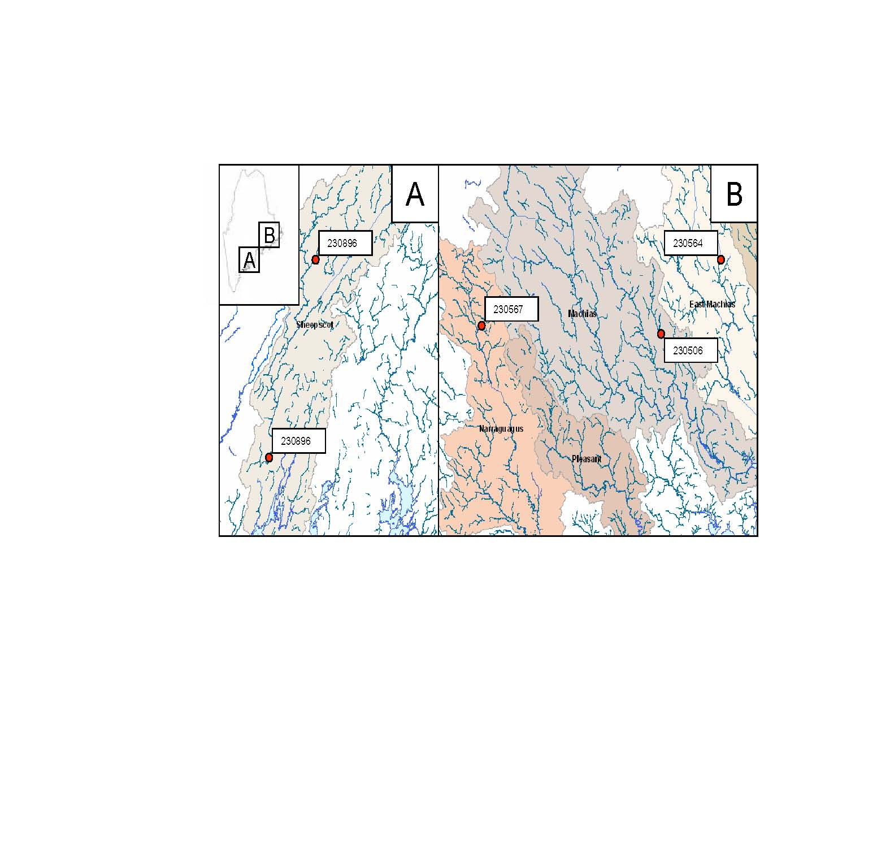
The study includes four watersheds (Sheepscot, Narraguagus, Machias, and East Machias). Five of the eight sites (red dots) to be treated in 2010 are located in HUC-6 sub-watersheds.

III. PHOTOGRAPH OF PROJECT AREA

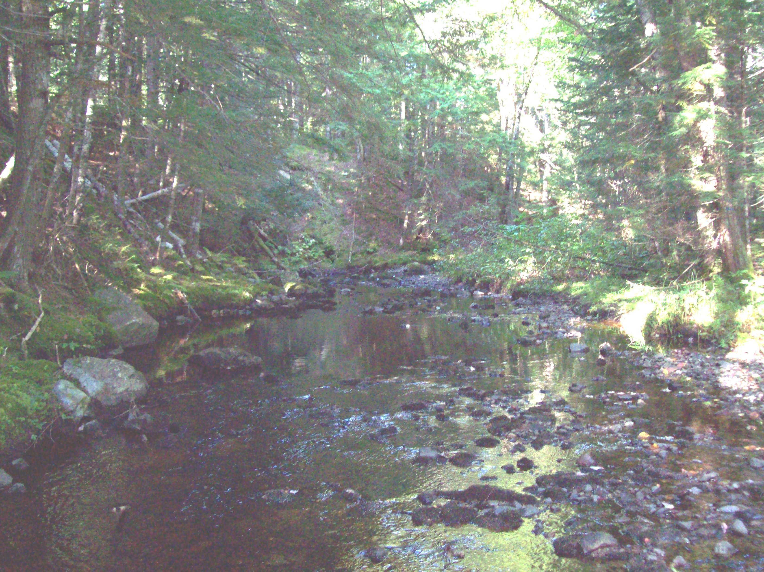
Photo from EBTJV subwatershed 230567, Narraguagus drainage. View upstream of pretreated treatment site. Note, the clearly over widened stream, lack of habitat complexity and lack of LW. This is a typical LW treatment site for Downeast Maine. Photo by Ben Naumann

IV. PROJECT BUDGET
Budget Item | Partner | Description of Activity | NFHAP Request | Non-Fed. Contribution | Total | Acres/ miles Affected
Supervisor, and office space | DMR BSRFH | Biologist II oversight (6 weeks) and office space |  | 17,700 | 17,700
LW treatment | Supplemental Environmental Projects (SEP) Funds | 2010 addition of large wood by GMO wood cutter | 6000 | 10,000 | 16,000 | 2 stream miles treated (2010)
LW treatment |  | On site supervision, LW manipulation | 10,000 |  | 10,000
LW site determination | DMR BSRFH | GIS Activities, and on the ground scouting | 2,000 |  | 2,000
Monitoring | DMR BSRFH | Pre & post Geomorphology monitoring & LW Survey | 10,000 |  | 10,000 | 6 stream miles treated/ control
Monitoring | DMR BSRFH | Pre & post fish response Monitoring | 9,000 |  | 9,000 | 6 stream miles treated/ control
Vehicle/ Mileage | DMR BSRFH |  |  | 3,000 | 3,000
Staffing | DMR BSRFH | 1 Seasonal staff & and intermittent personal |  | 6,500 | 6,500
 |  | Total | 37,000 | 37,200 | 74,200 | 8 miles

V. EVALUATION QUESTIONS
A. Conservation of Sustainable Brook Trout Populations
The LW project specifically addresses range wide EBTJV objectives 3 “improve 30% of reduced sub-watersheds to healthy classification and maintain 70% of reduced sub-watersheds in existing or improved condition by 2025”. Our goal is that this first LW enhancement project in Downeast Maine will pave the way for future larger scale habitat mediated population enhancements for brook trout and Atlantic salmon.

The project is consistent with four Priorities, Goals and Strategies outlined in EBTJV’s Conservation Plan for Maine.
- Priority 1 (Assessment), The project will “Maximize the contribution of wild brook trout stocks to the fishery” (Goal 1.3), via Strategy 4 “continue annual monitoring of wild brook trout streams for fishery independent estimates of population status, fish condition, and size/age structure”.
- Priority 2 (Habitat Protection), the project will “restore degraded brook trout habitats” (Goal 2.4) via Strategy 1 (“increase collaborative partnerships with State, Federal, Tribal and private entities to implement stream restoration projects”) and Strategy 2 (“monitor efficacy of implemented projects for ecological responses and indicators of success”). Furthermore, our activities will “prevent continued degradation of brook trout habitats” (Goal 2.5) via Strategy 1 (“work with landowners to…protect or restore stream bank stability, eliminate erosion and sedimentation concerns, maintain shading and thermal regimes, and reduce rapid precipitation runoff”).
- For Priority 3 (Outreach), our project “raises awareness of Maine’s wild brook trout resources” (Goal 3.1) by “encourage(ing) volunteer…participation in assessment and monitoring programs” (Strategy 2) and will “foster public/private collaborative stewardship of brook trout resources” (Goal 3.2) by “inform(ing) the public and encourage(ing) interest and participation in addressing environmental issues” (Strategy 1). Results from this project will “contribute toward public policy that includes brook trout population health and sustainability as positive indicators toward improving or enhancing environmental quality” (Strategy 3).
- For Priority 4 (Recreational Fishing), this project will “Optimize brook trout angling opportunities” (Goal 4.1)

Maine’s action plan is not clearly specified however there general mission is to “examine the health of wildlife and prescribe actions to conserve wildlife and vital habitat before they become more rare…” This project specifically addresses the importance and enhancement of vital habitat to assure population persistence for brook trout and federally endangered Atlantic salmon.

B. Threatened and Endangered Species and Species of Conservation or Management Concern
Atlantic salmon (Salmo salar) have been listed federally as endangered since 2000 has genetically distinct populations within the Gulf of Maine. In the most recent status review (2006), and in the new proposed rule (2008) and critical habitat (2008), stream complexity has been identified as a critical to functioning productive salmon habitat. Furthermore, studies in Maine estimated overwinter survival of large Atlantic salmon parr that were lower than literature values (Legault 2004). Higher winter survival has been linked to habitat complexity in salmonids, including Atlantic salmon (Cunjak 1996). The lack of habitat complexity has the potential to limit smolt production and population recovery (Fay et al. 2006). Therefore, adding habitat complexity can increase abundance for all Atlantic salmon juvenile life history stages, along with an increase spawning habitat for returning adults.
The bald eagle, listed as threatened is also gaining from this project by increasing the availability of fish species in streams.
The state endangered pygmy snaketail dragonfly is found in the Machias river watershed and inhabits fast flowing water. It is possible by reducing the wetted channel of the stream faster flowing water would move through the system, therefore creating critical habitat for the pygmy snaketail.
Along with Atlantic salmon having a distinct genetic population in the project area, brook trout have a distinct genetic population because the project area has never been stocked.
Species of conservation concerns from within the project area consist of brook trout and the American eel.

C. Project Benefits:
The EBTJV map for the LW project location is labeled as intact. The watersheds that the project encompasses have the highest watershed EBTJV priority ranking of .66, with that said this project will enhance habitat in these altered tributaries. Five or the eight sites to be treated next year are located in HUC-6 sub-watersheds (see map above for locations); the other three sites still need to be determined.
The majority of the treatment sites are on second order streams, with small populations of brook trout, these populations are especially vulnerable to extirpation after catastrophic spring floods or summer droughts. Addition of LW is intended to mitigate the effects of disturbances by reducing flow, creating pools and promoting deposition and retention of spawning gravel, thus improving the likelihood of population persistence. The project will provide expansion of existing brook trout habitat because suboptimal habitat (shallow runs) will be changed into preferred brook trout habitat (wood structure and pools).
There is a very high probability of long-term success for this project to benefit Downeast Maine brook trout populations. This research pioneers adding LW to low gradient coastal brook trout streams, however there are countless number of successful LW addition projects from which brook trout populations have benefited.

- Endurance of Benefits:
In the Machias watershed it is estimated that 10% of the proposed project is protected through the Machias River Corridor Initiative.
Smallmouth bass (Machias, East Machias, and Narraguagus) and largemouth bass (East Machias) are found within the watersheds of the project, however no life history stages of these two species have been found in any project site. The bass species do have access to project sites however the project sites are in not in preferred bass habitat.
Currently within the project watersheds Atlantic salmon fry are stocked annually, at a density of 100 fish per habitat unit (100m²).

- Management Assets:
This project was created using an adaptive management frame work. In a survey and analysis of large wood in the coastal Atlantic salmon rivers of Maine, Magilligan et al. (2008) found wood loading remarkably low, wood size small, and riparian stands with trees too small to successfully recruit to the streams as functional large wood naturally. After the above was determined the “chop and drop” LW project was implemented.
The public has unrestricted access for recreational angling to all of the project sites.
The extensive geomorphologic data being collected on pre and post treatments is a tailored quantitative approach to investigating changes in stream morphology. The longitudinal profile includes measurements at 20m intervals within the site and at each habitat type break. . Along with the longitudinal profile, cross sections will be taken every 20m within the site. Shelter availability measurements (a measure of embeddedness) have been collected using a new technique which uses a plastic tube to measure the interstitial space between substrate types (Finstad 2007). Surveys of the natural and felled trees’ orientation, tree type and movement will be collected annually using TWF Monitoring Program methods manual for the large woody debris survey (1999). For salmonid species we are estimating abundance using standard three-pass electrofishing, compute mean wet weights from all individuals collected, and estimate biomass as a product of density and weight.
We expect LW additions to increase the probability of maintaining sustainable fisheries. Currently, 2.5 percent of the trout we have collected from pre-treated LW sites are of legal harvestable size (> 6 inches in length). Because the LW additions will create habitat complexity we anticipate an increase in recruitment and mean size, therefore creating high potential for angler success.
This project already has and will continue to have a strong educational component with the public and with other agencies (Maine Inland Fisheries and Wildlife, and Downeast Salmon Federation). Presentations of the project have been given at quarterly Project SHARE meetings, and at a LW conference in Rutland Vermont. The public has volunteered their time to help collect data and have been educated on the project goals. We have also collaborated with the University of Maine at Machias to give project presentations and allow students to volunteer for field related tasks.
Project monitoring will take place for 3 to 5 years after treatment, this award will fund 1 year of geomorphologic and fish response monitoring. More reliable results will be obtained in the third year and beyond, as the LWD installations have time to affect the geomorphology of the stream. The evaluation of the project will determine if should continue the LW additions and at what scale.

References
Cunjak, R.A. 1996. Winter habitat of selected stream fishes and potential impact from land-use activities. Can. J. Fish. Aquat. Sci. 53 (Supplement 1): 267-282.
Fay, C. A., Bartron, M, Craig, S., Hecht, A., Pruden, J., Saunders, R., Sheehan, T. and Trial, J. 2006. Status Review for Anadromous Atlantic Salmon (Salmo salar) in the United States. National Marine Fisheries Service/ U.S. Fish and Wildlife Service Joint Publication. Gloucester, MA 294 pp.
Finstad, A.G. S. Einum, T. Forseth, O. Ugedal. 2007. Shelter availability affects behaviour, size-dependent and mean growth of juvenile Atlantic salmon. Freshwater Biology. 10. 1365-2427

Hicks, B. J., J. D. Hall, P. A. Bisson, and J. R. Sedell. 1991. Responses of salmonids to habitat changes. Am. Fish. Soc. Spec. Publ. 19. 483-518.

Legault, C.M. 2004. Population viability analysis of Atlantic salmon in Maine. Am. Fish. Soc. 134. 549-562

Magilligan, F.J., K.H. Nislow, G.B. Fisher, J. Wright, G. Mackey, M. Laser. 2007. The Geomorphic function and characteristics of large woody debris in low gradient rivers, coastal Maine, USA. Geomorphology. 97. 467-482

Schuett-Hames, D., A.E. Plues, J. Ward, M. Fox and J. Light. 1999. TWF Monitoring Program methods manual for the large woody debris survey. Prepared for the Washington State Department of Natural Resources under the Timber, Fish and Wildlife Agreement. TFW-AM9-99-004. DNR #106. March.

