Partnering with the NFHAP and EBTJV to restore aquatic organism passage within Wolf Laurel Branch, NC

Project Location: Nantahala National Forest, Graham County, NC
- Congressional District of Project: 11
- Congressional District of Applicant: 11
EBTJV / NFHAP Funding Requested: $50,000
- Total Project Cost: $297,000
- Total Federal Matching: $240,000
- Total Non-Federal Matching: $7,000

APPLICANT
Organization: U.S. Forest Service, National Forests in North Carolina
Project Officer: Jason Farmer, Fisheries Biologist, Nantahala National Forest
Street: 1070 Massey Branch Road
City, State, Zip: Robbinsville, North Carolina 28771
Telephone Number: 828-479-6431 x 4101
Fax Number: 828-479-6784
EMail Address: jfarmer@fs.fed.us

U.S. Fish and Wildlife Service Sponsoring Office
Fish and Wildlife Service Office: Wadmalaw Island Fish & Wildlife Mgmt. Assistance Office
- Project Officer: Walter (Tripp) Boltin
Street: P.O. Box 69
- City, State, Zip: Wadmalaw Island, SC 29487
- Telephone Number: 843-819-1229
Fax Number:
EMail Address: Walter_Boltin@fws.gov

U.S. Fish and Wildlife Service FONS Database Project Number: 42330-2011-154

Coordination Completed with US Fish and Wildlife Service Fisheries Office (Check One):
X Yes 08/09/2011 Date Coordination Began
No
I. PROJECT DESCRIPTION, SCOPE OF WORK, AND PARTNER INFORMATION

- Project Description and Scope of Work

Wolf Laurel Branch is located within the Santeetlah Creek watershed on the Cheoah Ranger District of the Nantahala National Forest (Figure 1). Currently, the Forest Service is designing a bottomless arch for the Sand Creek crossing. Construction on this crossing is scheduled to begin in the spring of 2012. Wolf Laurel Branch is a tributary of Sand Creek. Both streams support southern Appalachian brook trout . Replacement of the Wolf Laurel Branch crossing would eliminate all artificial barriers within the Sand Creek drainage.

Two crossings on Forest Service Road 81F (FSR 81F) have been identified as barriers to the upstream movement of brook trout (Figure 1). Improvement of these two crossings will reconnect existing populations of southern strain brook trout within approximately 2 miles of suitable habitat. This proposal addresses the crossing over Wolf Laurel Branch (Figure 2). The crossing over Sand Creek is currently funded by a Highway Transportation Aquatic Passage grant.

Recent monitoring has indicated that the Santeetlah Creek watershed is sensitive to acid deposition and has been negatively affected by the construction of a scenic highway. Furthermore, two brook trout subpopulations have been extirpated since the 1990s (upper Santeetlah Creek and Little Santeetlah Creek). This watershed has been identified by the U.S. Forest Service, North Carolina Wildlife Resources Commission, and Trout Unlimited as a priority watershed for native fish conservation. As such, this project will be the second of many projects to enhance and restore brook trout within the Santeetlah Creek watershed.

- Proposed Methods (Max Characters: 350)

This project proposes to replace the existing double culverts with a bottomless structure to provide passage for brook trout and native nongame species. The U.S. Forest Service would conduct site surveys and design of the new crossing structure. A contract would be let for the replacement of the existing crossing during the summer of 2012.

- Project Timeline

Project design will begin October 1, 2011, and is expected to take approximately five months to complete. Crossing replacement will begin in March 2012 and take approximately nine months to complete. It is anticipated that post-project monitoring could begin as early as the fall of 2012, and continue into at least 2014

D. Proposed Accomplishment Summary (Max Characters: 500)

Based on hydrologic and engineering analyses, bankfull width at this crossing is 14 feet. The drainage area for this structure is approximately 282 acres (Figure 2), which contributes to Q50 and Q100 values of 372 and 464 cfs, respectively. Upon completion of site-specific surveying for project design, a bottomless arch or bridge will be installed. Replacing these double culverts with a bottomless structure will eliminate the last remaining artificial barrier for brook trout within the Sand Creek sub-basin.

E. State the Importance of the project to the Resource (Max Characters: 350)

Future management for Santeetlah Creek watershed includes identification of streams affected by acid deposition, experimental stream liming where appropriate, highway runoff control, and brook trout restoration. This project removes the final barrier for aquatic passage in the Sand Creek sub-basin and provides access to available habitat for native brook trout. Additionally, the Wolf Laurel Branch brook trout population may serve as a source population for brook trout for restoration efforts within the entire Santeetlah Creek watershed.

F. Problem and Specific Cause of the Problem (Max Characters: 350)

Based on site-specific surveys, culvert slope and length have been determined to be the primary barrier to the upstream movement of brook trout at the Wolf Laurel Branch crossing. Culvert outlet drop is also a barrier to juvenile brook trout. The use of two corrugated metal pipes at this crossing also disrupts the natural stream hydrology by trapping large woody debris and substrate upstream of the crossing.

G. Objective of the Project with Reference to the Problem (Max Characters: 350)

The objective of this project is to replace the existing double culverts with a bottomless structure to provide passage for brook trout and native nongame species. This project would enhance connectivity within a 2-mile reach of southern Appalachian brook trout habitat.

H. Partner Information

Partner Name | Contribution  In-Kind | Contribution  Cash | Federal or Non- Federal | Partner  Category | Role of Partner
U.S. Forest Service | $5,000 |  | Federal | Federal Agency | Permitting, NEPA documentation
HTAP*/Legacy Roads** funding |  | $225,000 | Federal | Federal Agency | Project implementation
EBTJV/NFHAP Grant |  | $50,000 | Non-Federal | Joint Venture | Project implementation
North Carolina Wildlife Resources Commission | $5,000 |  | Non-Federal | State Agency | Target species inventory & monitoring
Trout Unlimited | $2,000 |  | Non-Federal | Conservation Group (National) | Technical guidance & outreach
*HTAP = Highway Transportation Aquatic Passage program that allocates Federal Highway Administration
funding to the Eastern Federal Lands program by regional priority. The NFsNC has received an average of
$150,000/year in HTAP funding for the last several years. This project is the Forest’s top priority for HTAP funding proposals.
**Legacy Roads funding is derived from Congressional earmarks targeted at reducing road maintenance backlogs, specifically addressing reconnection of fisheries populations and clean water initiatives. The NFsNC has received an average of $350,000/year for the last several years. If HTAP funding is not received, the project will be become the Forest’s top Legacy Roads project.

II. MAP OF PROJECT AREA

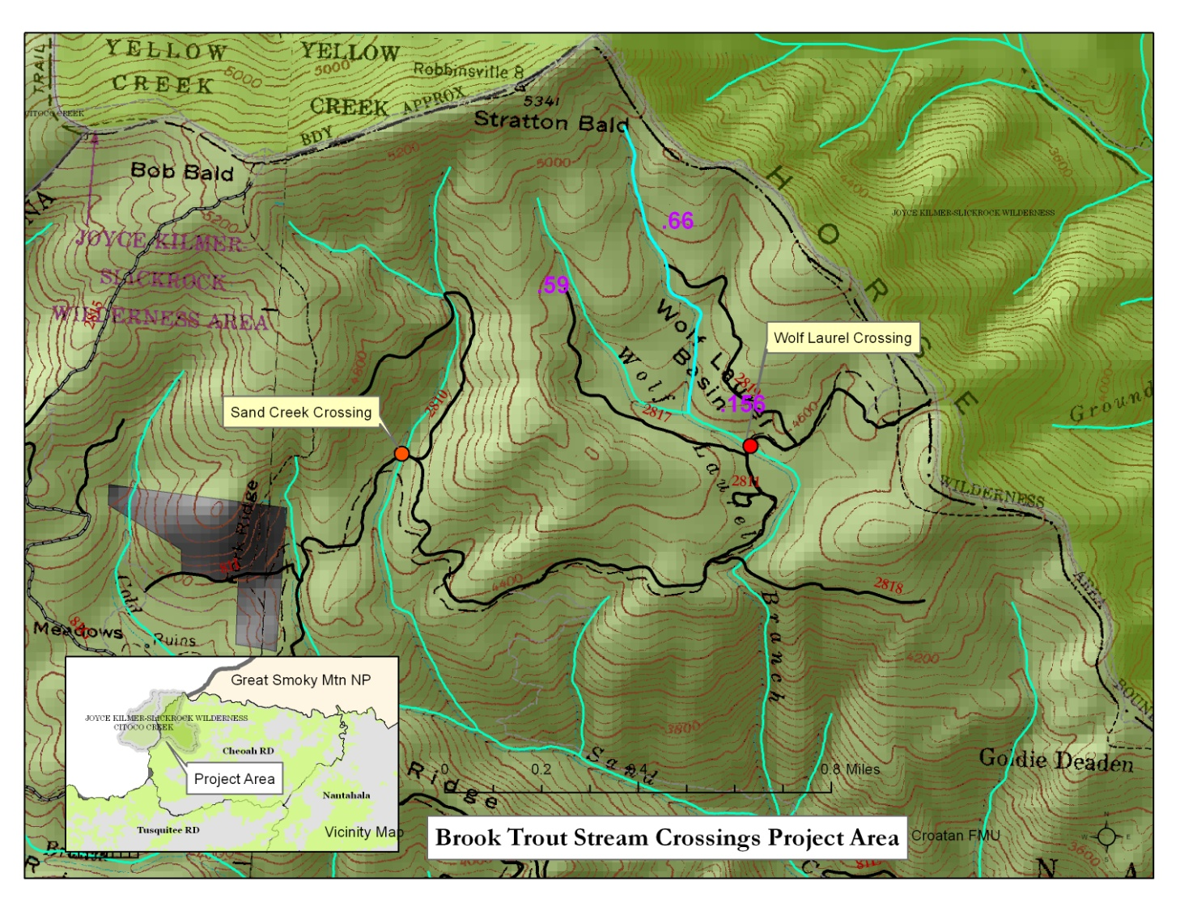

III. PHOTOGRAPH(S) OF PROJECT AREA (no more than 2, please provide credits and attach photo release forms)

Figure 2. Culvert outlet, existing crossing at Wolf Laurel Branch, Forest Highway 81F.

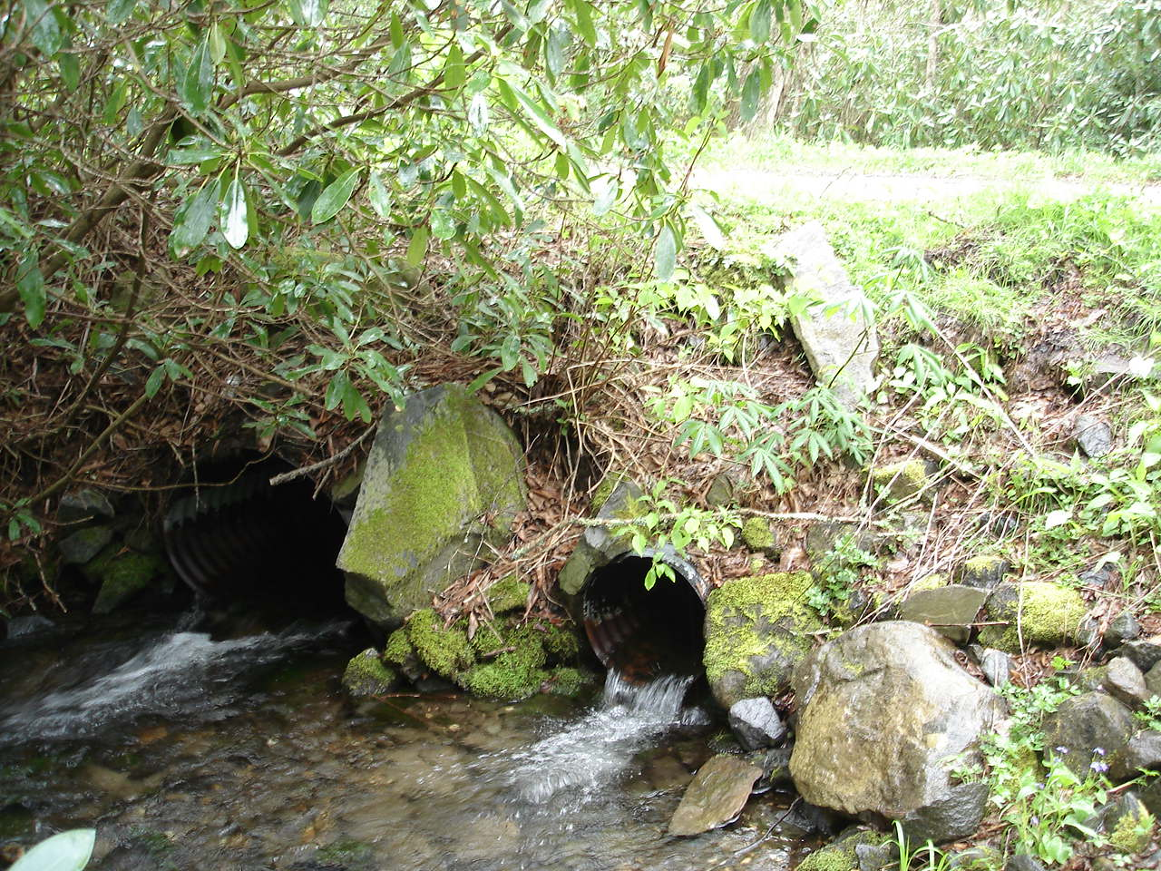
Photo by U.S. Forest Service, May 14, 2008

IV. PROJECT BUDGET

A. General Requirements

U.S. Forest Service in-kind contributions ($10,000) have been used to initiate the National Environmental Policy Act (NEPA) review. The final documents are expected to be completed by January 1, 2012. Additionally, U.S. Forest Service in-kind contributions will be used to develop the construction contract for this project. These tasks will be completed by March 30, 2012. The EBTJV/NFHAP funds will be used to fund the design of the new stream crossing structure. HTAP/Legacy funds will be used to implement the project (replace the crossing) through September 30, 2012. NCWRC in-kind funds will be used to complete initial population inventory and post-implementation monitoring through at least 2014.

B. Budget Table

Partner Name | Partner Category * | Activity of Partner ** | Budget Category*** | EBTJV  NFHAP Request | Non-Federal Contribution |  | Federal Contribution |  | Total Contribution | Acres/Miles Affected
 |  |  |  |  | In-Kind | Cash | In-Kind | Cash
U.S. Forest Service | Federal Agency | NEPA | Personnel |  |  |  | $10,000 |  | $10,000
 |  | Restoration/Site Survey | Personnel | $2,500 |  |  | $2,500 |  | $5,000
 |  | Monitoring | Personnel |  |  |  | $2,500 |  | $2,500
 |  | Culvert Removal | Design/ Construction | $47,500 |  |  |  |  | $47,500 | 2.0 Miles
HTAP*/Legacy Roads** funding | Federal Agency | Culvert Removal | Design/ Construction |  |  |  |  | $225,000 | $225,000
North Carolina Wildlife Resources Commission | State Agency | Monitoring | Personnel |  | $5,000 |  |  |  | $5,000
Trout Unlimited (Asheville Field Office and TU State Council | Conservation Group (National) | Technical guidance & outreach | Design/Construction |  | $1,400 |  |  |  | $1,400
 |  |  | Other |  | $600 |  |  |  | $600
Total Contribution |  |  |  | $50,000 | $7,000 |  | $15,000 | $225,000 | $297,000 | 2.0 Miles

*Partner Categories - Federal Agency, State Agency, Local Government, Conservation Group (Local), Conservation Group (National), Native American Tribe, Private Landowners, Corporations/Businesses

**Activity - Acquisition, Fish Ladder, Dam Removal, Culvert Removal, Restoration, Monitoring

***Budget Categories - Equipment, Construction, Contractual, Personnel, Travel, Supplies, Other.

NOTE: This is not a Federal Grant program and therefore does not exclude non-federal match used here from being matched to other Federal Grant sources to leverage funds for the project. Indicate if partnering contributions are in-kind or new cash. NFHAP requests should illustrate how the dollars will be spent and by what organization. Overhead such as utilities, office space, and salary to prepare applications and develop partnerships will not be funded with NFHAP funds and should not be a line item or built into the project. Activities that directly relate to completion of the project such as travel and salary to do design work let and/or monitor contracts are allowable expenses with NFHAP funds but should not constitute more than 10% of the funding request. For more information on the use of NFHAP funds, please see http://www.fws.gov/policy/717fw1.html.

- EVALUATION QUESTIONS
Please refer to the website (www.easternbrooktrout.org) for application instructions.

- Please provide the GPS Coordinates for the project in UTM NAD 83.

Easting 228979
Northing 3917405

- Please list the type of project. Examples include: in-stream habitat, riparian planting, fencing, acid mine drainage restoration, fish passage, reintroduction, assessment, etc.

This project involves restoring fish passage by replacing two tandem corrugated metal pipes with a bottomless structure.

- Are brook trout currently present at the project site or in the project stream? If not, were brook trout historically present? Is the habitat known to be suitable for restoration / reintroduction of brook trout?

Native, southern Appalachian brook trout are currently located within Wolf Laurel Branch.

- Please describe how the project will provide for the expansion or improvement of existing habitat?

This project will provide year-round connectivity to available habitat in Wolfe Laurel Branch and the Sand Creek sub-basin. In addition to providing increased access spawning and rearing habitats, improved connectivity will improve gene flow within the population. By restoring the natural hydrological regime, this project will improve aquatic habitats within Wolf Laurel Branch and downstream.

- Does the project include a protection component? If so, explain how the project sufficiently protects brook trout habitat. Does the project include fee simple land purchase or easements?

This project is permanently protected; the project area is located on land owned by the U.S. Forest Service. These lands are managed under the Nantahala/Pisgah Land Resources Management Plan which provides protective measures to maintain water quantity and quality.

- What percentage of the watershed above the proposed project is protected in perpetuity?

100%

- List the specific regional EBTJV habitat objectives addressed by the project and describe how the project will contribute towards them.

Objective 5. Strengthen brook trout populations in 105 subwatersheds classified as reduced by 2012 – Southern Region = 30.

This project will strengthen a brook trout population within a reduced watershed by 2012 by restoring fish passage within Wolf Laurel Branch. Restored passage will enable spawning brook trout to access historic spawning and rearing habitats upstream of the existing stream crossing.

Objective 6. Maintain 1,372 reduced subwatersheds in existing condition by 2012 – Southern Region = 189.

This project will maintain the existing brook trout population within Wolf Laurel Branch by ensuring that the population continues to produce strong year classes.

- Please state whether the project is an enhancement, restoration or protection project.

Enhancement

- State which, if any, EBTJV priority the project addresses:

Priority 1. Protect brook trout populations across the eastern United States.

Priority 2. Restore brook trout populations where original habitat conditions exist and where habitats can be restored.

Priority 3. Monitor and evaluate brook trout population responses to habitat protection, enhancement and restoration projects.

Priority 5. Increase recreational fishing opportunities for wild brook trout.

- What is the EBTJV subwatershed number and priority ranking for the proposed project watershed for the type of project (enhancement, restoration or protection) being proposed?
Watershed # = 3701428
Priority Score = 0.23
Map = Enhancement
Note: Proposed projects in watersheds that are classified as “other subwatersheds” and shown in grey on the state priority maps are not eligible for funding for that type of project.

- Will the completed project benefit any federally listed threatened or endangered species?

No

- Will the completed project benefit any state listed threatened or endangered species?

No

- Will the project provide or enhance connectivity to or within an intact subwatershed?

The project provides connectivity within the Sand Creek sub-watershed; however, this sub-watershed is not considered intact by the Eastern Brook Trout Joint Venture classification structure.

- What are the root causes of the watershed degradation and which of these are addressed by the project?

Fragmentation of habitat, acid deposition, introduction of rainbow trout and brown trout, and road/highway runoff are the root causes of habitat degradation within Santeetlah Creek Watershed. Habitat fragmentation is the source of degradation within the Sand Creek sub-basin; this project addresses that issue.

- Describe the plans for project monitoring and evaluation.

The new crossing structure will be evaluated during construction and after completion to ensure it meets the required hydrologic design features. Resident brook trout populations will be marked downstream of the crossing with adipose fin clips. Surveys downstream and upstream of the new crossing will be done to document the movement of previously marked individuals into the restored stream reach at least two years post crossing installation.

- Describe the expected effect on the brook trout population. To what degree will the project strengthen the brook trout population status?

Restoration of fish passage at this crossing is expected to significantly improve the brook trout population’s access to spawning and rearing habitat within the headwaters of Wolf Laurel Branch. This project is expected to strengthen one of only three brook trout populations remaining within the Santeetlah Creek watershed and provide a source population for future expansion and restoration efforts within the watershed.

- Please describe the long term benefit of the project and provide an estimate of the length of time the project is expected to be effective. If a plan for long term maintenance is necessary, please describe it.

This project will provide unimpeded access to the headwaters of Wolf Laurel Branch. Furthermore, the elimination of the double culvert will permanently reduce the potential for culvert fouling and allow large woody debris and substrate to pass through the crossing. Bottomless road crossing structures have proven to be more hydrologically stable on the forest and require lower maintenance. The structure will be documented within the Forest Service’s infrastructure database (INFRA) and periodically monitored and maintained as needed.

- What size stream does the project benefit? Is this stream a tributary or mainstem habitat?

The estimated bankfull width of Wolf Laurel Branch is 14 feet. This stream is a tributary of Sand Creek. This project will provide access to approximately 2.0 miles of suitable habitat for the southern Appalachian brook trout population.

- What competitive non-native or invasive fish are in the watershed with access (no barrier) to the proposed project?

No competitive non-native fish occur within the proposed project area.

- Are other strains of brook trout, salmonids, or exotics present in the proposed watershed? Where (e.g. upstream, downstream, and distance from project site) does the stocking take place with respect to the project site?

Northern strain brook trout have been stocked within the Santeetlah Creek watershed but not within the Sand Creek sub-basin. Additionally, natural barriers keep brown and rainbow trout downstream of the project’s sub-basin.

- Please describe the current status of the project. Is it planned, permitted and ready to begin? Please identify the targeted month and year for project completion.

The environmental review (NEPA) is approximately 90% complete. Completion of the NEPA documentation is expected by January 1, 2012. The new crossing design will be complete and a contract let by March 30, 2012. Construction will occur during the summer of 2012 with a completion date of September 30, 2012.

- Will public access be allowed at the project site? If so, what kinds of recreational activities are allowed - public fishing, nature trails, etc?

Yes. Forest Service Road 81F is a primary access route to the Joyce Kilmer/Slickrock Wilderness Area. This road is open to vehicle traffic from March through December of each year. The road is closed during the freeze/thaw period of winter to minimize road damage and erosion. This road will be temporarily closed during construction to increase the efficiency of the contractor and eliminate the cost of constructing a detour route. Wolf Laurel Branch is open to public fishing year-round under North Carolina Wildlife Resources Commission Wild Trout Waters regulations.

- What is the recreational quality of the potential fishery?

Wolf Laurel Branch and Sand Creek provide one of the few locations within the Santeetlah Creek watershed where anglers can easily access southern Appalachian brook trout waters. As a primary access route to designated wilderness, this area also appeals to those anglers who wish to catch the native brook trout rather than an introduced species. Thus, the recreational quality of the fishery is high.

- Describe any outreach or educational components of the project and how many individuals / students will be served.

The NCWRC and USFS will partner to develop an educational kiosk at either the Sand Creek culvert replacement location, Wolf Laurel Branch culvert replacement location, or other suitable location, to showcase the importance of restoring brook trout habitat in the Santeetlah Creek watershed, the species and habitats being restored, and the partnerships used in that process. Furthermore, this kiosk will highlight the diversity of aquatic species within the watershed and the importance of watershed protection. Trout Unlimited will publicize the project to membership within North Carolina (~3,600 members), and submit an article on the project in the context of southern Appalachian brook trout restoration to Trout Magazine. Trout Unlimited will also co-host an “open passage” event with the USFS and NCWRC at project completion.

- If applicable, please briefly describe how this project will promote adaptation to climate change.

Water temperature monitoring in 2008 within Sand Creek (downstream of the proposed project area) indicated that this stream remains cold throughout the summer months. Furthermore, the headwater streams begin at elevations of >4500 feet above mean sea level. Enhancement of existing populations within these high elevation habitats should increase the species’ ability to persist within the Santeetlah Creek watershed.

- Please explain how this project is a good investment of funds, using a quantitative approach where possible and the recreational and / or economic value of the project.

Approximately 60% of Graham County is within the National Forest System. As such, this community is a popular destination for outdoor enthusiasts of all types. As more exploitative land uses become less attractive, outdoor recreation has become a key component of the community’s economy. Recreational fishing in Graham County has become a primary attraction and provides additional revenue to the county. The NCWRC documented that wild trout fisheries generated $55.2 million to local economies in 2008 (Responsive Management 2009). Enhancement and restoration of the native brook trout fishery resources within the Santeetlah Creek watershed, and specifically with Wolf Laurel Branch for this project, provides an improved fishery resource for the recreational angler.

- SUPPORTING DOCUMENTATION:

- Literature Cited

- References to published interagency fishery or aquatic resource management plans.

Besler, D. A., A. P. Wheeler, and M. G. Martin. 2007. A summary of wild trout
population monitoring in the Tellico River watershed, 1994−2006. North Carolina
Wildlife Resources Commission, Raleigh.

NCWRC. 1989. Casting the future of trout in North Carolina: A plan for managing North
Carolina’s trout resources. Division of Boating and Inland Fisheries, Raleigh.

NCWRC. 2003. Brook trout management in North Carolina. North Carolina Wildlife
Resources Commission, Raleigh.

Responsive Management. 2009. The economic impact of mountain trout fishing in North Carolina. North Carolina Wildlife Resources Commission, Federal Aid in Sport Fish Restoration, Project F-86, Final Report, Raleigh.

