Restoration of Natural Hydrology and Habitat Complexity
in the Machias Rivers, Maine: EBTJV

Project Location (Maine, Washington County, Town of Wesley and several townships in the upper Machias River Watershed)
- Congressional District of Project: Maine 2nd District (Congressman Michaud)
- Congressional District of Applicant: Maine 2nd District (Congressman Michaud)

NFHAP / EBTJV Funding Requested: $33,000

Total Project Cost: $72,841
Total Federal Matching: $10,361
Total Non-Federal Matching: $22,080 in kind + $7500 cash = $29,580

Applicant:
Organization: Project SHARE
Project Officer: Steven D. Koenig
Street: 14 Boynton Street
City, State, Zip: Eastport, Maine 04631
Telephone Number: (207) 853 -091
Fax Number: (207) 853-0931
EMail Address: skoenig@salmonhabitat.org

U.S. Fish and Wildlife Service Sponsoring Office
Fish and Wildlife Service Office: Maine Fisheries Resource Office
- Project Officer: Scott Craig
Street: 306 Hatchery Road
- City, State, Zip: East Orland, Maine 04431
- Telephone Number: (207) 469-6701 ext 226
Fax Number: (207) 469-6725
EMail Address: Scott_Craig@fws.gov

USFWS FONS Database Project Number: FONs I.D. 53371-2011-368
Coordination Completed with Sponsoring U.S. Fish and Wildlife Service Office (Check One):
X Yes August 22, 2011 Date Coordination Began
No

I. PROJECT DESCRIPTION, SCOPE OF WORK, AND PARTNER INFORMATION

- Project Description Project SHARE is engaged in habitat restoration in priority sub-watersheds in the Machias River. To date 125+ road crossings have been replaced with bankfull spanning open bottom arch culverts, bridges or road decommissions. The next phase of watershed restoration involves addressing legacy impacts of the log drive era: remnant dams, over-widened channels, and loss of stream complexity. To date SHARE has removed a dozen remnant dams and has been placing large woody debris (LWD) in stream channels at several dozen locations

SHARE intends to remove 11 remnant log drive dams within priority restoration focus areas in the Machias River on lower order streams where road/stream crossings have been corrected replaced with 1.2 x bankfull open bottom structures. Remnant dam removal will improve fish passage and connectivity to approximately 34.4 miles of accumulative upstream habitat. Using matching funds, large woody debris will be added to these same streams as deemed necessary.

B. Proposed Methods (Max Characters: 350) A longitudinal profile will determine the elevation of the natural stream bottom. Cross sectional transects will determine channel cross sectional morphology. SHARE staff will manage all projects. Additional labor will be supplied as in-kind contributions from partners in the project. Given that the location of the dams are remote and access by heavy equipment is not practical, SHARE ahs previously acquired hand tools (grip hoist and cable systems) that may be carried into the sites. Hand operated equipment has successfully been employed to remove rock/crib remnants at similar remnant dam sites. Logs and rocks removed from the remnant dam structure may be placed in the stream channel to further promote habitat complexity.

C. Project Timeline Sites have been identified and ground-truthed. Large wood placement will begin September – November 2012 and continue through 2013 as funds permit. Sites will be surveyed and baseline information documented in June 2013. The instream work of dam removal will take place during the applicable permit window of July 15 through September 30th 2013 and. July 15 through September 30th 2014. Post restoration monitoring will occur summer 2013 and 2014 following a fall and spring season of high water events.

D. Proposed Accomplishment Summary (Max Characters: 500) We intend to remove11 remnant log drive dams and add LWD to restore fish passage, stream connectivity and natural stream processes that will in turn passively restore cold water habitat to tributaries of the Machias River. The projects will build upon 125+ stream/road crossing restoration projects that have already been completed in the Machias River watershed. A total of 27.2 miles of stream upstream of the dam sites will be affected by the projects. The projects will return the streams to a natural flow regime with reduced back watering and thermal stress.

E. State the Importance of the project to the Resource (Max Characters: 350) Legacy impacts of dams and reservoirs include dead waters, over-widened channels, decreased current velocities, loss of riparian buffers and shade. Temperature loggers deployed by the USFWS have documents summer water temperatures that are not conducive to cold water fishes which must seek cold water refugia. Legacy remnant dams and their associated reservoirs promote habitat qualities favoring warm water non-native fish such as bass and pickerel at the expense of cold water salmonids that that feed on insect drift.

F. Problem and Specific Cause of the Problem (Max Characters: 350) Remnant log drive dams and associated reservoirs maintain dead waters with lower current velocities and elevated water temperatures. Decreased habitat complexity from LWD removal has reduced the number of pools in affected reaches.

G. Objective of the Project with Reference to the Problem (Max Characters: 350) ) The principle objectives of the project are to: Remove legacy hydraulic checks created by log drive dams, which in turn will lower the water table in associated reservoirs/ This will allow riparian vegetation to once again approach the stream channel, decrease the wetted width of the over widened channel, and increase current velocities through the legacy reservoir. LWD additions coupled with restoration of the natural hydrology will restore stream processes that create pools and sequester fine sediments.

H. Partner Information

Partner Name | Contribution  In-Kind | Contribution  Cash | Federal or Non- Federal | Partner  Category | Role of Partner
Maine DMR | $2400  (5 x 24 hrs x $20/hr) | $7500 | Non-federal | State agency | In kind labor for dam removal, cash source for LWD placement
USFWS | $16,500 |  | Federal | Federal Agency | In kind labor for monitoring and dam removal
Downeast Lakes Land Trust | $2400  (5 x 24 hrs x $20/hr) |  | Non-federal | Local Conservation Group | In kind labor for dam removal
Project SHARE member groups | $3200  (10 x 16 hrs x $20/hr) |  | Non-federal | Local Conservation Group | In kind labor for dam removal
Washington Academy | $7680  (12x 32 hrs x $20/hr) |  | Non-federal | Local government (school) | In kind labor for dam removal
University of Maine Machias | $6400  (20 x 16 hrs x $20/hr) |  | Non-federal | Local government  (school) | In kind labor for dam removal

II. MAP OF PROJECT AREA

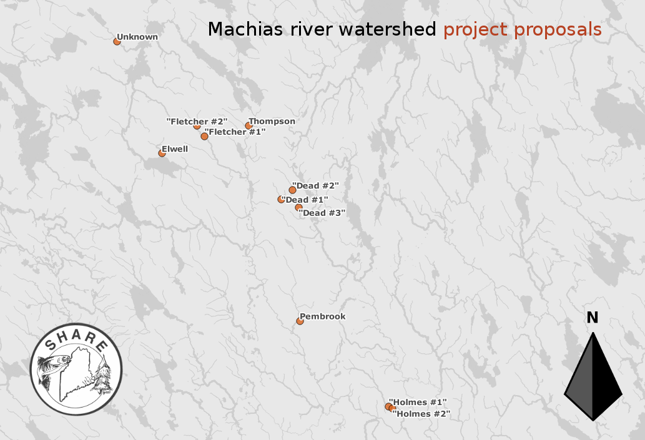
III. PHOTOGRAPH(S) OF PROJECT AREA
Photo 2. Public domain aerial photograph of two locations of remnant dams on Fletcher Brook and the associated over-widened channel through the legacy reservoirs.

Photo 1. Removal of remnant dam by SHARE and partner’s staff using a high line and grip hoist. (photo by SHARE staff)

IV. PROJECT BUDGET

Partner Name | Partner Category * | Activity of Partner ** | Budget Category*** | EBTJV  NFHAP Request | Non-Federal Contribution |  | Federal Contribution |  | Total Contribution | Acres/Miles Affected
 |  |  |  |  | In-Kind | Cash | In-Kind | Cash | Total Contribution | Acres/Miles Affected
Project SHARE | Conservation group (local) | monitoring | personnel | 7,240 |  |  |  |  | 7,240 | See table
Project SHARE | Conservation group (local) | monitoring | travel | 1,010 |  |  |  |  | 1,010 | Question #1
Project SHARE | Conservation group (local) | Dam removal | personnel | 21,120 |  |  |  |  | 21,120
Project SHARE | Conservation group (local) | Dam removal | travel | 3,630 |  |  |  |  | 3,630
Maine DMR | State Agency | restoration |  |  |  | 7500 |  |  | 7,500
Maine DMR | State Agency | Dam removal | personnel |  | 2400 |  |  |  | 2,400
USFWS | Federal Agency | Dam removal | personnel |  |  |  | $10,361 |  | 10,361
DELLT | Conservation Group (local) | Dam removal | personnel |  | 2400 |  |  |  | 2,400
Project SHARE member groups | Landowner, conservation groups | Dam removal | personnel |  | 3200 |  |  |  | 3,200
Washington Academy | school | Dam removal | personnel |  | 7680 |  |  |  | 7,680
University Maine Machias | school | Dam removal | personnel |  | 6400 |  |  |  | 6,400
Total Contribution |  |  |  | $33,000 | 22,080 | 7,500 | 10,361 |  | 72,841

*Partner Categories - Federal Agency, State Agency, Local Government, Conservation Group (Local), Conservation Group (National), Native American Tribe, Private Landowners, Corporations/Businesses

**Activity - Acquisition, Fish Ladder, Dam Removal, Culvert Removal, Restoration, Monitoring

***Budget Categories - Equipment, Construction, Contractual, Personnel, Travel, Supplies, Other.

NOTE: This is not a Federal Grant program and therefore does not exclude non-federal match used here from being matched to other Federal Grant sources to leverage funds for the project. Indicate if partnering contributions are in-kind or new cash. NFHAP requests should illustrate how the dollars will be spent and by what organization. Overhead such as utilities, office space, and salary to prepare applications and develop partnerships will not be funded with NFHAP funds and should not be a line item or built into the project. Activities that directly relate to completion of the project such as travel and salary to do design work let and/or monitor contracts are allowable expenses with NFHAP funds but should not constitute more than 10% of the funding request. For more information on the use of NFHAP funds, please see http://www.fws.gov/policy/717fw1.html.
V. EVALUATION QUESTIONS

- Please provide the GPS Coordinates for the project using UTM NAD 83.

Location UTM X UTM Y EBTJV EBTJV Miles
_of dam___________________________________________ Score Restored
Pembrook 594279 4972332 230545 1.58 5.5
Holmes 1 603208 4963706 230545 1.58 3.7
Holmes 2 603569 4963543 230545 1.58 3.9
Thompson 589145 4991940 230471 1.63 2.9
Fletcher 1 584700 4990869 230471 1.63 1.7
Fletcher 2 583946 4991901 230471 1.63 0.8
Elwell 580415 4989152 230477 1.63 1.3
Unknown 575911 5000417 230477 1.63 5.6
Dead 1 592423 4984544 230519 1.58 3.0
Dead 2 593505 4985460 230519 1.58 1.0
Dead 3 594156 4983727 230519 1.58 5.0
34.4
- Please list the type of project. fish passage and instream habitat restoration

- Are brook trout currently present at the project site or in the project stream? If not, were brook trout historically present? Is the habitat known to be suitable for restoration / reintroduction of brook trout? Brook trout have been identified as present within the watershed. Several of the streams identified in this proposal have had efishing evaluations that demonstrate the presence of brook trout in the streams, however, the specific restoration site location has not been efished at this point. Fisheries biologist consider these project are located within the “best of the best” brook trout habitat in Downeast Maine.

- Please describe how the project will provide for the expansion or improvement of existing habitat? Removal of the dams and associated reservoirs will restore fish passage, natural hydrology, current velocities, and sediment transport. Over time, we expect riparian buffers to become better vegetated with tree affording shade and cooling.

- Does the project include a protection component? Is the project footprint located on private or public land? Is the land currently protected? Does the project include land purchase or easements as match? The project does NOT include a protection component. The main stem and larger tributaries of the Machias River are protected by easements along the riparian corridor. The land owners are aware of the importance of shaded riparian corridors on Atlantic salmon and brook trout rivers. One landowner has a self imposed riparian buffer management plan that has been in place for over a decade.

- What percentage of the watershed above the proposed project is protected in perpetuity?
Conservation easements are in place associated with the riparian areas DOWNSTREAM of these sites. One location is on property owned by the state of Maine and managed by the Department of Conservation.

- List the specific regional EBTJV habitat objectives addressed by the project and describe how the project will contribute towards them.
The project addresses Regional Habitat Objectives:
1 – Maintain the status of 477 Northern sub-watersheds classified as healthy.
2 – Strengthen brook trout populations in 20 sub-watersheds classified as healthy.

- State which, if any, EBTJV priority the project addresses:
- Project protects the “best of the best” habitats that already support healthy, stable brook trout populations.
- The project improves and reconnects habitats adjacent to the best of the best that also have a high likelihood of supporting stable brook trout populations.

- What is the EBTJV subwatershed number and associated priority ranking for the proposed project?
Watershed # =
Priority Score = See Table in Question #1 above
Map =

- Will the completed project benefit any state listed threatened or endangered species?
Yes: Atlantic salmon which are federally listed as endangered

- Will the project provide or enhance connectivity to or within an intact subwatershed? Yes: projects consist of removing legacy remnant dams which are presently hydraulic checks responsible for the perpetuation of remnant reservoirs (dead waters). They can effectively inhibit fish passage, cause dead waters which impact current velocity, sediment transport, and increased temperatures to cold water habitat. Removal of these legacy hydraulic checks will restore instream connectivity and stream process.

- What are the root causes of the watershed degradation and which of these are addressed by the project? 1) Legacy impacts from historic commercial logging practices where the rivers were used as the transport mechanism via log drives. 2) The road system associated with modern commercial logging where undersized culverts have fragmented the stream ecosystems. This project addresses threat associated with legacy impacts. Stream connectivity has already been restored at the road crossings on these same streams using other funding sources.

- Describe the plans for project monitoring and evaluation. The Gulf of Maine Stream Barrier Removal Monitoring Guide provides details regarding pre-and post restoration monitoring protocols that SHARE incorporates into our restoration program. Longitudinal profiles and benchmarked transects will be surveyed prior to dam removal and again post-removal following a year of high water following through the site.

- Describe the expected effect on the brook trout population. To what degree will the project strengthen the brook trout population status? We expect Brook trout populations to increase in both density and size quality. The projects will enhance fish passage and stream connectivity. Restoration of current velocities through habitat inundated by legacy reservoirs will increase insect drift and reduce surface area of thermal heat sinks. Reduction of the water table in the legacy reservoirs will also allow riparian vegetation to colonize stream banks increasing shade over time. Long term benefits will increase the availability of pool habitat that is generally reduced in the project areas.

- Please describe the long term benefit of the project and provide an estimate of the length of time the project is expected to be effective. If a plan for long term maintenance is necessary to maintain project benefits, please describe it. These projects will remove legacy hydraulic checks that have been in place for a century or more. Once the anthropogenic checks are removed, natural stream processes will be restored. Restoration of natural stream hydrology will allow natural stream processes improve instream habitat in perpetuity.

- Are other strains of brook trout, salmonids, or exotics present in the proposed watershed? Do stockings of other strains of brook trout, salmonids, or other exotics occur, and if so, where does the stocking take place with respect to the project site (in HUC, in HUC but below barrier, or in adjacent HUCs)?
Brook trout and Atlantic salmon are present in the proposed watersheds. Stocking of Atlantic salmon fry occurs at numerous locations in the Machias River subject to suitability of habitat including several of the streams identified in this proposal.

Smallmouth and largemouth bass have been identified in the Machias River watershed, typically in habitat of higher stream order than these project sites. Reducing the impact of legacy reservoirs as sources for increased water temperatures is considered to be a means of reducing bass habitat as well as increasing brook trout habitat suitability.
- Please describe the current status of the project. Is it planned, permitted and ready to begin? The projects are planned, permits are in place. LWD placement will occur 2013. Preconstruction surveys will begin in 2013 and remnant dam removal will occur during the instream work window of July 15 – September 30th 2013/14 if the project is funded and the contract is in place.

- Will public access be allowed at the project site? If so, what kinds of recreational activities are allowed – public fishing, nature trails, etc? Public access is allowed at all project locations. Activities include hunting, fishing, snowmobile and ATV use on approved trails in the area, hiking, etc.

- What is the recreational quality of the potential fishery? The Machias River watershed has a recognized recreational brook trout fishery.

- Describe the outreach or educational components of the project and how many individuals / students will be served. Students for Washington Academy and University of Maine Machias have historically assisted with habitat restoration projects. Generally 20 to 30 students participate each year. SHARE and USFWS collect time lapse photography of dam removal projects which are posted on web sites

- If applicable, please briefly describe how this project will promote adaptation to climate change. While we cannot directly impact causes of climate change, the proposed work will directly impact legacy impacts that contribute to warmer water temperatures. USFWS staff have monitored water temperatures in similar legacy reservoirs and have demonstrate they contribute to increasing water temperatures at similar sites. The projects are intended to restore coldwater refugia in these focus sub-watersheds.

- Please explain how this project is a good investment of funds, using a quantitative approach where possible and the recreational and / or economic value of the project. This project benefits from the concept of “economy of scale”. Given the history of SHARE’s restoration program, equipment required for monitoring and site restoration has been previously purchased. Background watershed monitoring and assessment has previously been conducted with funding from previous projects that have occurred in these watersheds. Partnerships and experience already in place will be tapped as the in-kind labor force to leverage the EBTJV funds being requested. As a result, it is reasonable to expect that we will be able to complete 11 remnant dam removal projects for approximately $3,000 apiece which is cost effective investment.

- SUPPORTING DOCUMENTATION:

- Literature Cited
- References to published interagency fishery or aquatic resource management plans.

