Our Mission
Canaan Valley Institute is a 501(c)3 non-profit organization that works to create healthy communities, vibrant economies, and clean watersheds across Central Appalachia. We restore degraded land and streams to conditions that are healthier for people, plants, and animals. By providing education, outreach, and technical assistance, we also help organizations, local governments, and communities gain the tools and skills necessary to develop lasting solutions.

Our Vision
Our vision is for local governments and organizations to work together to develop lasting solutions to linked economic and environmental challenges. Economic development and diversification efforts will build upon local assets and will include the restoration of degraded land and streams. Effective partnerships will help cities and counties across the Central Appalachian states of West Virginia, Virginia, Maryland, and Pennsylvania build healthy communities, vibrant economies, and clean watersheds

What we do…

Community Capacity Building
- Empowers communities, local governments and businesses to improve the quality of life in their watersheds through cost-effective, locally determined solutions

Stream and Habitat Restoration
- Assessment of stream conditions and restoration options
- Wetland delineation and restoration
- Watershed and mitigation planning
- Development of designs and construction specifications
- Coordination with regulatory agencies
- Construction management planting
- Long-term monitoring and reporting

Wastewater Management
- Assist local, county, and watershed groups to assess current treatment conditions
- Identification of treatment alternatives including traditional and alternative technologies
- Development of projects that are relevant to and reflect local priorities

- Assistance to small communities with system design, permitting, and installation oversight
- Development of funding strategies, incorporating non-traditional sources of funds and services
- Targeted education programs to homeowners, local decision makers, and management entities

Outreach & Education
- Promoting environment-based outreach and education as tools for increasing community vitality, ecological integrity, and academic achievement
- Immersing students and local stakeholders in the natural resources around them,
- Working with schools, nonprofit organizations, private businesses, and local and state agencies to develop educational opportunities that engage students and local stakeholders in meaningful learning experiences in their natural world

Since 1995, Canaan Valley Institute has been dedicated to providing Central Appalachia with clean rivers and streams.
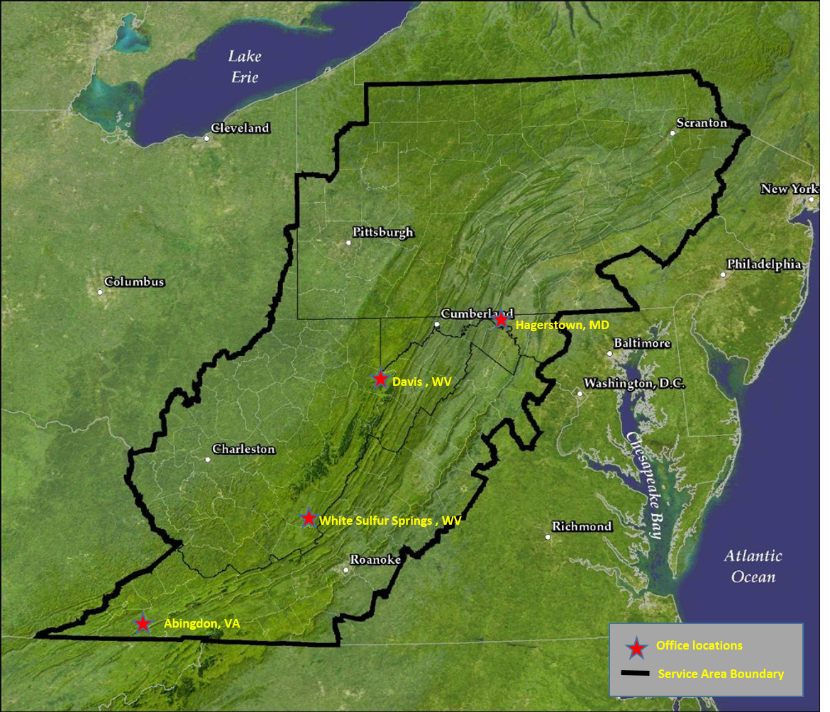

Our partners…
Allegany County Health Department
Blue Ridge Community & Technical College
Choose Clean Water Coalition
Downstream Strategies
Environmental Protection Agency
Frederick County Health Department
Howard County Health Department
Maryland Department of the Environment
Maryland Department of Natural Resources
Montgomery County Health Department

National Fish & Wildlife Foundation
Sprouting Farms
US Fish & Wildlife Service
US Forest Service
Upper Tennessee River Roundtable
VA Dept. of Game & Inland Fisheries
Washington County Health Department
West Virginia Department of Environmental Protection
West Virginia Brownfields Assistance Centers
West Virginia Rivers

