Summary of results for: Ranking Brook Trout Habitats in West Virginia and Maryland to Climate Change
The objectives of this research are to develop climate change resilency rankings for brook trout populations in West Virginia and Maryland. This will be done by developing a predictive model using land use metrics and air and water temperature curves to predict the resilency of brook trout to climate change.
Summary of Results
Many climate change models predict both subtle and dramatic changes to aquatic systems. Large scale models based on simple air temperature – water temperature relationships have been useful in highlighting potential threats to cold water dependent species such as brook trout, predicting major losses of suitable habitat and substantial reductions in geographic distribution. However, spatial variability in the relationship between changes in air temperature to changes in water temperature complicates predictions. In order to better predict changes in the persistence of cold water habitat, we directly measured paired summer air and water temperatures over the summer of 2010 in a stratified representative sample of watersheds (habitat patches <1 – 274 km2) containing wild brook trout populations throughout the southeastern states Virginia, West Virginia, Maryland, Tennessee and North Carolina as well as Pennsylvania, USA. Data were also available for 2009 in Virginia. We used the temperature data to classify streams in terms of two important components of habitat vulnerability: sensitivity (predicted change in water temperature per unit increase in air temperature) and exposure (predicted frequency, magnitude, and duration of water temperatures averaged over a range of temperatures). Sensitivity was significantly lower (median sensitivity = 0.35 degrees) than the 0.80 degrees assumed in some previous models, and was generally consistent across the two years of the study. In contrast, exposure was considerably greater in 2010 (a particularly warm summer) than in 2009. Variation in sensitivity and exposure among habitat patches was influenced by landscape metrics such as percent forested riparian corridor, patch area, maximum air temperature, and elevation. Overall, our direct measurement approach identified significantly more brook trout habitat patches with low sensitivity and low exposure that would persist under warming air temperatures than do previous large scale models. Figure 1 provides estimated classes of sensitivity and exposure. Our sensitivity and exposure classification should provide a useful general framework for managers in making investment decisions for protecting and restoring brook trout habitat at the population scale.

Figure 1. Predicted exposure and sensitivity classes using a 0.5 prediction cutoff. HEHS = high exposure,
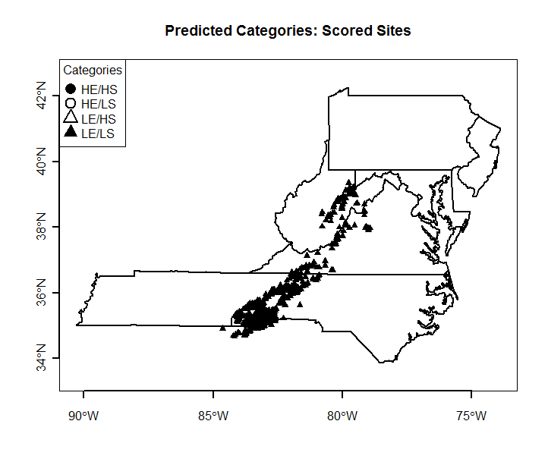
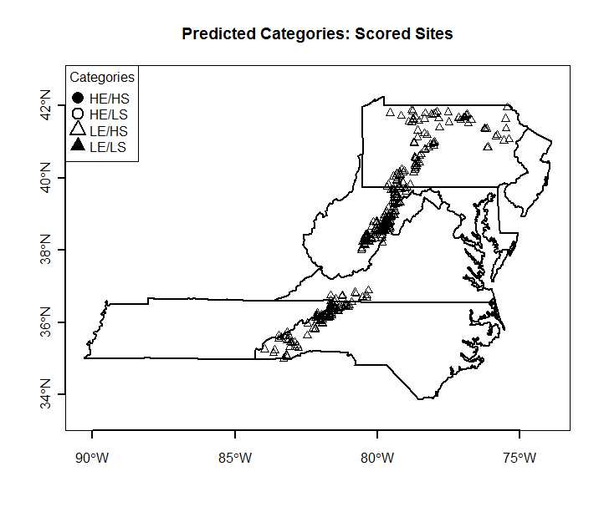
high sensitivity, HELS = high exposure, low sensitivity, LEHS = high exposure, low sensitivity, LELS =low
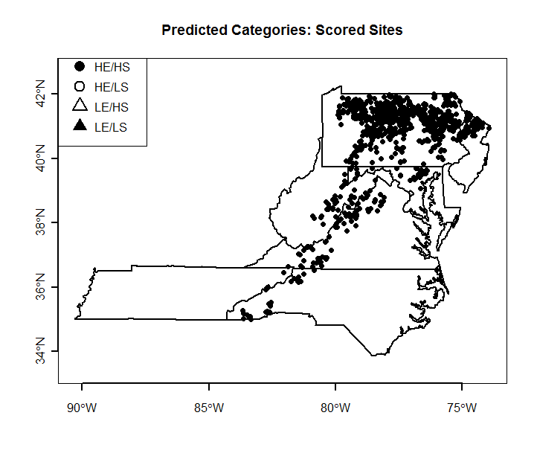
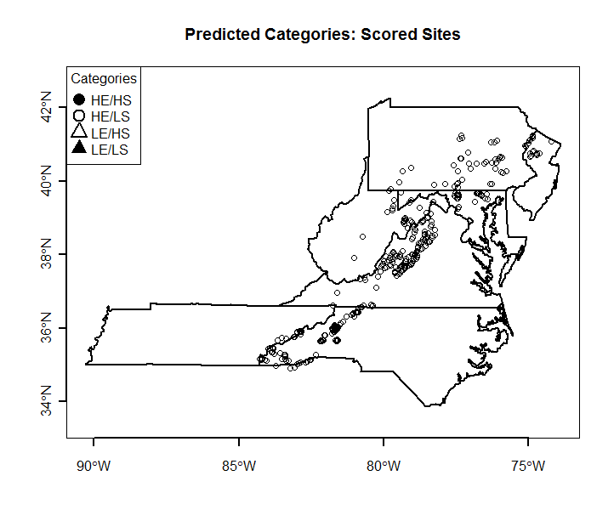
exposure, low sensitivity.

