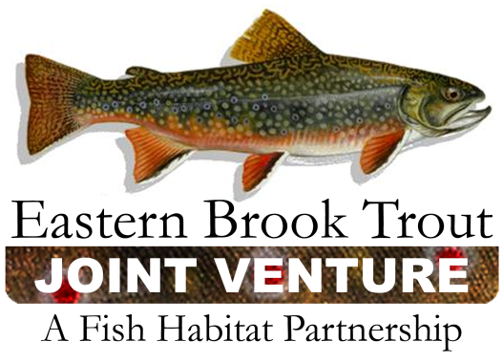

EBTJV Steering Committee
Conference Call Summary
June 28, 2011
10:00 – 11:40 am
Attendees: Steve Moore, Doug Stang, Merry Gallagher, Tom Sadler, Jeff Durniak, Jim Habera, Bob Carline, Karen Knotts, Doug Besler, Callie McMunigal

- Revision of NFHAP - effort to date and next steps

- Request from National Park Service re: continue with Lynn Camp project or not
Steve Moore sent a letter to EBTJV asking for advice on the future of the Lynn Camp project. The letter was distributed to the group prior to the call. During the call, Steve explained the status of the Lynn Camp project. After NPS removed the rainbow trout from the stream, some were illegally introduced in the stream again. Steve is asking whether the EBTJV supports NPS continuing to spend limited resources on this project. Several states / partners are going to send support letters to the NPS. Additionally, the Steering Committee agreed to send letter of support to NPS for Lynn Camp Project. The future priority for this project may be elevating enforcement rather than moving funds to another project location. EBTJV wants to be supportive of these restoration efforts. This is an investment for EBTJV and the partners and we should be asking what we can do to ensure protection of this investment into the future?
Action - Doug will draft a letter by the end of the week. Merry Gallagher, Jeff Durniak and Tom Sadler agreed to review the letter.

- Status of 2011 EBTJV Projects and FWS 2011 Budget
The list of funded projects for FY11 is not yet available, but it looks like we will be able to fund approximately 8 projects (1-6 and 8-9 on the ranked list). This is a result of the top projects in each FWS region being funded this year. Applicants will be notified as soon as the list is finalized and approved.
- Status of 2012 EBTJV Project Applications (anything submitted yet, reminder of deadline)
The FY12 budget is unknown at this point, but could be a bit tighter than previous years. We should move forward with the announcement for proposals by placing a statement on the website / application materials that the process may be more competitive than usual. We should also recommend that all applicants call EBTJV contacts with their state and the Service to discuss their project early and solicit feedback before going through with the application process.

Action – Callie will work with Jeff Dobson to update website to include this information. It will be posted on the webpage where they click to apply and also be placed in the application materials.

- Request from Orvis re: potential projects to fund
Doug received a request for project ideas from Orvis. The request was distributed to SC members prior to the call. Orvis is interested in habitat restoration projects that they can fund or contribute towards. Projects sent to Orvis need some flash or need a local connection to an Orvis store / community.
Action – Doug will work with Callie to pull high ranked, unfunded projects off of our 2011 project list.
- Status/ options for EBTJV website
Jeff Dobson finished his paperwork and can accept credit card payments. Callie will pay him for 1 year of support. Options for future website maintenance include continuing to hire Jeff Dobson for support or ask Andrea Ostroff / USGS to train us so that we can manage our site ourselves. The latter option would likely require our website to be nested with the other NFHAP websites.
Dianne will serve as the point of contact for website updates with Jeff. She will also spend some time reviewing the website to get it up to date.
- EBTJV presentation(s) at 2011 AFS meeting - update, request for information
We are part of a combined presentation of the eastern partnerships during the fish habitat partnership symposia on Monday afternoon. Doug is waiting on final abstract and will share with the group when available. We are also eastern brook trout habitat restoration efforts throughout the range during a habitat restoration symposia on Wednesday afternoon. Doug will share both presentations with the SC for review when they are available.
- Northern Work Group report/ update – Merry Gallagher
The team is still working on their habitat objectives, but it hard to make progress on these during field season. They expect progress this fall.
They discussed the information request for the AFS presentation. The group felt that the email and the abstract to date already included everything that should be there. Doug just needs some examples from the members on these actions.
They also talked about issues that may be more of a regional issue that could be addressed through coordination such as stream connectivity. They will continue these discussions during their next call.
- Southern Work Group report / update
N/A
- Committee reports (Science / Data, Outreach, Grants and Development)
Outreach – Trademark paperwork is available and will be sent to Callie for permanent storage with EBTJV files.
Grants & Development – Possible funding opportunities with Orvis and the MSCG with SARP and ACFHP.
Science / Data – Callie submitted Mark Hudy’s two projects (updated catchment assessment and climate change analysis) to the ALCC and the NALCC this year for funding consideration.
Action - Callie will send out the names of folks that are on the interim steering committee for the ALCC. State partners can work with these individuals on issues / priorities / etc for the LCCs.
- Next Annual Meeting
There was a proposal to coordinate the next EBTJV meeting with a future SDAFS Trout Committee meeting. The next SDAFS meeting is likely going to be in Frostburg, MD in early June, 2012.

Action – Group agreed that June 2010 timeframe would be amenable. Steve will follow up with Alan Heft and report back on SDAFS meeting location / time.

- Next Steering Committee Conference Call
September 27, 2011 at 10:00 am

