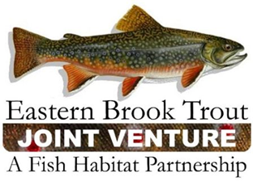
Steering Committee Conference Call
September 18, 2018
1:00 – 3:00 p.m.

Call-In Number: 866-793-8933
Participant Code: 86086865

AGENDA

- Steering Committee Roll Call & Establishment of Quorum (Nat Gillespie)

- Approval of June 26, 2018 Conference Call Summary (Nat Gillespie)

- Proceedings from the EBTJV Sponsored Symposium held at the 2018 AFS Annual Meeting (Nat Gillespie)

- FY18 FWS-NFHAP Funding for Brook Trout Conservation Projects (Steve Perry)

- Project Recruitment for FY19 FWS-NFHAP Funding Considerations (Steve Perry)

- EBTJV Meeting - Planning Update (Steve Perry)

- EBTJV Roadmap to Restoration, Version 2 (Nat Gillespie/Steve Perry)
(2017 WNTI Annual Report)

- 2018 Multistate Conservation Program Grant (Steve Perry)

- EBTJV Results (EBTJV Responses to Measures 1-4 and Measures 5-11) from the NFH Board’s 2018 FHP Performance Evaluation (Steve Perry)

- National Fish Habitat Partnership’s 2018 Waters to Watch Nominations (Steve Perry)

- 2018 Central Appalachia Habitat Stewardship Program (Steve Perry)

- Other Business

