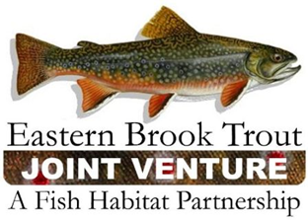
Steering Committee Meeting
June 12, 2019
1:00 – 5:00 p.m.
Frostburg State University
Frostburg, MD

Call-In Number: 866-793-8933
Participant Code: 86086865

AGENDA

- Steering Committee Roll Call & Establishment of Quorum (Nat Gillespie)

- Approval of March 26, 2019 Steering Committee Call Summary (Nat Gillespie)

- Brief Update on the EBTJV’s FY19 NFHAP Workplan and Accomplishment Report (Steve Perry)

- Discussion about the proposal to make the EBTJV Assessment Database update-able by Partners

- Brook Trout Genetics – Next Steps

- Fund Raising and Promotional Opportunities

- Other Business

