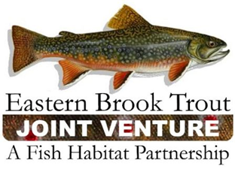
Steering Committee Conference Call
March 26, 2019
1:30 – 3:30 p.m.

Call-In Number: 866-793-8933
Participant Code: 86086865

AGENDA

- Steering Committee Roll Call & Establishment of Quorum (Nat Gillespie)

- Approval of December 18, 2018 Steering Committee Call Summary (Nat Gillespie)

- EBTJV’s FY19 NFHAP Workplan and Accomplishment Report (Steve Perry)

- Eastern Brook Trout Roadmap to Conservation (2018) (Steve Perry)

- EBTJV January 8-9, 2019 Meeting Summary (Steve Perry)

- East Coast Trout Management and Culture Workshop VI

- Other Business

